Hålabäcksskolan, Kungsbacka, Sweden
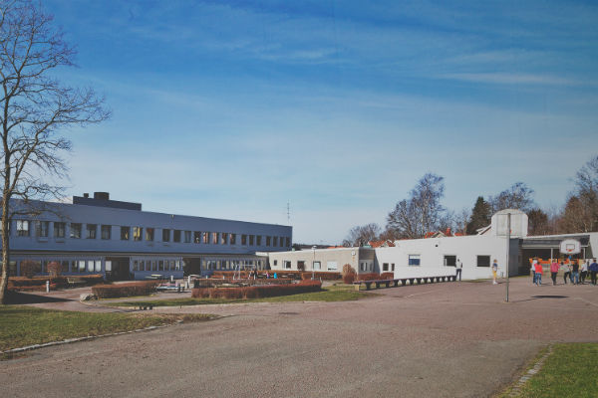
Hålabäcksskolan is located near the centre of Kungsbacka. We have 330 students today, ages between 10 -16 years old. The school is undergoing a huge renovation-project and the estimated number of pupils are 520 the coming years. We will have access to our rebuilt school in february 2020.
The school has a handball-profile in every grade from grade 6 to 9.
Our town, Kungsbacka, is situated on the swedish westcoast some 30 km from the second city of Sweden – Gothenburg. By commuter train it takes 25 minutes to the citycentre.
We have nearby lakes, rivers, forests and the sea and Kungsbacka is a popular summertown with a lot of recreation areas and beaches.
Kungsbacka itself has around 90 000 inhabitants.
The main sports here are soccer, handball, horsebackriding, icehockey and floorball.
Our students backgrounds are very divided since parts of the area around the school is a socio-economic weak area.
We study 17 subjects at school including home-economics, arts and craft and woodwork.

