My holiday memory
During my holiday I visited few places.
I was at the sailing camp in Barlinek. There I practiced my sailing abilities on the Optymist boat. The lake was big and the town – a nice place to visit.
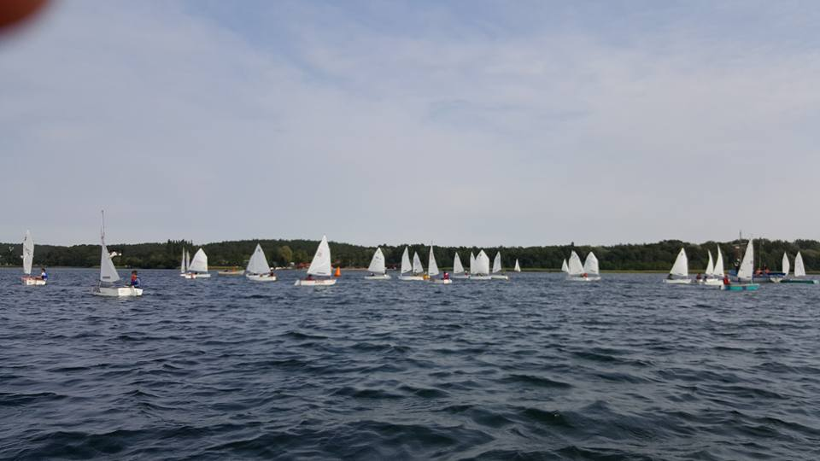
I also went to the seaside. To Słowiński National Park where I tried windsurfing on the beautiful and very big lake Gardno. The nicest thing about this lake is that it is very shallow so it’s safe to practice water sports.
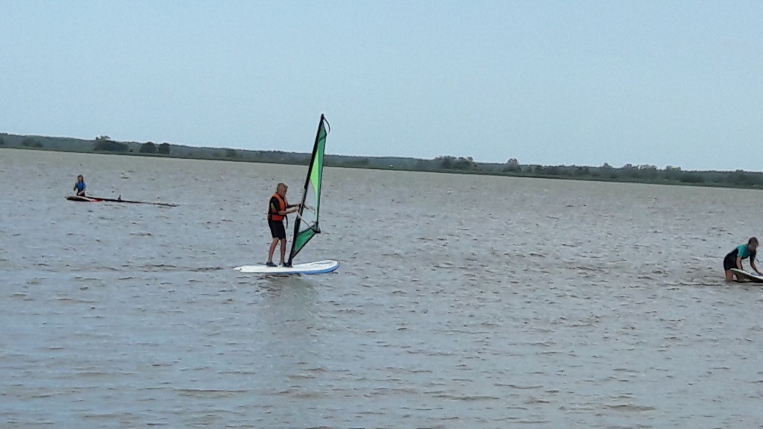
I visited small sea villages with very interesting coast and very wide beaches in the Słowiński National Park. The most amazing thing there, were the moving dunes.
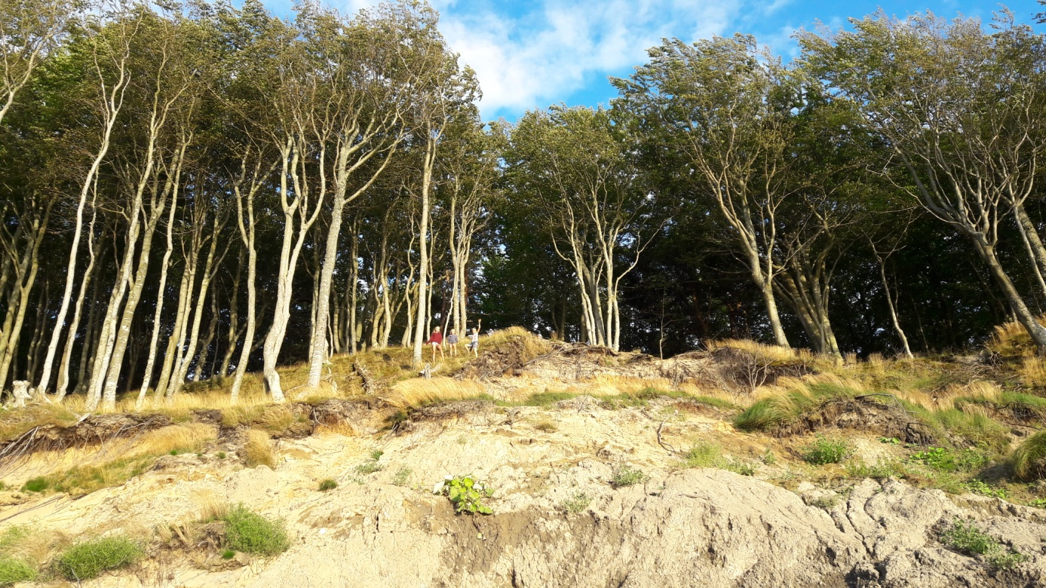
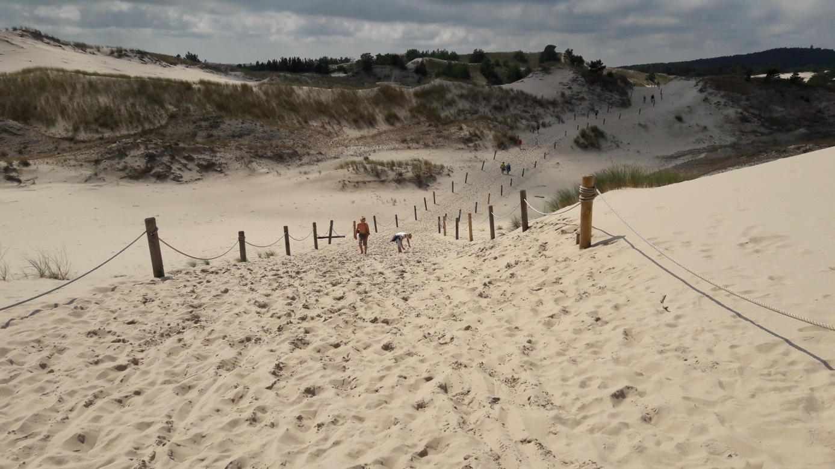
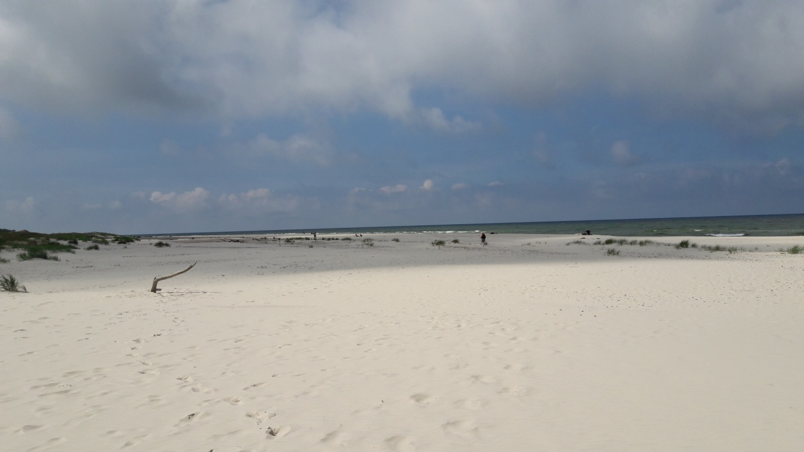
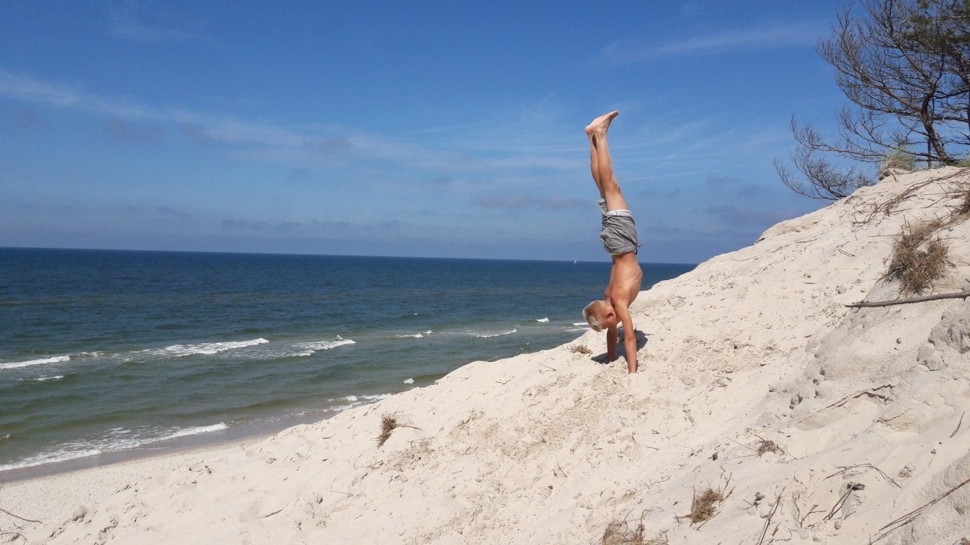
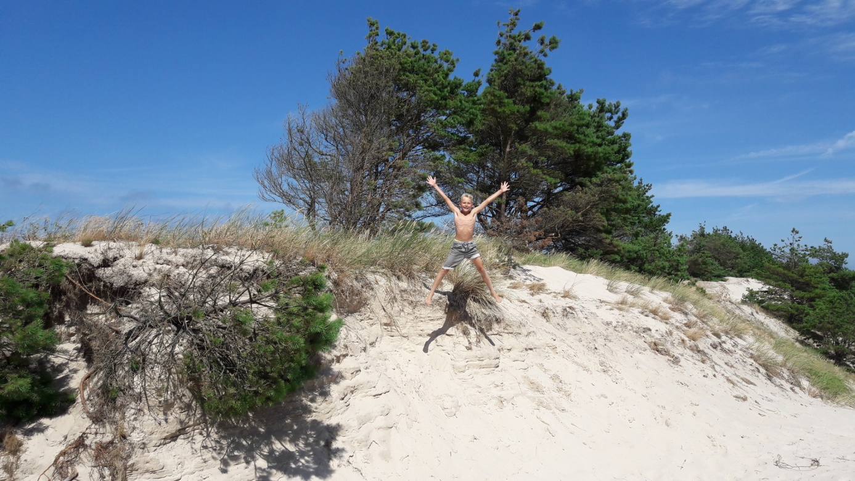
I also visited the city Ustka where I ate tasty ice cream, cotton candy – Polish sweet food - you can eat everywhere at the seaside.

Then I went to the basketball camp to Brodnica. That was very satisfying sport time. A lot of training but also visiting the town and its monuments, for example the Krzyżacki Castle.
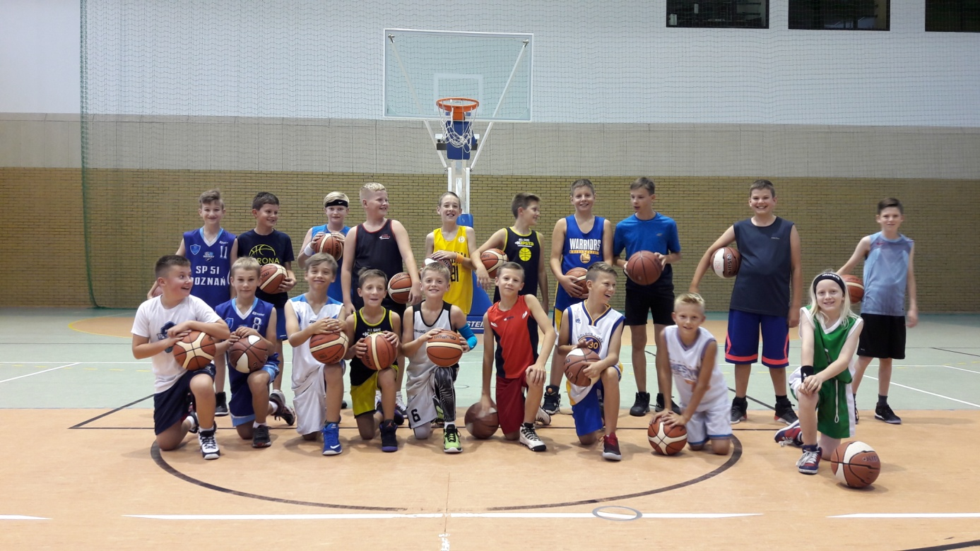
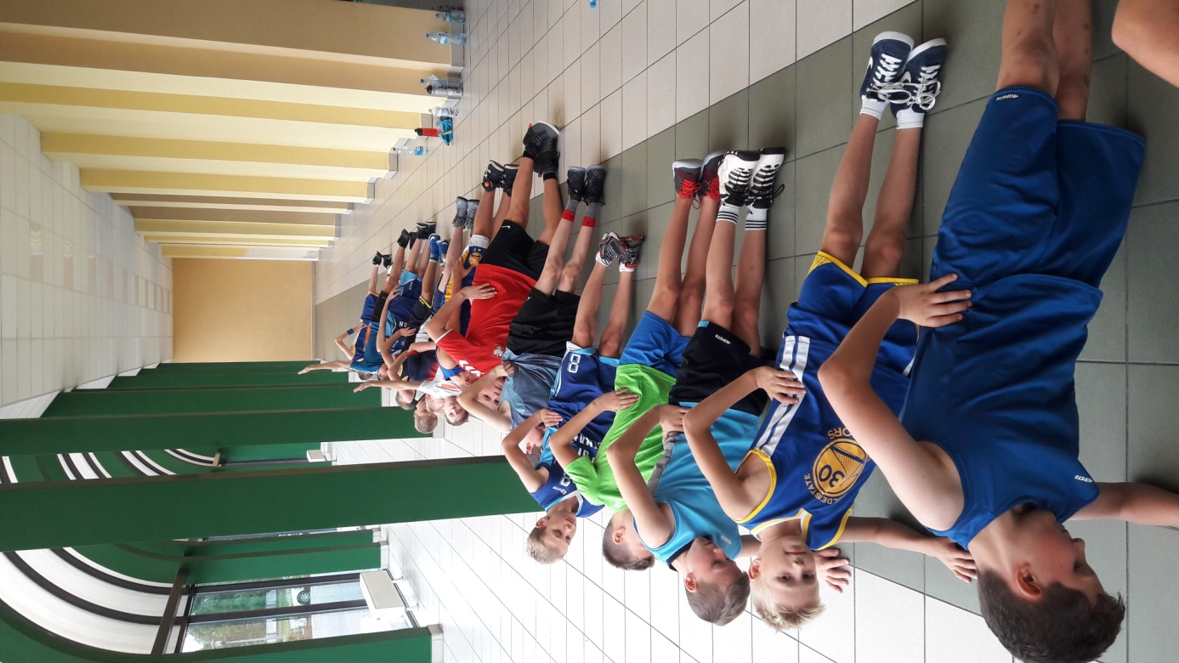
The rest of my holiday I spent at home by the lake, swimming, playing and spending time outside.
That was really nice holiday.
Szymon

