On my vacation I was in Croatia. I liked it very much. There is a beautiful landscape there . We stayed very close to the island of Pag.
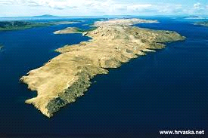

It was very hot. On our way to Croatia we drove through Czech Republic, Hungary, Slovakia, Slovenia.

I loved swimming in the sea because in your sea the water is very warm and clear and also salty so it is easy for you to swim. 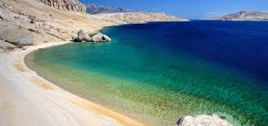
What I enjoyed a lot as well was the Plitvice Lakes National Park.
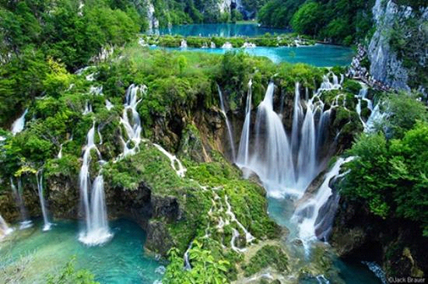

The lakes there are breathtaking and there are a lot of various fish that are really beautiful. My dad noticed a huge pike :)
Eliasz

