PUST

Many Slovene folk traditions are associated with seasonal celebrations. Adults and children enjoy the spring Carnival season, called Pust (Mardi Gras). Pust, carnival, masquerade, a pre – Christian holiday celebrating the end of the winter and the beginning of spring, begins this year on Fat Thursday, February 8 and ends on Ash Wednesday , February 14.

Celebrations include parades, carnivals, and masquerade balls. Kurentovanje in the city of Ptuj (in north-eastern Slovenia) is the most famous tourist attraction. The central figure in the event is the kurent, who has fur clothing and unusual masks with horns. These represent human and animals traits. They are meant to evoke images of another planet. Always happy, the kurent is considered to forecast spring, fertility, and new life. Accompanied by a ceremonial ploughman, he visits farms and wishes their owners a prosperous year.

The Kurant is the main character and mascot of the Kurentovanje. The traditional Korant outfit consists of a very colourful mask with beautiful ribbons and heavy sheep skins coat with many cow bells around the waist. In his hands, the Kurant holds a weapon: the ježevka, a thin wooden stick with real hedgehog spikes at the top. The Kurant parades the streets, jumping from side to side, makes a lot of noise and chases winter away

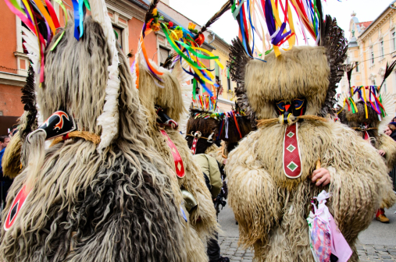
http://www.dailymail.co.uk/travel/travel_news/article-2943816/Slovenia-gets-ready-chase-away-winter-locals-hills-sheepskin-costumes-bizarre-designs-100-000-people-expected-visit-carnival-celebrations.html

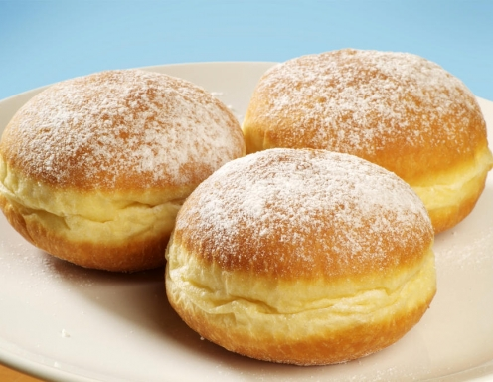

During the celebration of Pust, one of the most popular snacks is the Krof, a puffed donut filled with jam and generously sparkled with white sugar.
Although, in Slovenia, it is believed that if everyone is well-fed during Pust, then the year’s harvest will be good.
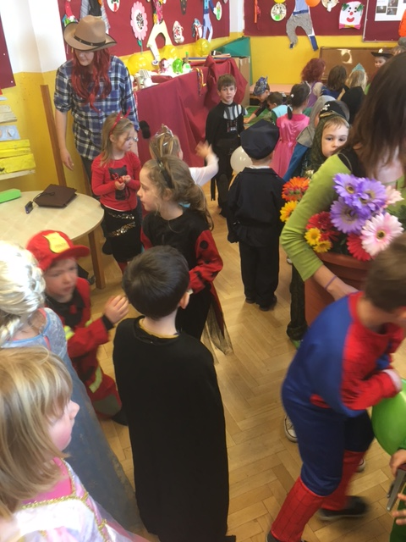

On »Pustni torek« - Tuesday day of Pust we all dress in costumes and we have a big party – masquerade (maškare) as we say.

Costumed children, wearing masks, go from house to house, asking: "Do you have anything for Pusta, Hrusta?"
They say if the masquerade comes into house, there will be luck for the whole year.

