Slovenia Flag
three equal horizontal bands of white (top), blue, and red, derive from the medieval coat of arms of the Duchy of Carniola; the Slovenian seal (a shield with the image of Triglav, Slovenia's highest peak, in white against a blue background at the center; beneath it are two wavy blue lines depicting seas and rivers, and above it are three six-pointed stars arranged in an inverted triangle, which are taken from the coat of arms of the Counts of Celje, the great Slovene dynastic house of the late 14th and early 15th centuries) appears in the upper hoist side of the flag centered on the white and blue bands

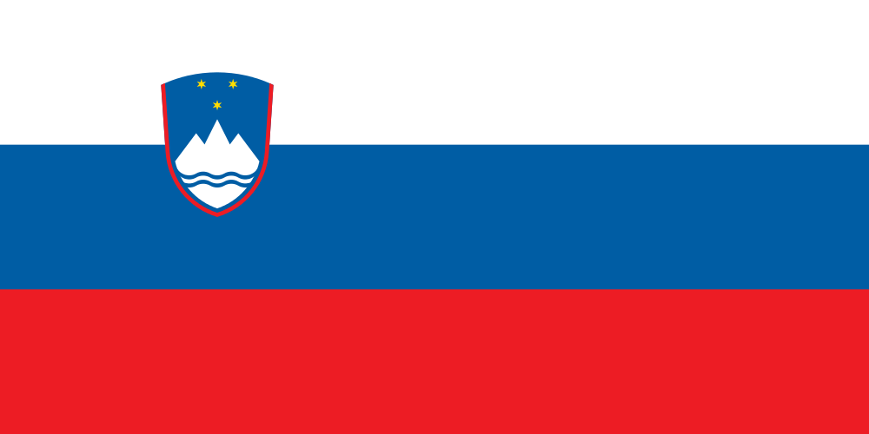

More of history:
https://www.youtube.com/watch?v=3oSObiTqXyE

