women in the window

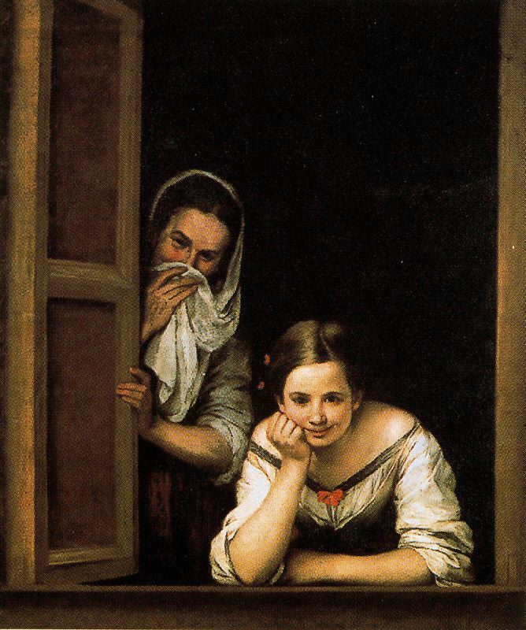

Women in the window is an oil made by the Spanish painter Bartolomé Esteban Murillo between 1665 and 1675 on canvas
in the painting there are two women leaning out of a window. the older one is the procuress and the young woman is the prostitute who calls the attention of the client
The generosity of her neckline and floral ornaments, would support this theory. It is one of Murillo's most enigmatic paintings. It shows two women in a window looking at someone or something that catches their attention.
It is exhibited at the National Gallery of Art, Washington DC, United States.
Composition of painting
the composition of the canvas is very successful: a right angle angled in the lower left corner of the frame frames the scene. The angle is indicated by the sill and the wooden shutter, and by the two women, the young girl supported and the older one that looks out.

