Romania is situated in the north of the Balkan Peninsula on the western shores of the Black Sea. It enjoys great natural beauty and diversity and a rich cultural heritage.
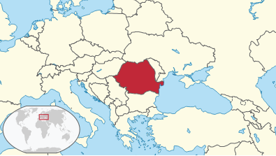

Romania enchants visitors with its scenic mountain landscapes and unspoiled countryside areas, and also with its historic cities and its busy capital, Bucharest.
Things for which Romania is famous include: the Carpathian mountains, sculptor Constantin Brancusi, wine, salt mines, George Enescu, medieval fortresses, Eugene Ionesco, "Dacia" cars, Dracula, stuffed cabbage leaves, Nadia Comaneci, dense forests, the Black Sea, Gheorghe Hagi, sunflower fields, wolves and bears, painted monasteries, the Danube Delta, and so many others.
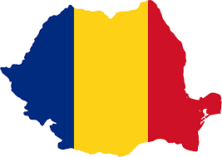

Mangalia is a city and a port on the coast of the Black Sea in the south-east of Constanța County, Romania.
It is Romania’s oldest city, founded in the 6th century BC by the Ancient Greeks who named it Callatis. A century later it came under Roman rule when it was conquered by the Roman general Lucullus. Over the years it was invaded many times. Its strategic coastal location on the coast enabled it to thrive and become an important trade hub. By the 9th century the city was known under several names; the Romanians called it Tomisovara and the Greeks named it Panglicara, but it was the Turks who gave it its present name, which derived from the Greek name which was too hard for them to pronounce.
The municipality of Mangalia also administers several summer time seaside resorts: Cap Aurora, Jupiter, Neptun, Olimp, Saturn, Venus.

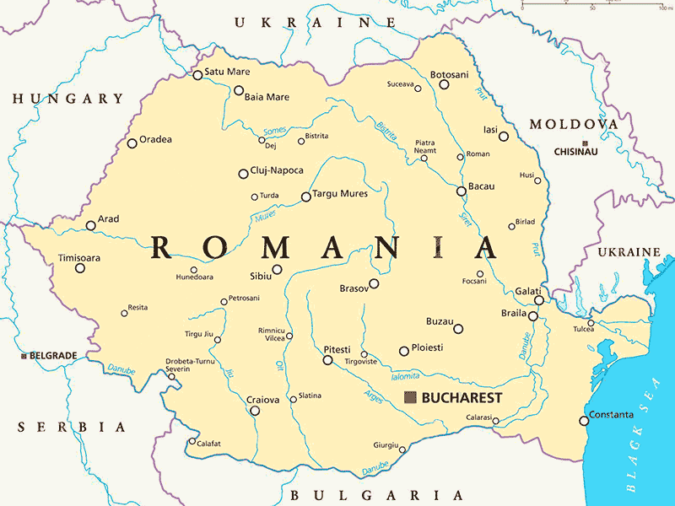
MANGALIA

Callatis Archeology Museum has a unique collection of Hellenistic coins, Roman sculptures, ceramics, jewellery and tools found on archeological digs in the city. Close to the museum you can visit the remains of a 4th century Roman-Byzantine necropolis. The 6th century BC Callatis Fortress was built by Dorians and is well worth a visit. Many items of great historic significance have been found here including South Eastern Europe’s oldest document in Latin.
The Scythian tomb discovered in 1959 where archaeologists unearthed fragments of a papyrus in Greek, the first document of this kind in Romania
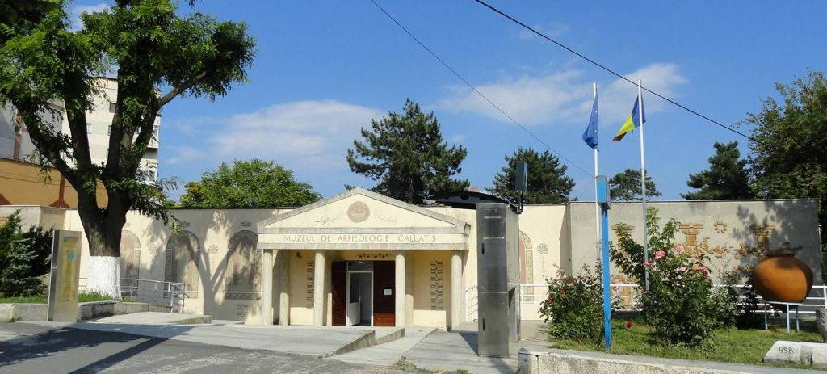
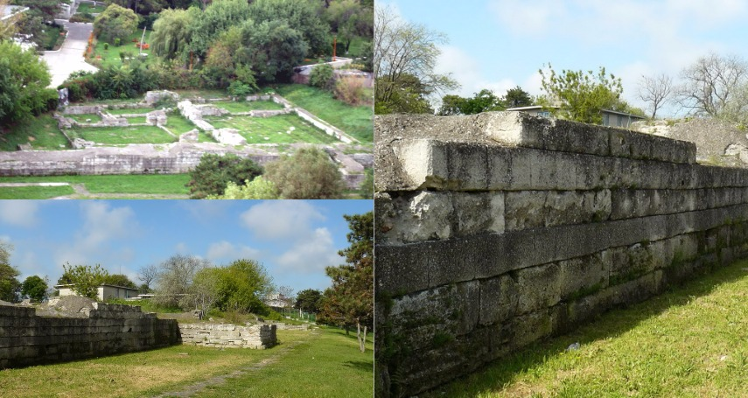
The 16th century Moorish mosque known as the Esmahan Sultan Mosque built in 1525 by the Ottoman Turks houses many treasures including a selection of oriental carpets and a lovely, well-manicured garden and Turkish cemetery. It is known to be the oldest mosque in Romania.
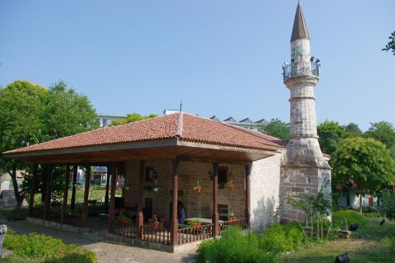
Mangalia Marina is a harbour for yachts and small boats(up to 18 m long) located on the Black Sea coast. It is the most modern tourist harbour in Romania.
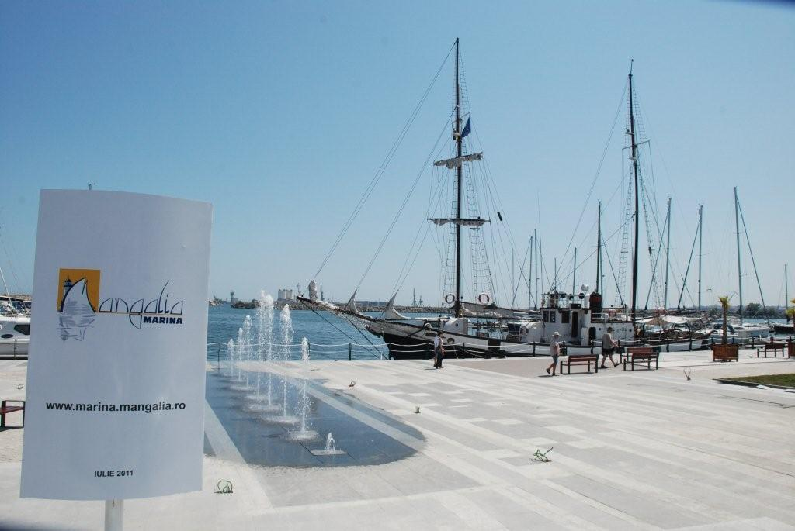
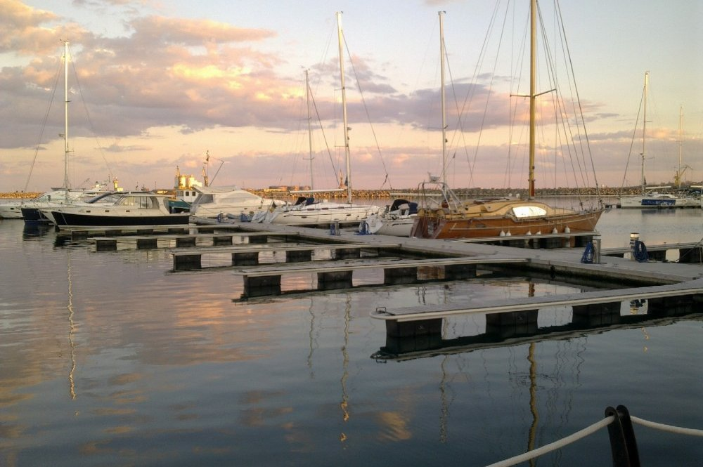
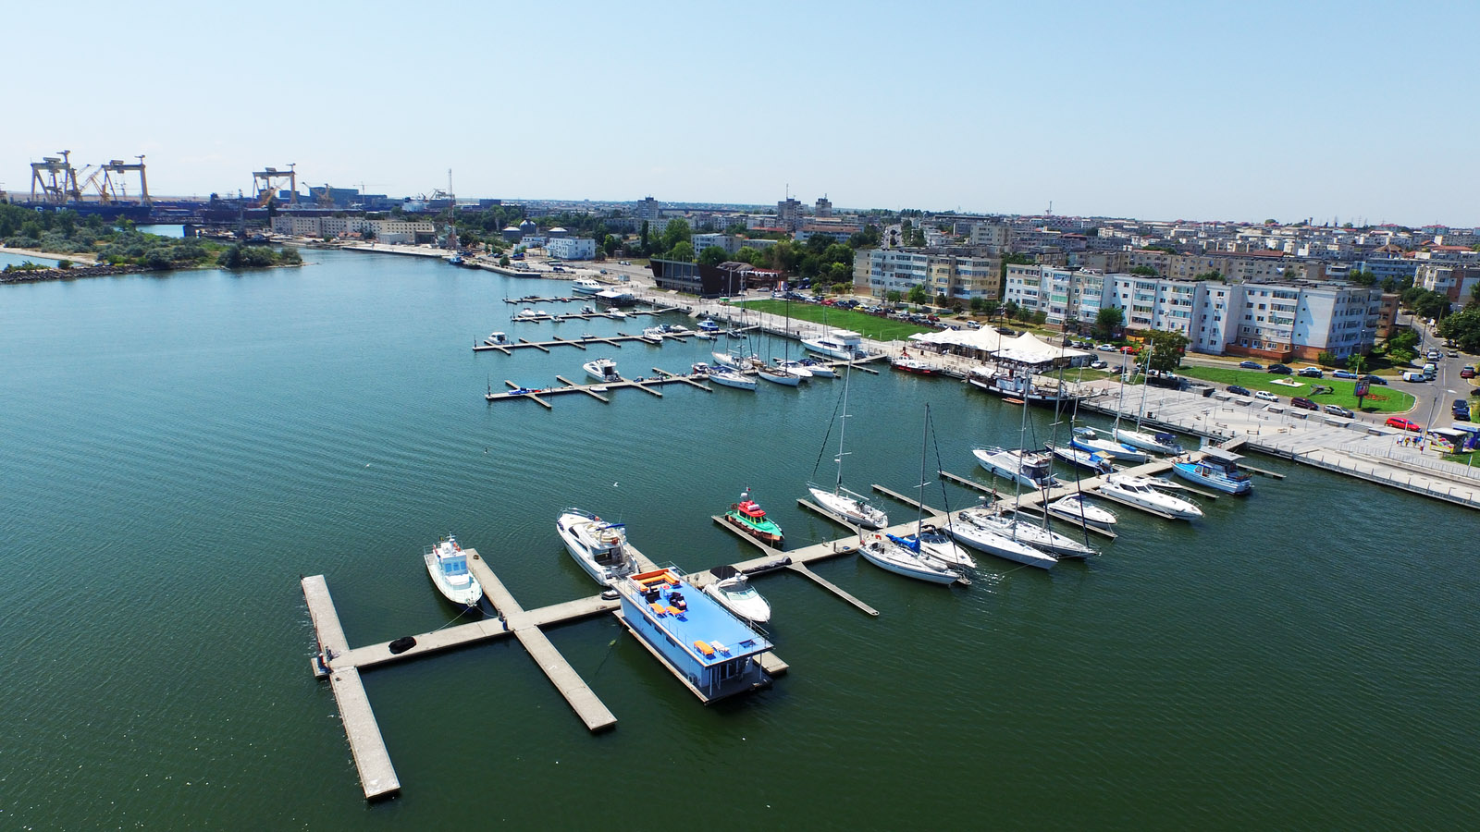

Romanian Black Sea resorts
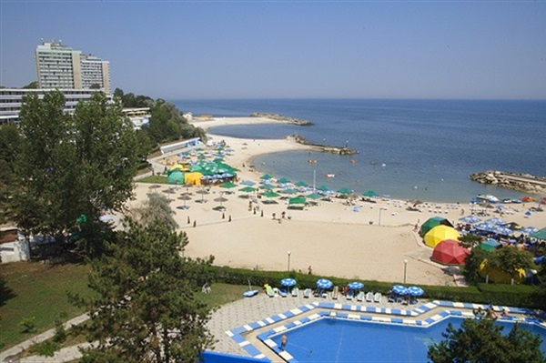
Olimp
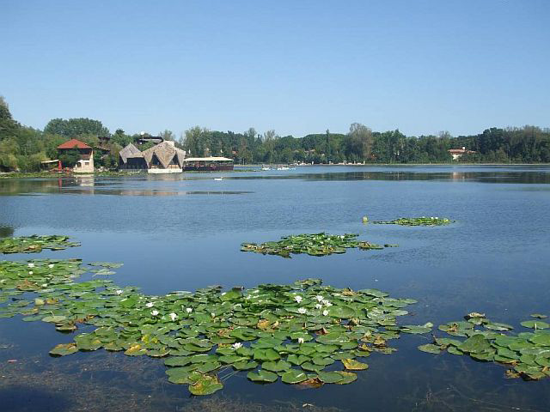
Neptun
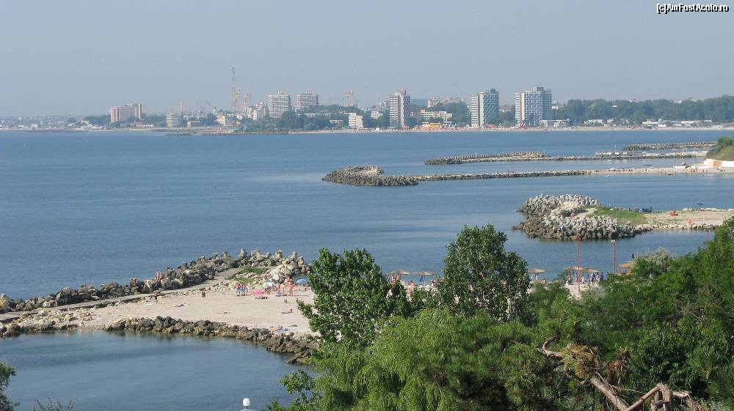
Jupiter
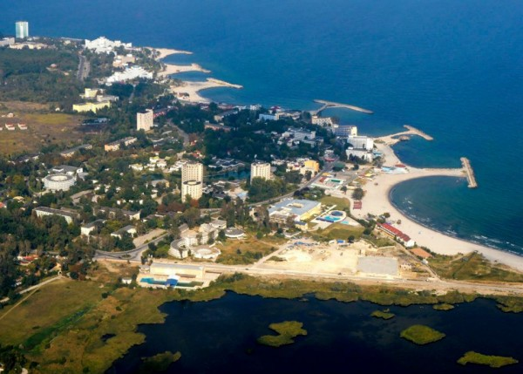
Venus

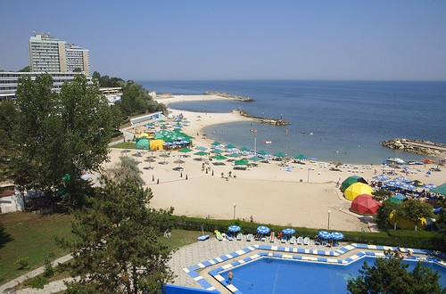
Saturn

