About the Greek Language:

Greek is an independent branch of the Indo-European family of languages, native to Greece and other parts of Eastern Mediterranean and the Black Sea. It has the longest documented history of any living Indo-European languages spanning 34 centuries (3,400 years) of written records. Greek has been spoken since the 3rd millennium BC or possibly earlier. The earliest written evidence is a Linear B clay tablet found in Messenia that dates to between 1450 and 1350 BC, making Greek the world’s oldest recorded living language!
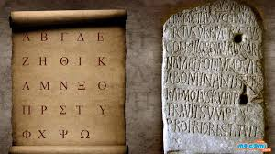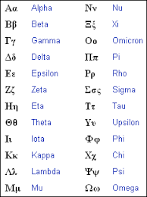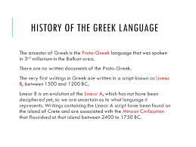
Maskalidou Eleni

