The Weather and climate of Greece:
The climate in Greece is predominantly Mediterranean. However, due to the country’s unique geography, Greece has a remarkable range of micro-climates and local variations. To the west of the Pindus mountain range, the climate is generally wetter and has some maritime features. The east of the Pindus mountain range is generally drier and windier in summer. The highest peak is Mount Olympus 2.9218 meters. The north areas of Greece have a transitional climate between the continental and the Mediterranean climate. There are mountainous areas that have an alpine climate.
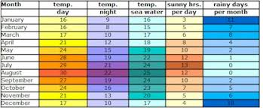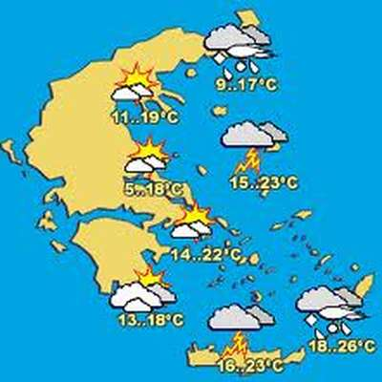
Karagiannopoulou Ioanna

