Greek traditional music or “dimotiki music” as it is called, includes all songs, tempos and rhythms of the Greek regions. These compositions, in their vast majority created by unknown authors, exist for more than a century and their origins are located in the Byzantine period and Greek antiquity.
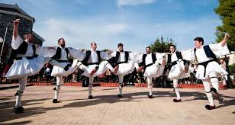
This group consists of not one but many types of compositions usually characterized based on the area where they are performed or created (Greek islands, Epirus, Pontus) . Apart from territorial criteria, traditional songs can also be classified according to their content and the occasion upon which they are performed (carnivals, weddings, migration) .
Greek traditional song can be divided into two musical movements: the akritic and the klephtic. The akritic style dates from the 9th century AD and it was created to express the life and struggles of the frontier guards of the Byzantine Empire, the "akrites". The klephtic style was born between the end of the Byzantine period and the beginning of the Greek Revolution that led to the Greek Independence in 1821. This style was created by the "kleftes", the heroes who left to live in the mountains, leading a revolutionary action against the Ottoman tyranny. The klephtic musical style is monophonic, with second voices repeating a given rhythmical formula, without any harmonic accompaniment. It is composed by love songs, wedding songs, songs of exile, songs of freedom, death and sorrows. It expresses an important, bloody part of the history and the life of the Greeks. Musical instruments used in Greek folk songs are the lira and laouto (lute), the tambouras and gaida (bagpipe), the zournas (shawm), the daouli (drum), the dachares (tambourine), the ziyia (paired groups) and the violi (violin).
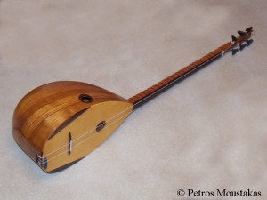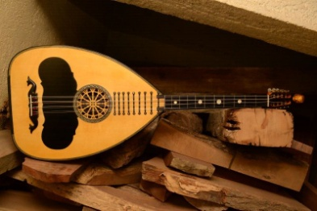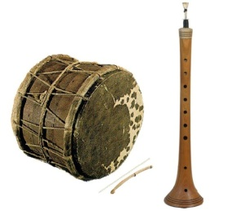

Other types of traditional Greek music
- Kantada

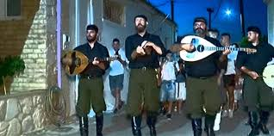
- Originated from Kefalonia island and created at the beginning of the 19th century.It is a style of romantic music, with three male voices , accompanied by guitar or mandolin. This style had been influenced by the Italian music and soon gained all the Ionian Islands and the rest of Greece.
- Nisiotika
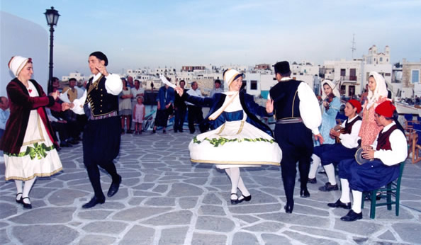
- This kind of popular songs was born in the Greek islands. Every island has its own nissiotiko style and its own way of dancing it. Violin, lira, clarinet and guitar accompany the women voices. Nissiotika are still easy to listen in every festival on any Greek island.

- Rebetiko
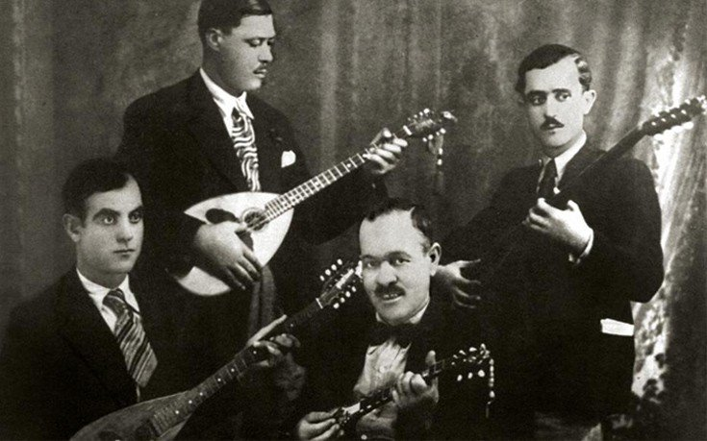
- Rembetiko music was spread by the two million Greek refugees coming from Asia Minor in 1922, after the destruction of Smyrne by the Turks. Homesick and rejected by the Greek population, those Greeks who had never lived in Greece and who had lost everything, sang about their surroundings, poverty, pain, hunger, prison. Rembetiko was the forbidden music. The rembetiko slowly in the 1950s came out of the underground world and started to be played in the nightclubs of Athens, were it became very popular. The principal instruments of the rembetiko are the bouzouki,the baglama, which looks like a miniature bouzouki, and the guitar as well as, for accompaniment, the ziyia and the ntefi, a leather small tambourine with little metallic plates circling it. Some of the greatest and most famous players and singers are Vassilis Tsitsanis, Markos Vamvakaris, Marika Ninou and Sotiria Bellou. During the 1960s, the rembetiko became unpopular again. Young people preferred the new rock music coming from the West and the oldest one started listening again to the candhades of the 1920s. But this music styles is back in the trends and many taverns propose rebetika music bands during weekends.
Ioanna Damaskou

