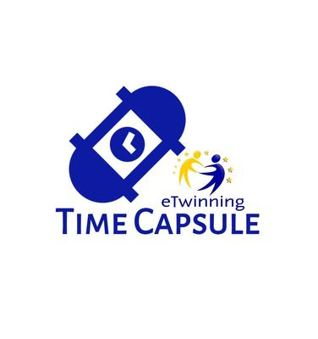
STATISTICS
Collobrative Work Skills: “TIME CAPSULE: LEAVE A MESSAGE TO THE FUTURE”
Teachers Name: María del Rosario Lendínez Robayo / Amelia Martínez Jiménez
School : R.E. La Aduana Country : SPAIN

Statistics number of students in the classroom: 9

➢ In the table below, enter the added values for each category :

CATEGORY | Number of answers  LEVEL 4 | Number of answers  LEVEL 3 | Number of answers  LEVEL 2 | Number of answers  LEVEL 1
Overall impression of the project | 9
Topic of the project | 9
My contribution: time management | 5 | 4
My contribution: quality of work | 2 | 7
My contribution: collaboration in my team/ house | 6 | 3
My contribution: problem- solving | 4 | 5
Topic of my task | 9
My team’s contribution: quality of work | 2 | 7
My team’s contribution: collaboration in my team/ house | 6 | 3
My team’s contribution: time management | 5 | 4
My team’s contribution: problem- solving | 4 | 5
SUMMARY >>> What did you like best about the project? (Only keywords)
The mystery of who are going to open and read our messages.

SUMMARY >>> What could be improved in future projects? (only Keywords)
Making a final video in which every school shows how they bury their capsules.

