Recipe from Sicily-Italy
Dessert name: Gelo di anguria
Number of Doses (Pax): 6 Preparation time: 5 hrs Sale price:€
Quantity | Ingredients |  | Unit Price | Total Price | Preparation Technique
1.5 kg | Seedless watermelon flesh, chopped |  |  | € 2.00 | Chilling time 4 hours  - Place watermelon in a blender or food processor and blend until smooth. Strain into a bowl through a fine sieve and, using the back of a spoon, push down to extract as much of the liquid as possible.  - Place sugar and starch in a saucepan and whisk to combine, then add 80 ml watermelon juice, vanilla extract and a pinch of cinnamon powder, stirring until the cornflour has dissolved. Add remaining watermelon juice and bring to the boil over medium heat, whisking constantly. Continue to whisk for a further 6 minutes or until thick  - Remove from heat and cool to room temperature, whisking mixture occasionally to prevent surface forming a skin.  - Transfer to a clear glass serving cup (for best results) and cover with plastic wrap.  - Chill for 4 hours or until set. Serve topped with pistachios, dark chocolate chips and jasmine flowers
100gr | caster sugar |  |  | € 0.20
100gr | wheat starch |  |  | € 0.50
A pinch | vanilla extract |  |  | € 0.20 | Comments:  This delicious Sicilian summer dessert hails from the capital, Palermo, and is a popular way to make use of the season’s watermelon. The refreshing jelly is typically prepared in the hottest month, August. It generally only includes three ingredients – watermelon, sugar and cornflour – but the garnishes vary from area to area, ranging from cinnamon, jasmine and pistachios, to chocolate chips, which are thought to resemble watermelon seeds.
 | Chopped pistachios, dark chocolate chips, cinnamon and jasmine flowers to garnish |  |  | € 0.50
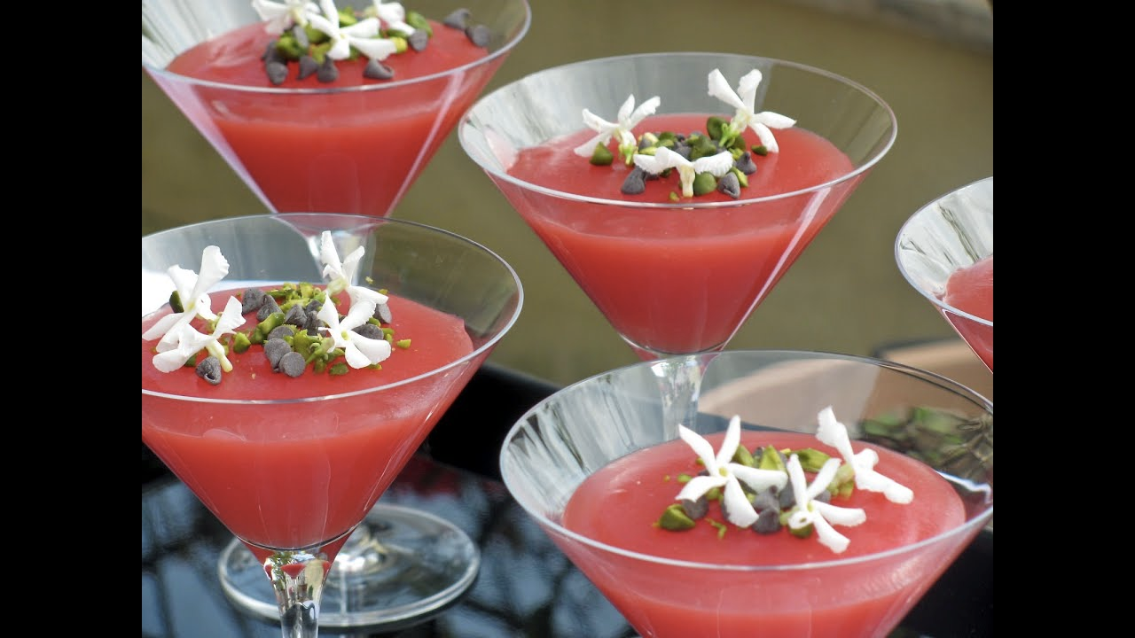
Total Cost:€ |  | Cost / Dose:€ |  |  |  | Student Name: Valentina Mercadante
Ratio (%): |  | Contribution Margin: |  |  |  | Class: 5th year Cookery course  Year: 2020

