Recipe from Sicily-Italy
Dish name: Pasta alla Norma
Number of Doses (Pax): 6 Preparation time: 3 hrs Sale price:€
Quantity | Ingredients |  | Unit Price | Total Price | Preparation Technique
500 gr | Rigatoni |  |  | € 1.00 | - Gently fry the whole garlic and add the cleaned tomatoes cut into pieces and a few leaves of basil. Season with salt and pepper and cook over low heat  - When the tomato is withered, remove from heat, pass it through a sieve and set aside the obtained sauce.  - Wash and dice the aubergines . Fry the cubes in plentiful olive oil and place them on food oil absorbing paper.  - Cook pasta “al dente” and mix it with the tomato sauce.  - Serve laying down on it the fried aubergines, some basil leaves and a final sprinkling of freshly grated salted ricotta cheese.
1 kg | Ripe tomatoes |  |  | € 2,00
4 | aubergines |  | € 0.50 | € 2.00
1 | bunch of basil |  |  | € 0.50 | Comments:  Pasta alla Norma is the most popular pasta with tomato and aubergines in Sicilian cuisine and it is a symbol of the city of Catania. Pasta alla Norma is the connection between Vincenzo Bellini, the famous musician, and the Sicilian town at the foot of mount Etna, the highest volcano in Europe. As a matter of fact this dish takes its name from the opera “La Norma”by the famous composer from Catania.
2 | cloves of garlic |  |  | € 0.20
200 gr | salted ricotta cheese |  |  | € 2.00
salt and pepper | to taste
olive oil | for frying |  |  | € 0.50
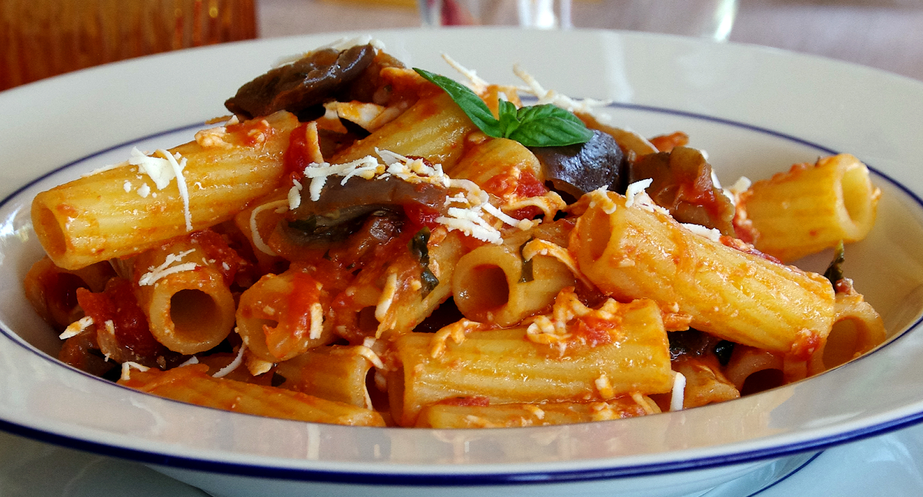
Total Cost:€ |  | Cost / Dose:€ |  |  |  | Student Name: Federica Miosi
Ratio (%): |  | Contribution Margin: |  |  |  | Class: 5th year Cookery course  Year: 2020

