Recipe from Coimbra - Portugal
Dessert name: “Arroz Doce à moda de Coimbra” (sweet rice pudding)
Number of Doses (Pax): 6 Preparation time: 1 hrs Sale price: 1,53 €
Quantity | Ingredients |  | Unit Price |  | Total Price | Preparation Technique
0,75kg | rice |  | 0,89€ |  | 0,67€ | - Boil the milk with the lemon zest.  - Meanwhile, in a saucepan take 1 dl of water to the boil.  - When it starts to boil, add the rice, well washed and drained.  - After the rice has cooked for 3 to 4 minutes, depending on the grain size, the hot milk is added little by little always stirring.  - This process takes about an hour.  - Add the sugar and let it boil a little more.  - Place on platters and sprinkle with cinnamon.
1,5L | milk |  | 0,48€ |  | 0,72€
100gr | sugar |  | 0,69€ |  | 0,07€
0,040gr | Lemon (zest) |  | 1,39€ |  | 0,06€
0,005 | Cinnamon (powder) |  | 22,38€ |  | 0,12€
Comments:
Rice pudding, in the Coimbra region, was mostly used in weddings as a way to let the community know that someone was going to get married. The girls, together with their mother and godmothers, visited the families they knew, to whom they offered a bowl of rice pudding in a “canastra” (a kind of chest) covered with a cloth made on handlooms (Almalaguês cloth). Eight days later, they would go back to pick the bowl or platter where they had placed the rice pudding and received a present.
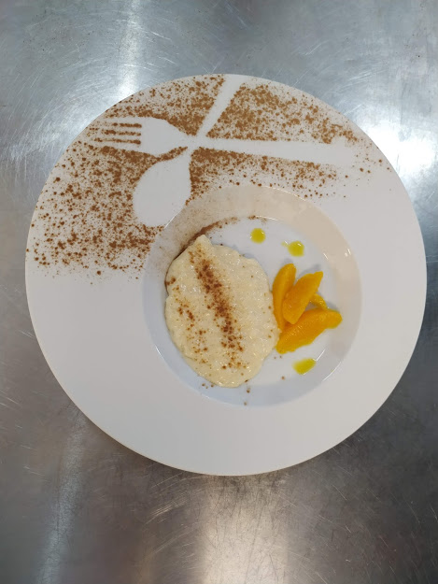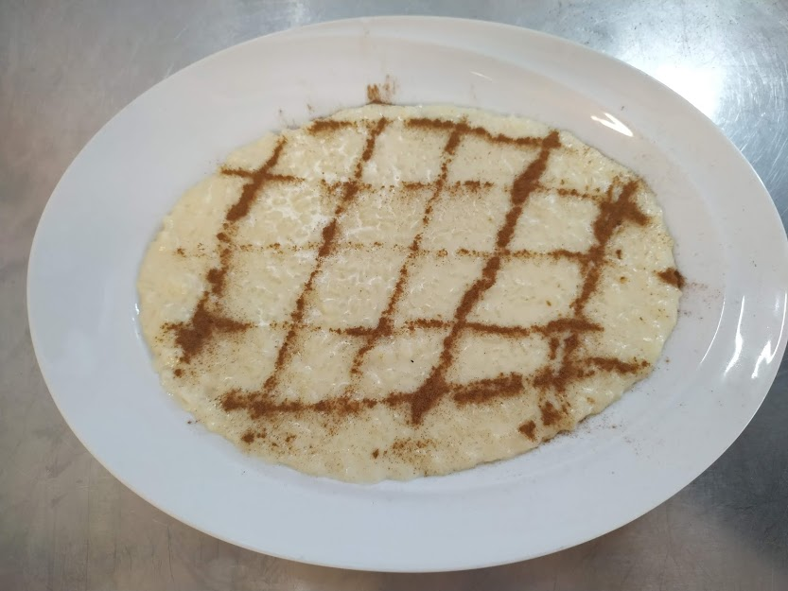
“Gourmet”
“Traditional”
Total Cost: 1,64€ |  | Cost / Dose: 0,27€ |  | Students Name: Alice Moutinho, Samuel Carvalho and Rafael Fonseca
Ratio (%):20% |  | Contribution Margin:5 |  | Class: 1th year Cookery course |  |  | Year: 2020

