Recipe from Coimbra - Portugal
Dessert name: “Caldo Verde” (Green Soup)
Number of Doses (Pax): 6 Preparation time: 30 min Sale price: 4,04€
Quantity | Ingredients |  | Unit Price |  | Total Price | Preparation Technique
1,5kg | potato |  | 0,90€ |  | 1,35€ | - Cut the potato, onion and garlic, placing everything in a pan together with the olive oil.  - Add the water and the chorizo ​​and cook. Season to taste.  - Cook the cabbage separately in boiling water; cool and quickly cool it in ice water.  - Once the chorizo ​​is cooked, remove and cut into slices.  - Mash the potato base and pass through the chinois.  - Bring back to the heat and adjust the seasoning.  - Serve with slices of corn bread.
150gr | onion |  | 1,59€ |  | 0,24€
20gr | garlic |  | 7,48€ |  | 0,15€
250gr | Meat Chorizo |  | 13,45€ |  | 3,36€
300gr | Kale (thin julienne) |  | 1,49€ |  | 0,46€
0,1L | Olive oil |  | 4,60€ |  | 0,46€
0,005. | Salt |  | 0,19€ |  | 0,00€
Comments:
Caldo verde is a typical cabbage soup typical of the region of northern Portugal, but it is frequently consumed throughout the country and also in other Portuguese speaking countries such as Brazil. It is a cabbage from the “Kale” family, a very trendy food for healthy diets. In 2011, Caldo Verde was elected one of the Seven Wonders of Portuguese gastronomy. It is such a famous dish that it even has a festival: the Caldo Verde of Irivo Festival, near Penafiel. “Caldo Verde” started out being, five hundred or sixhundred years ago,a soup from the north of Portugal, very much appreciated by the most disadvantaged class, which at the time was practically everybody. Today, it became nationalized, and became soup everywhere and across statutes.
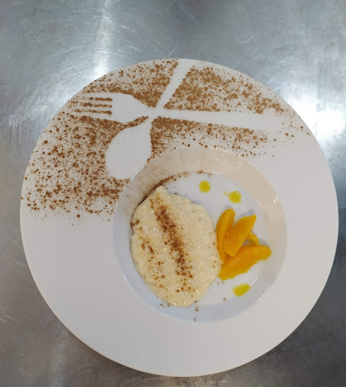
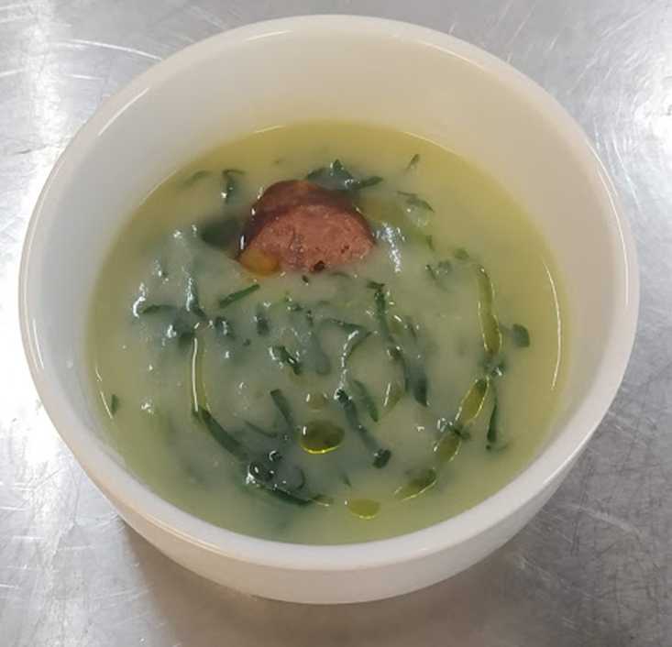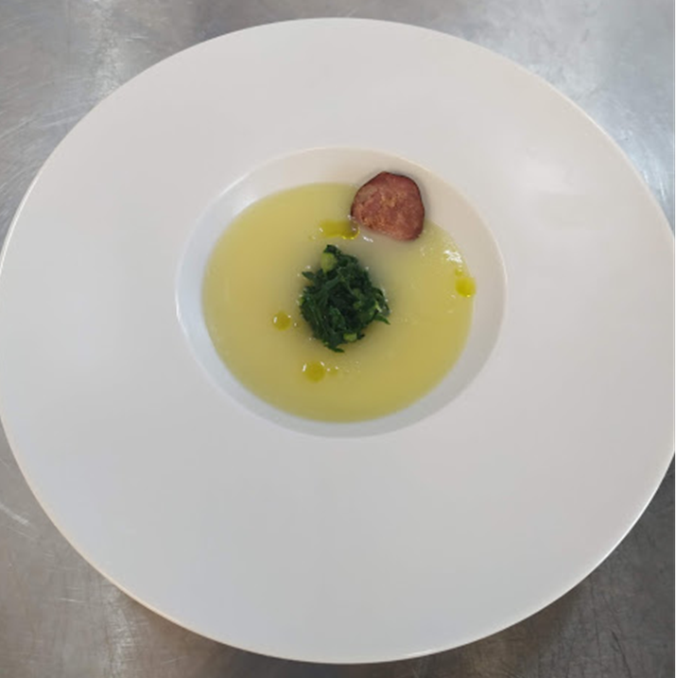
“Traditional”
“Gourmet”
Total Cost: 6,02€ |  | Cost / Dose:1€ |  | Students Name: Alice Moutinho, Samuel Carvalho and Rafael Fonseca
Ratio (%):28% |  | Contribution Margin: 3,57€ |  | Class: 1th year Cookery course |  |  | Year: 2020

