Recipe from Coimbra - Portugal
Dessert name: “Bacalhau à Lagareiro” (Lagareiro Codfish)
Number of Doses (Pax): 6 Preparation time: 1 hrs Sale price: 7,38€
Quantity | Ingredients |  | Unit Price |  | Total Price | Preparation Technique
0,6kg | Cod fish (dry) |  | 12,92€ |  | 7,75€ | 1. Cut the cod into large squares and soak for 24 hours, changing the water two or three times.  2. An hour or two before cooking, drain the cod, cover with milk and season with sliced ​​garlic cloves, salt, pepper and lemon juice.  3. Then drain and pass the cod fillets through the beaten eggs and breadcrumbs and place them in a “clay” frying pan.  4. On top of each fillet, place a small piece of butter.  5. Put the oil in the frying pan (it should not cover the cod) together with two tablespoons of the milk that was used to season the cod.  6. Bake in the oven, basting occasionally with the sauce.  7. The cod must be very “blond”.  8. Eat hot with boiled potatoes.  9. A good salad is served separately.
0,2L | milk |  | 0,48€ |  | 0,10€
0,008Kg | garlic (cloves) |  | 7,48€ |  | 0,06€
0,002 | Pepper |  | 35,33€ |  | 0,07€
0,030kg | Lemon |  | 1,39€ |  | 0,042€
2un | eggs |  | 0,15€ |  | 0,30€
0,100kg | breadcrumbs |  | 1,58€ |  | 0,16€
30gr | butter |  | 5,56€ |  | 0,67€
0,4L | Olive oil |  | 4,60€ |  | 1,84€
Comments:
For many people, Codfish “à Lagareiro” is a Portuguese recipe that was started by the people who worked with olives. There are doubts about that. What we take for granted is that it is one of the most requested ways to cook our most appreciated fish. ”
“Every October, it was improved in the “lagares” (the place where olive oil is made) of Beira interior. The dish became so good and well accepted that the octopus later started to be cooked in the same way.
“It is thought that the first lands to test something that later became Codfish “à Lagareiro”, were the borders, probably with greater incidence in the interior, corresponding to Beira Baixa and Beira Alta, because it is there that we find better conditions for planting olive trees. ”
“If this theory were to be believed, the oil mills were in fact its beginners, who cooked it in boilers in the places where they worked - and the formula must have been designed for several years, always in the autumn, as this is where the olives are trodden, resulting in new oil. ”
“The gastronomist and scholar of traditional Portuguese food Maria de Lourdes Modesto placed the origin of this dish, however, in Minho – strangely enough given that such a province has too humid climate for the production of oil.”
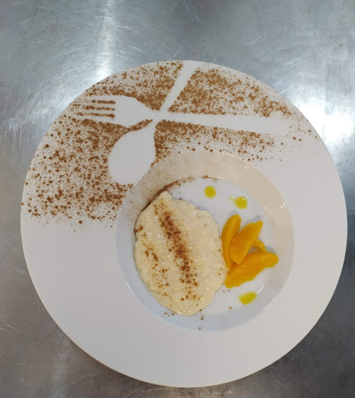
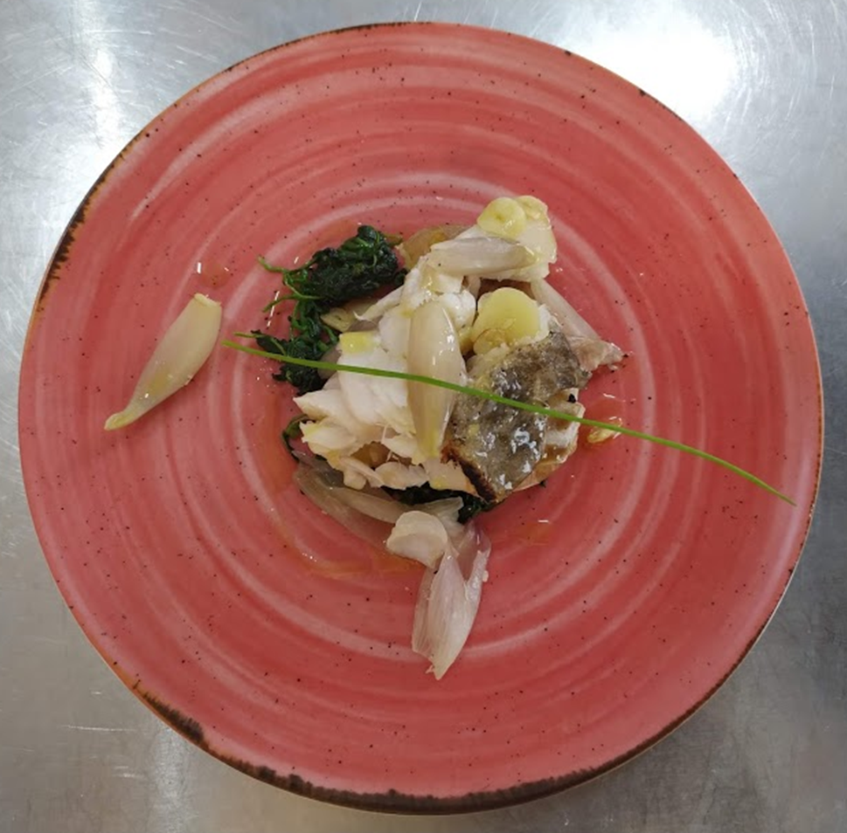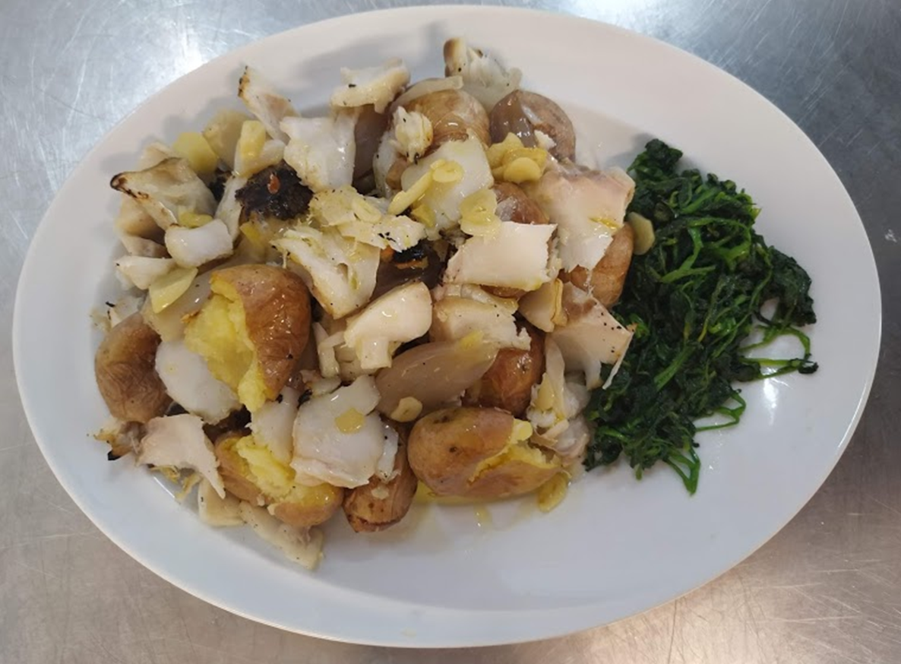
“Gourmet”
“Traditional”
Total Cost: 10,99€ |  | Cost / Dose:1,83€ |  | Students Name: Alice Moutinho, Samuel Carvalho and Rafael Fonseca
Ratio (%):28% |  | Contribution Margin:3,57 |  | Class: 1th year Cookery course |  |  | Year: 2020

