Recipe fromLleida-Catalonia-Spain
Dish name: Catalan cream

Number of Doses (Pax): 6 Preparation time: 3 hrs Sale price: 5.14€
Quantity | Ingredients |  | Unit Price | Total Price | Preparation Technique
500 ml | whole organic milk |  |  | 2,55€ | - In a large saucepan, beat together the egg yolks and 3/4 cup sugar until the ingredients are thoroughly blended and the mixture turns frothy.  - Add the cinnamon stick and lemon zest and stir.  - Add the milk and cornstarch and slowly heat the mixture, stirring constantly, just until it begins to thicken.  - As soon as the mixture thickens and you feel resistance while stirring, remove the pot from the heat immediately or the mixture may curdle or separate. If this happens, the texture of the finished crema Catalana will be grainy instead of smooth and creamy as it should be.  - To cool, remove the cinnamon stick and ladle the milk mixture into 4 to 6 ramekins (depending on size). Allow them to cool to room temperature, then refrigerate for at least 2 to 3 hours.  - Before serving, heat the broiler. Take the ramekins with the crema Catalana out of the refrigerator and sprinkle the rest of the sugar over each ramekin.  - When the broiler is hot, place the ramekins under the broiler on the top shelf and allow the sugar to caramelize and bubble, turning golden brown. This may take 5 to 10 minutes or so, depending on your broiler. Keep a close eye on your crema Catalana so that it does not burn. Remove and serve immediately.  - If you'd like, you can serve the crema Catalana chilled, but some think it has more flavor when served warm from the broiler.
zest | of one lemon |  |  | 0.35€
1 | cinnamon stick |  |  | 0.60€
7 | egg yolks |  |  | 0.99€
95 g | sugar |  |  | 0.25€
1 | tablespoon cornstarch |  |  | 0.40€
Comments:

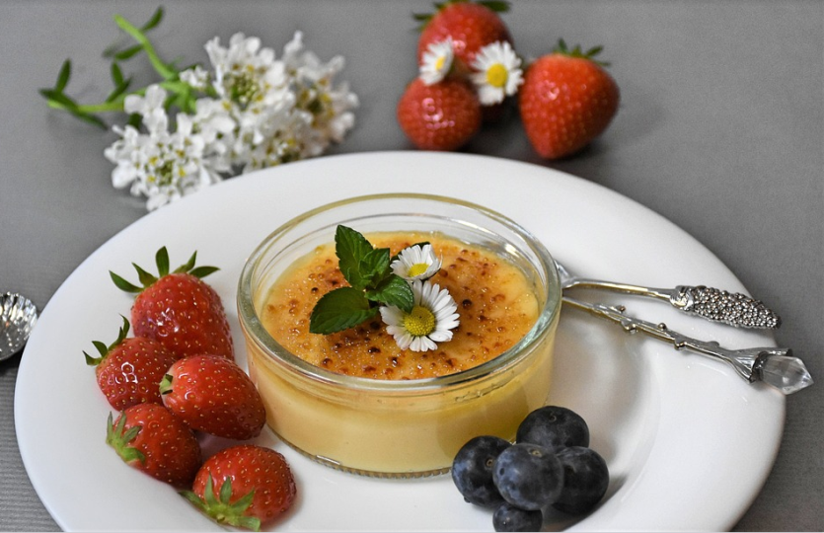
Total Cost: 5,14€ |  | Cost / Dose: 0,86€ |  |  | Student Name:
Ratio (%): |  | Contribution Margin: |  |  | Class: 1st year course CFGS SOCIAL INTEGRATION  Year: 2020

