How to send a Twin Mail

- Go to Twin Mail bu clicking on the Mail Icon (see the red arrow)
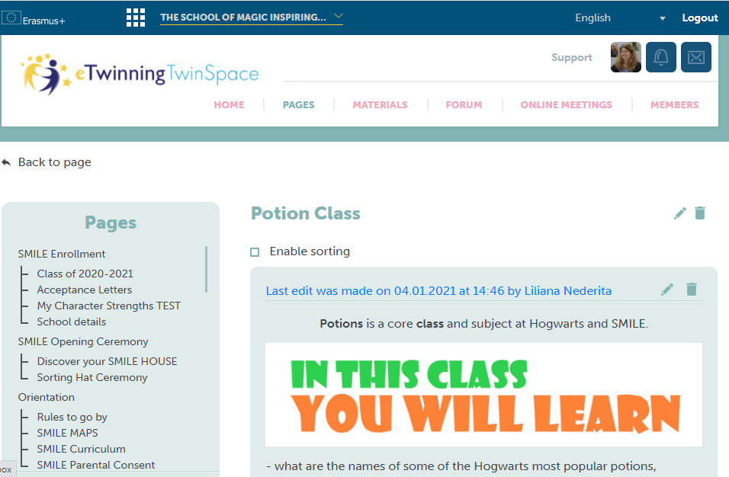

- Select the Twin Space name
- Write in the Name of the person you are sending it to in the “To” section
- Write - Potion Class “Label the potions” in the Subject section
- Write the answers in the “Message” section.
- Finally, send it by clicking on the “Send” button.

