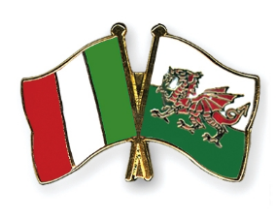
Famous buildings in our countries

Click (Control + Click) on the link below to the google slides we worked on as part of our eTwinning project. Find the answers to the questions to complete the table.
Work hard - we will be having a Kahoot quiz on this work very soon!!!!

Google Slides Link

Question | Answer |  | Image
What is the name of the famous cathedral in Milan?

What is the cathedral made of?

What can you enjoy if you take a lift to the rooftop?

What is the name of the church in Swansea?

What happened to the original church?

What is the church famous for?

What do the cathedral in Italy and the church in Swansea have in common? |  |  | 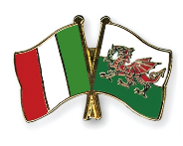  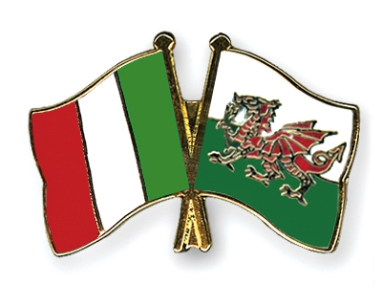
Question |  | Answer |  | Image
What type of building is the Unicredit Tower in Italy?

What is the name of the designer?

How tall is the building?

What is the name of the building in Swansea that has 29 floors?
What does the building have on the top 3 floors?
What can you see from this building and how tall is it?
How long did both towers take to build? |  |  |  | 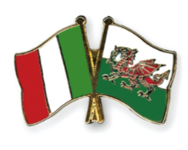
What else do both buildings have in common?

Question | Answer | Image
Name a famous landmark in Italy.
How many towers can you find there?
Name 3 people who designed this landmark.
When was Mumbles Pier built?
What else can you find on the pier today?
What used to be on the pier years ago?

Question | Answer | Image
Name a famous opera house in Milan.
When was it built?
How many seats are there?
Name a famous theatre in Swansea.
When was it built?
How many seats are there?
What do both theatres have in common? |  | 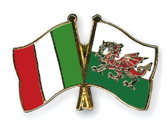

Question | Answer | Image
What is the name of the city hall in Milan?
Who was it named after?
Why did it have to be restored?
What building in Wales that you have looked also needed to be restored? |  | 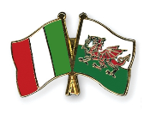
What is the name of the building where the Welsh Government is located in Cardiff?
When was it opened and by who?
How much did it cost to build?
What can you find there if you visit?

Questions | Answers | Image
Name a castle you can find in Milan.
When was it built?
What is the castle surrounded by?
What does “Castell Coch” mean in English?
What is it famous for?
What can you find there?
What is the castle surrounded by?

Question | Answer | Image
What is the name of the park in Bareggio, Italy?
How big is the park?
What can you find there?
What is the name of the park in Neath, Wales?
How big is the park?
What can you do there?
What similar things can you do in both parks? |  | 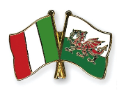

Question | Answer | Image
What is the name of the football stadium in Milan, Italy?
What Italian clubs play there?
How many seats are in the stadium?
Who is the stadium named after?
What is the name of the stadium in Cardiff?
Who is it home to?
How many seats are in the stadium?
What is special about this stadium?

