INTRODUCTION
OF TURKEY

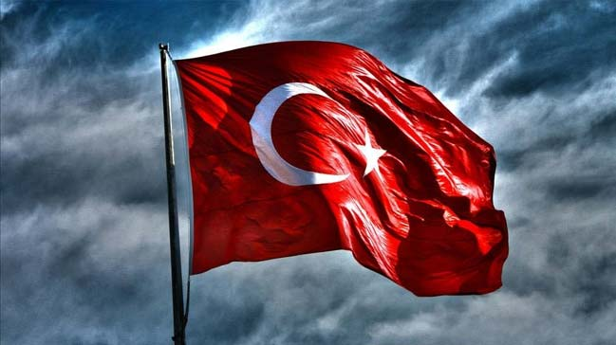

NATURAL BEAUTİES:
İNSUYU CAVE BUGDUR;
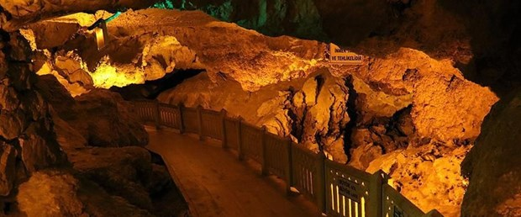
INSUYU cave is the first cave opened in Turkey's tourism.It is a horizontal cave with a length of 597 m.As the result of the melting and erosion of the karstic structure in İnsuyu Cave,
stalactites and stalagmites appear inside the cave.
While it may emerge from limestone sediments in various shapes and structures and adjust the stalagmites' formation styles, we estimate that the cave began thousands of years ago.
There are 9 large and small lakes in the caves which open in various directions. There is a cool and clean air flow in the cave. It is believed that
some of the cave waters are medicinal for diabetes and stomach diseases.

AGRI MOUNTAIN;

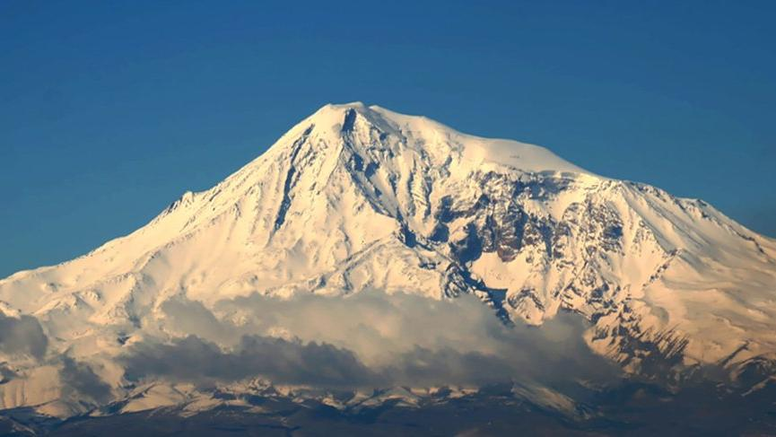
Mount Ararat, at an altitude of 5,137 meters, is engaged in Turkey's highest mess. Mount Ararat in eastern tip of Turkey, 16 km west of Iran and Armenia, is 32 km south. 65% of the mountain is in Iğdır province and 35% is in Ağrı.

PAMUKKALE ;
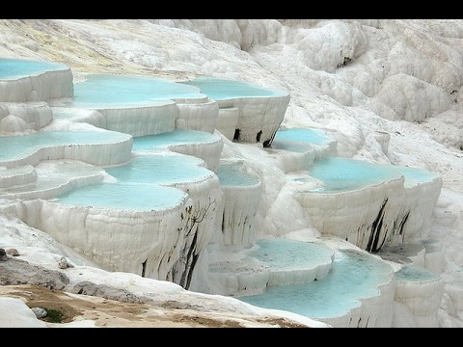
Pamukkale Tourism, the intercity bus company lived in Denizli by Sadık Bababalım in 1962. In 1972, the headquarters of the company moved to Izmir. Turkey's first local service is the company started opening its first service and ticket-booking services.

KAPADOKYA ;
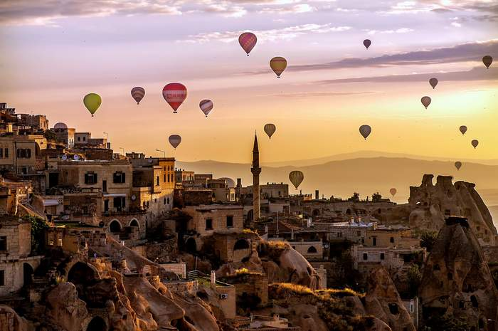
Cappadocia, 60 million years ago, Erciyes, Hasandağı and Güllüdağ, lava and ashes formed by millions of years of soft layers in the region found that rain and wind.

NEMRUT MOUNTAİN;

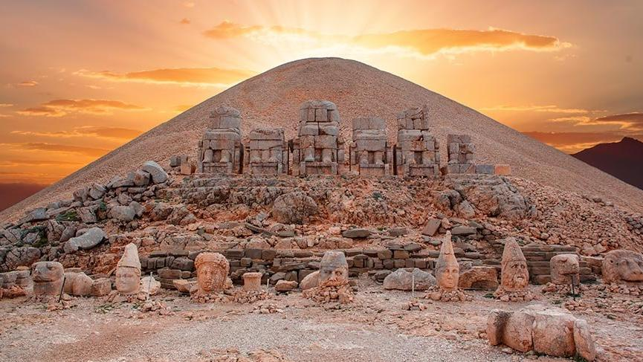

Mount Nemrut is a 2,150 m high mountain near the Ankar mountains near the Kahta district of Adıyaman. The Taurus Mountains are in the mountains. It is within the borders of Adıyaman province in Southeast Anatolia Region. It was declared in 1988. The area is 13,827 hectares.

CITY AND FOOD :
ADANA;
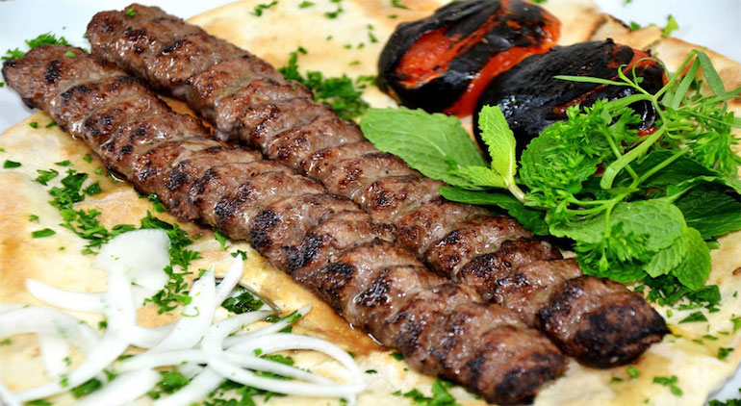
Adana kebab is a kind of kebab in Turkish cuisine, cut with a piece of meat cut by hand and called z armor ve and is a kebab made with a knife specific to Adana. The most distinctive feature that distinguishes Adana kebab from other kebabs is the meats used.

MERSİN;İÇLİ KÖFTE
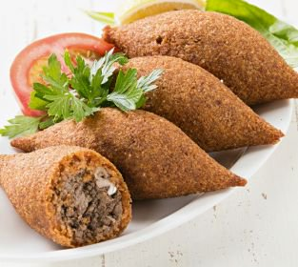
İçli köfte or Oruk, a meal made in Turkish cuisine made by filling the bulgur into dough. Originally from the Levant cuisine, this dish is also called Kibbe and stuffed meatballs in some regions. İçli köfte is prepared in two kinds. The first is the scalding method.
MERSİN; CEZERYE
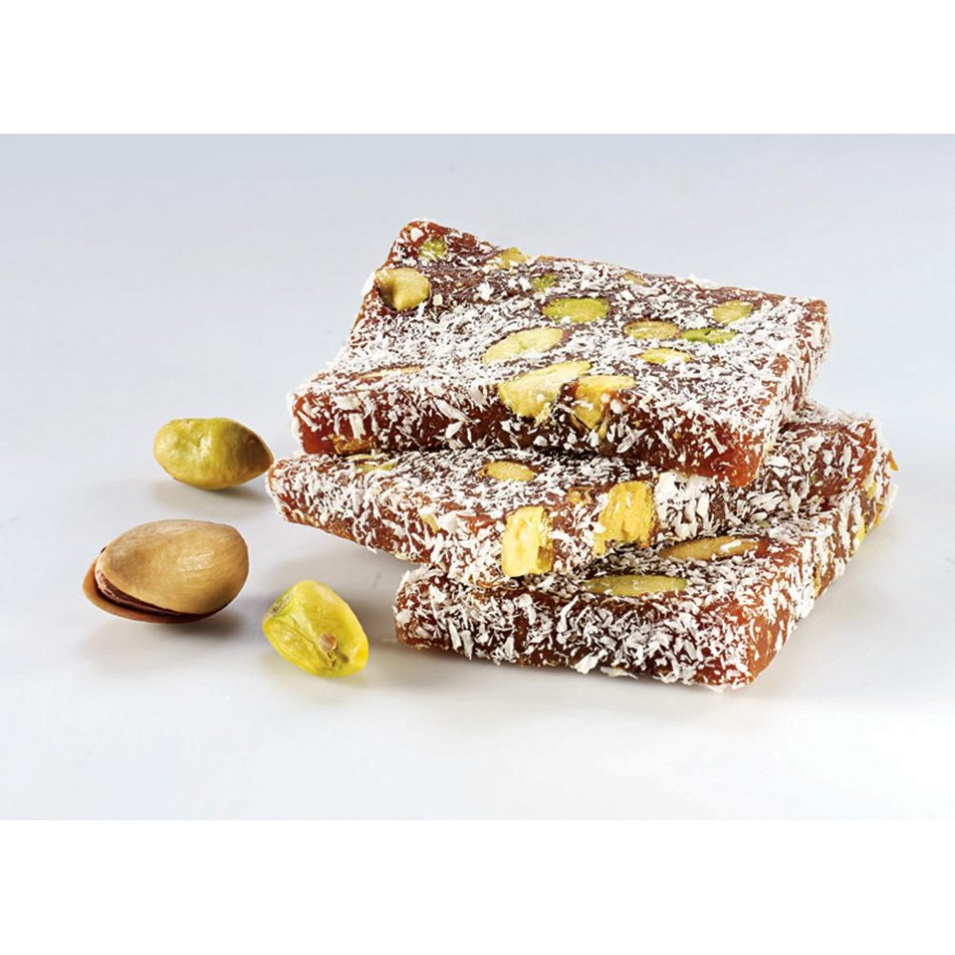
Cezerye is a common dessert type in Mersin. It is made of carrot, granulated sugar, walnut and coconut. Its name comes from the word in Arabic that comes from taking my tongue. Grated potatoes are first boiled and then roasted with sugar.

DENİZLİ TANDIR KEBABI ;
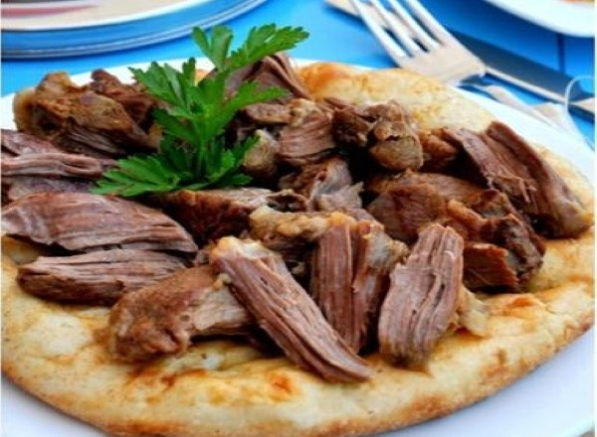
We leave the meat with the thyme and salt to boil. Between boiled and soft meats, lavash, rice with lamb tandir kebab you can know the taste of a kebab recipe. ... It is a soft, soft meat, a super flavor, very easy to prepare ...
AMASYA ŞERBETLİ PİDE;
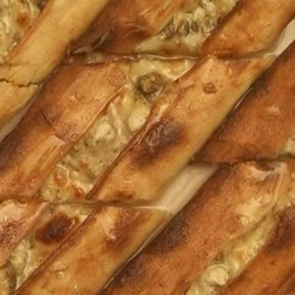
. In the name of "pita with sherbet with pita", the flavor of the food that gives the feature The sherbet pide master Yıldız: ... makes a special pita with minced meat and cheese of lemon, water PREPARD.

ARTVİN BAL ;
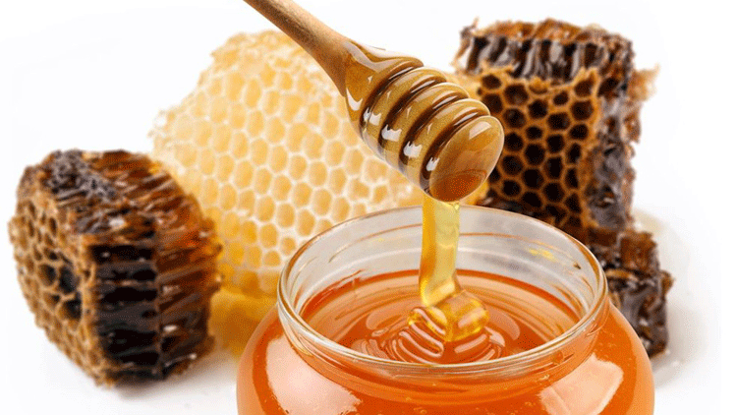
Honey is a multi-element food that is made by researching the diversity of chemical substances in invertase enzyme in the organs called honey stomach of the bees of nectar swallowed them from the buds of flowers and fruits such as bees and placed in honeycomb cells in the hive.

YAPANLAR :SELİN KART
:SİDELYA ALKAR

