A TOUR TO TURKEY

Turkey is a pennisula .It’s a bridge between Asia and Europe. Turkey has many historical and natural attractions.

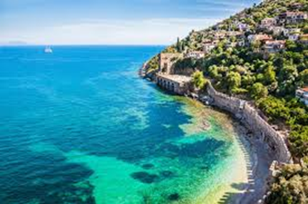

Turkey’s area is 814.578 kilometres squares and its population is about 70 million. It has got 81 cities. The capital city is Ankara. The other most important cities are Istanbul,Izmir,Trabzon, Antalya, Adana and Bursa. There are 7 geographical regions in Turkey:
-Marmara Region,
-Black Sea Region,
-Agean Region,
-Central Anatolia Region,
-Mediterranean Region,
-East Anatolia Region,
-Southeast Anatolia Region

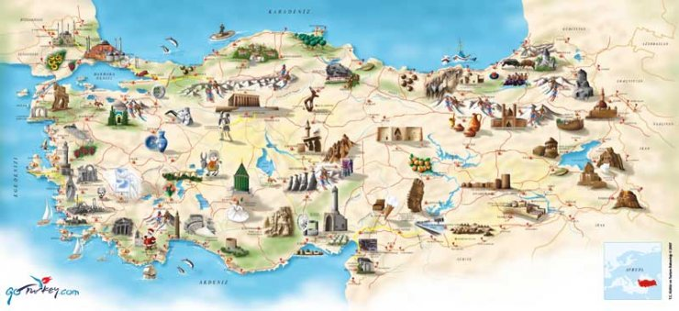

Istanbul is an old city and the cultural center of Turkey. It takes place on two side of Bosphorous Strait. Istanbul has a rich cultural history. It is the capital city of the four famous Empires in the world namely Roman Empire, Byzantine Empire, Latin Empire and the Ottoman Empire. It has got many tourist attractions. About two million tourists come to Turkey every year. Istanbul is also shopping centre…You can buy carpets, kilims, leather clothes, Turkish delight in Covered Bazaar.

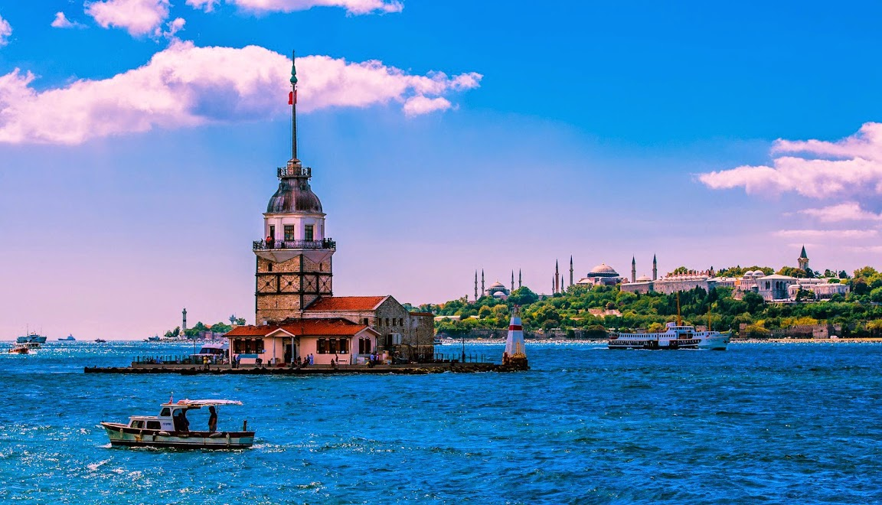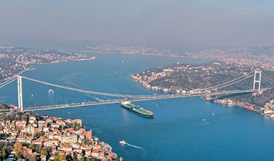

DONT’T LEAVE WITHOUT
-Seeing two masterpieces of religous art of Istanbul: Süleymaniye and Blue Mosques
-Visiting Hagia Sophia Museum, Dolmabahçe and Topkapı Palaces
-Eating fish in Bosphourus
-Drinking Turkısh cofee you know ‘A cup of cofee has a memory of 40 years.’

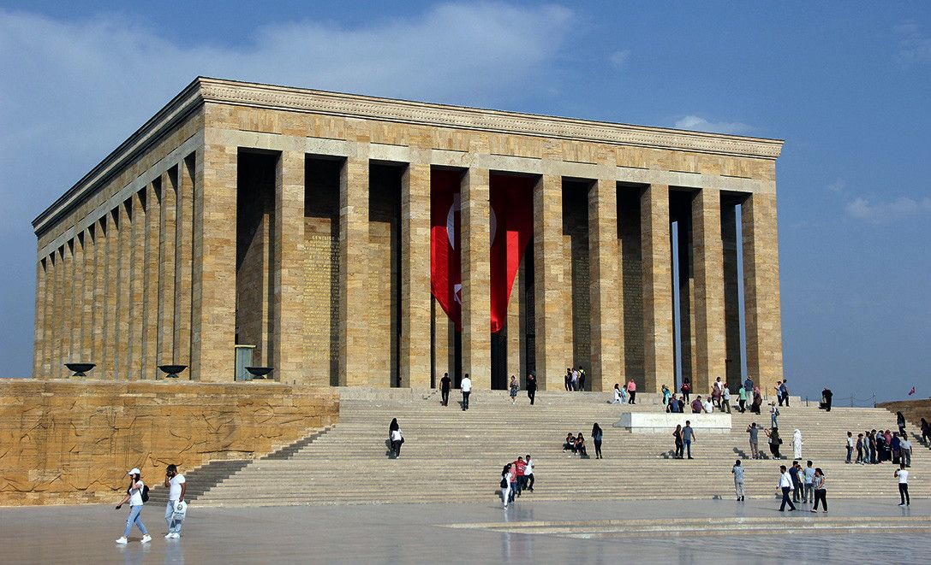

Ankara is the capital city of Turkey. Our leader, Atatürk’s mousoleum is here, in Anıttepe.About 4 million people are living in Ankara. You can also buy copper, ceramics, textiles, leather and decoration items in Ulus.Becouse Ankara’s shopping centres are usually in Ulus. If you go to Ankara you should visit Atatürk forest farm, Science museum, Anatolian Civilization museums.

.

Trabzon is in the Black Sea Region of Turkey. It has got lots of plateous and mountains…In summer, Trabzon is rainy and warmand, it’s rainy and cool in the winter.Trabzon has got a lot of tourist attractions, such as Trabzon castle, Sumela Monastery, Atatürk museum and Uzungöl has got a wonderful natural beauty.

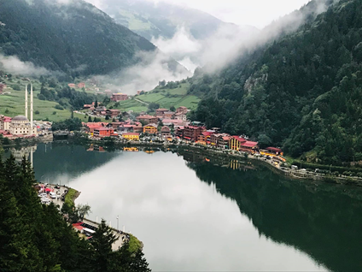

In Trabzon, there are lots of tea houses and restaurants. In a traditional restaurant, there are always hamsi, corn bread and black cabbage. As a beverage, there is always tea in the menu…

LETS GO TO ÇANAKKALE
Çanakkale is very important for our history. If you go to Çanakkale, you must visit Gallipoli Martyrs and commemorate our hero soldiers. You can also see the Troy horse and take photos of it. It is the most beautiful and also the biggest Agean city of Turkey. Because of its university, cultural heritage and industry, the population is about 6 million people.

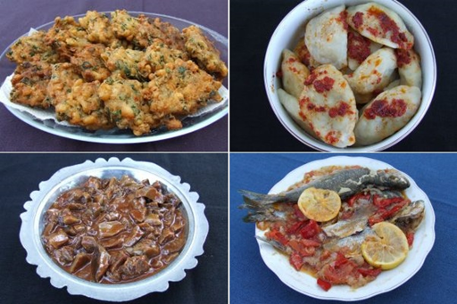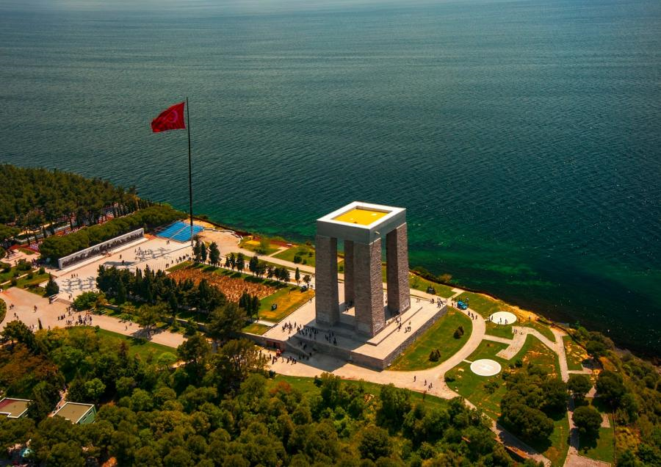

HOW ABOUT GOING TO ESKİŞEHİR?
-If you come to Eskişehir you can get on a train.
-You can visit Midas Ancient city.
-You can buy meerschaum chess set.
-Eskişehir is fameous for its meerschaum.

Fairy Chimneys have the most beautiful and popular views all over the world. This area is made from tough rocks and the buildings, churchs are also made from this stone.

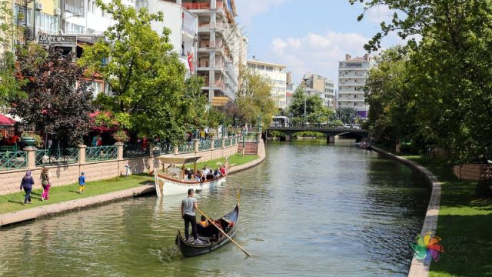

As all Mediterranean cities Antalya has magnificent views and beaches you should see. Espechially in summer, lots of tourists come to Antalya and other Mediterranean cities like Bodrum, Marmaris, Muğla…

Van is the biggest east city of Turkey. The biggest lake of Turkey, Lake Van and Castle of Van are the most beautiful ones you should see.

ILGAZ, ULUDAĞ, KARTALKAYA & PALANDÖKEN
If you want to ski in Turkey, there are lots of places that you can choose… With their hotels, skiing areas and activities, they are the most beautiful ones.

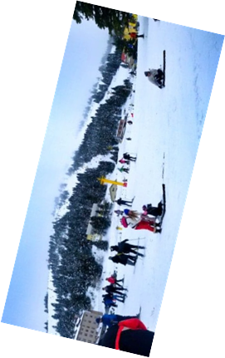

PAMUKKALE
It takes place in the Agean Area. There are White stairs which are on the way of sky.

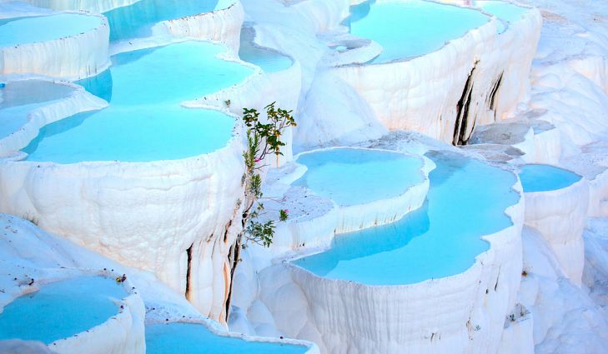

Made by: Elif Taştekin

