La colomba di Pasqua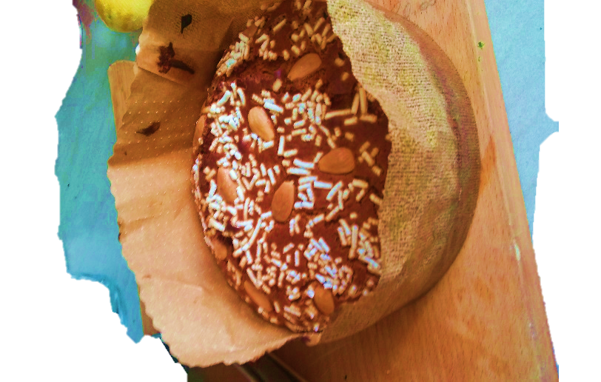
Colomba is a typical Italian Easter cake, in the shape of a dove that represents peace. On Easter day the family has lunch together; in Liguria we eat also the pasqualina cake, made with eggs, vegetables and cheese.

