

It is said that the beautiful daughter of the commander
of the Saracens, descending first from the vessel …



… let fall into the water, accidentally, the blue veil she always wore to cover her face.


No one had ever seen her face, but that day those
present at the landing were amazed, incredulous and
fascinated.


The girl was really beautiful and her face had the color
of an emerald and shone in the sun like a precious
jewel of rare workmanship.



All the fishermen and peasants of Agropoli were
enchanted, claiming they had never seen anything like
it, such a miracle.

\ \
l ' ' l

' ' l

That is why they decided to rename the girl as the
Green Queen.



Many fell in love with the beautiful girl and presented
themselves in front of the commander of the Moors
precisely to ask for his daughter's hand, which however sent everyone away.


One day the beautiful Green Queen, walking through
Trentova, near the moored boats, was the victim of an
accident …

....,
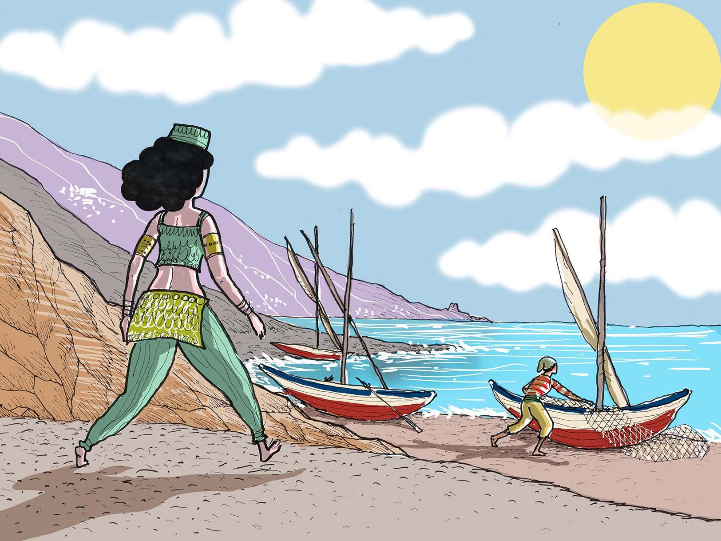
'

… A fisherman hit her involuntarily while he was pulling
the nets, to fix them and leave the next day.



An incident that did not cause her injuries, but instantly the
girl fell in love with the fisherman.


She watched his calloused and sun-ruined hands for a
long time, skillfully handling the nets that had struck
her. The Green Queen was literally enchanted by the face of that man, with a profound and mysterious beauty.


Even the fisherman was struck by the beauty of the girl …


… and the two were overwhelmed by a great passion: it
was love at first sight.


From that day, every morning, the green queen greeted
her beloved fisherman from the high cliff of the city,
who went off into the open sea.


But, a terrible day, the fisherman did not return,
drowned because of a great storm that had destroyed
and sunk his boat. The beloved waited for him for days, hoping to see again the face of his other half, but it was not so.
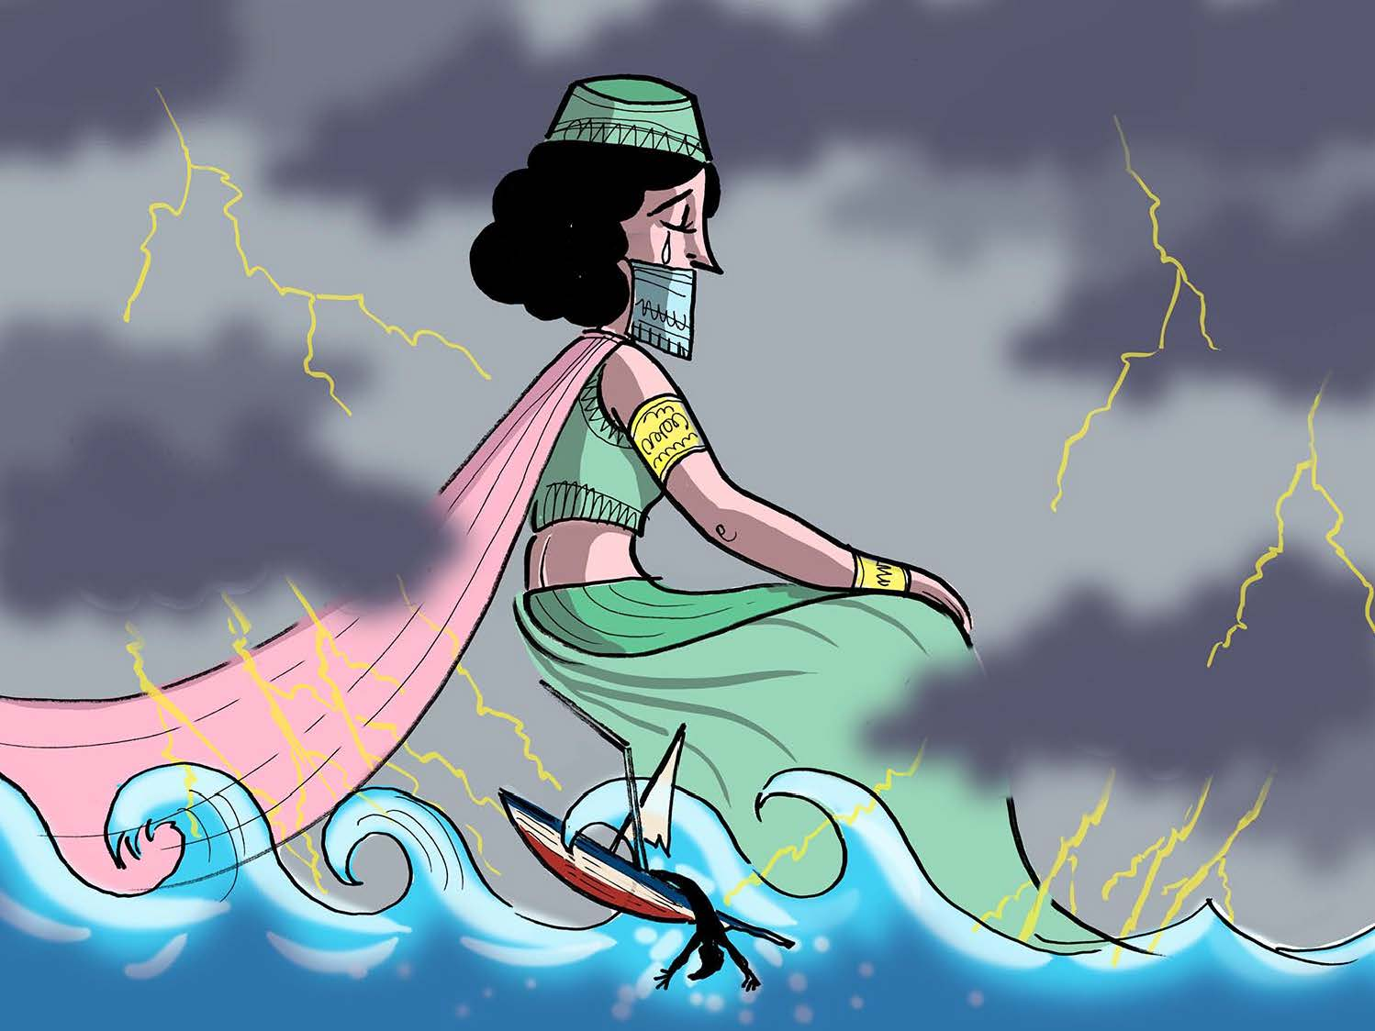

Desperate she threw herself right off the high cliff.

.

The gods, enchanted by what was a great and sincere
love, turned the queen into a nymph.



The legend says that the Green Queen still lives, now in
the guise of a beautiful nymph , in an underwater cave.
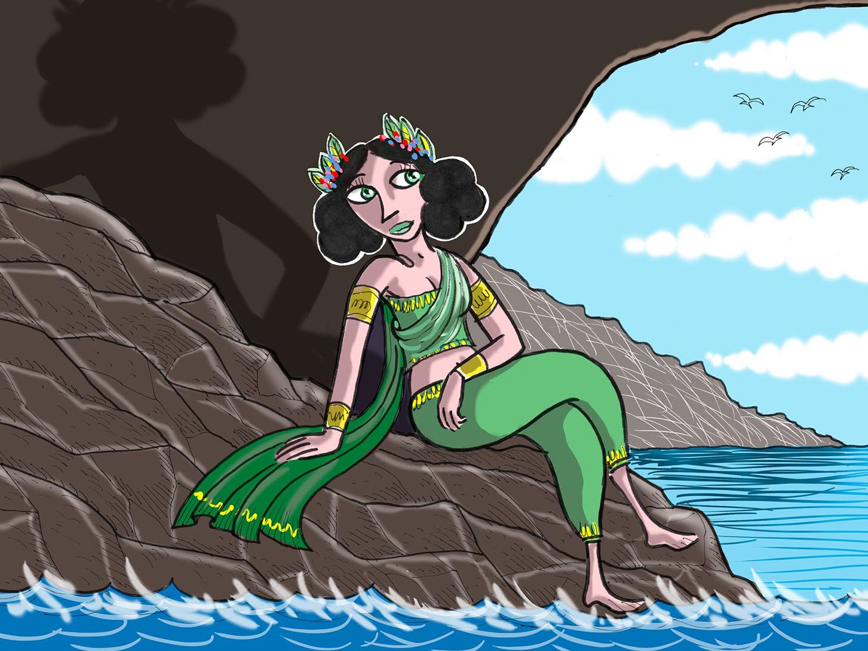

The fishermen of Agropoli usually hear her screams of
despair during the stormy nights, while she is still
looking for her beloved.



