Erasmus + Project Green Alliance
Mobility C5 Torremolinos 16-20 February 2020

“SUSTAINABLE TOURISM OUR WAY OF LIVING: TRAVEL GREEN”
Stem Teams
Estuary of Guadalhorce
Bird Watching
Look after our Coasts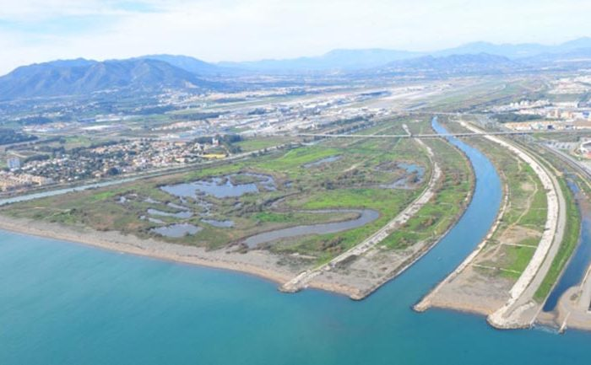

Bird Watching
The estuary of the Guadalhorce Natural Park is formed by a complex of unnatural lagoons, full of brackish and sweet waters. The sea and the riverbed converged causing extensive swampy land in a delta that of alluvial deposit of materials dragged by the Guadalhorce river over the centuries.
The space has a high ornithological value, being one of the most important stopover and rest points in the region for coastal migratory birds that can be found throughout the year. Depending on the season, the ospreys stand out, the kingfisher, the pink flamingo, the spatula, the black stork, the Audouin seagull and the piquirroja pay, in addition to other more common ones such as the terns, the coots or egrets; and the white-headed malvasia, visible throughout the year.
The natural site not only has relevance as a place of rest and protection of birds, it also constitutes a small green oasis next to the city of Malaga that allows to complete the reproductive cycle of many species.
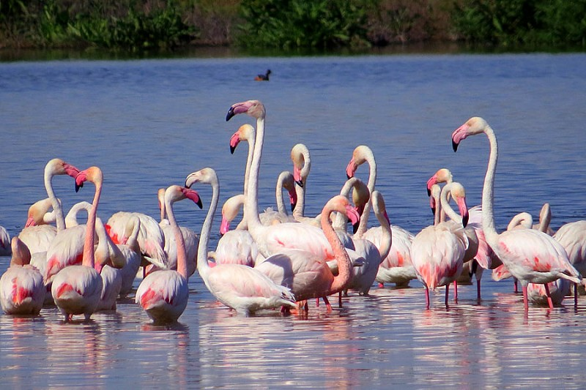

Look after our Coasts
The vegetation of the place is associated with different environments, where the presence of water and salt are relevant in its disposition and richness. The sands of the beach contains plants extremely adapted to this inhospitable environment.

Through the tour, assessing its environmental quality is intended to work the reality of the coast and assess and raise awareness about the valuable coastal heritage that our autonomous community has and the attitudes and behaviors that can contribute to its
conservation.

