DRAGOS VODA
the lord of Moldavia

Who was DRAGOS VODA?
Dragos Voda reigned between 1347-1354 and he is considered to be the founder of Moldova.

THE LEGEND OF DRAGOS VODĂ
It is said that Dragos Voda was a good hunter and he liked to cross the woods, to hunt wild animals. One day he started hunting with his pack of dogs.
They went trough some big forest, they walked until the dogs finally found a wild bull with some bent horns and a big beard.
It was a bison or a wisent, a powerful and large animal that can be found now only in natural reserves. The dogs chased that wisent who ran like a mad and seemed to have wings at his feet.
Dragos ran on horseback after the pack of dogs which all bark at the woods. Thus, they ran away all day and night without stopping. They wisent was running faster and faster, and the dogs were dying of fatigue one by one. Only one bitch was left standing that was to reach the wisent. But the beast arriving at the powers do not hold it. It struggles with its fears until suddenly it sank into the water and drowns.
Dragos also arrives there, and seeing the death of the poor bitch throws to the bison the mace curved with iron nails. The mace hit the beast straight up and the water of river became red with its blood. Then Dragos grabbed the bison and cut off its head and took it with him, as a sign of victory.
Dragos took the control of the country where this famous hunting party had taken place. The water in which his bitch was drowned was given the name of Moldova, because the bitch was called Molda; and the whole country around took the name of the river, and the sign of the new ruler of Moldova was the head of the bison killed in the water of Moldova by the brave Dragos.
Dragos' Sas and Balc descendants were removed by Bogdan, the liberator of Moldova under the influence of Hungary.
It is not know where he was buried, but it is assumed that he is in Moldova of nowadays.

COAT OF ARMS OF MOLDOVA
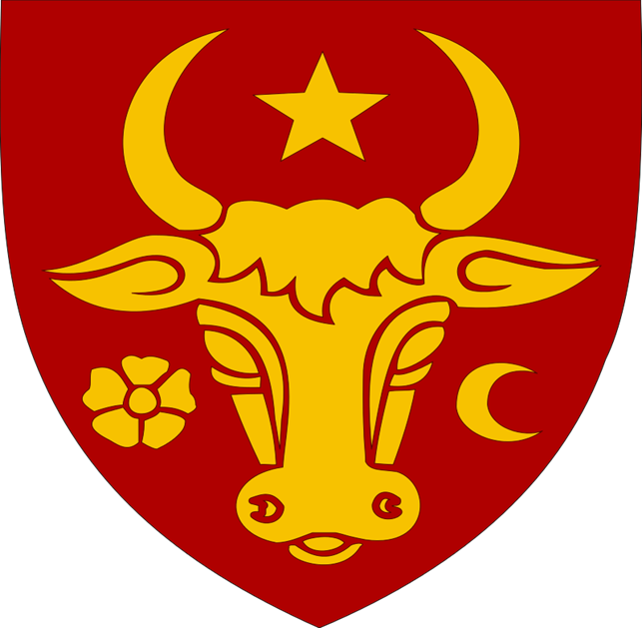
Source:WIKIPEDIA

Questions
Who was Dragos Voda?
What is Moldova?
Where was Dragos Voda burried?

Bibliography
S:Legende populare romanesti
S:Universdecopil.ro
S:Istoriileregasite
S:Adevarul.ro
S:Anticariatul

