Erasmus + Project Green Alliance
Mobility C5 Torremolinos 16-20 February 2020

“SUSTAINABLE TOURISM OUR WAY OF LIVING: TRAVEL GREEN”
Stem Teams
The Route of Vines and Wines, Olives and Oil
Route of El Torcal

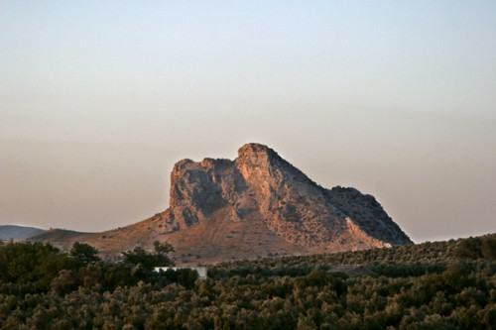

The Route of vines and wines, olives and oil
Spain is the biggest oil producer worldwide and Andalusia is the region known to have the biggest number of olive trees, so if you like olive oil and want to know a bit more about it, you came to the right place. Our tour will start by visiting a centenarian olive plantation, where we will teach you about how to harvest the olives and the traditional tools used in this procedure, a unique experience! After that we will drive you to an Andalusian Cortijo (country house) which has its own oil mill, where you will learn about the process of oil production. This house also has an old stone olive mill from XVIII century and you will learn how olive oil was made in the past. Lastly you will enjoy an olive oil tasting to what everyone’s appetite before lunch. After this visit, we will go deeper into La Peña de Los Enamorados sightseeing, the millenarian Dolmens and el Torcal.

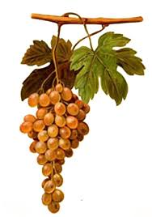
Route of El Torcal
The whole area was under the Tetis sea some 150 million years ago. Violent Earth crust movements forced the seabed upwards into hills and mountains, a couple of which, are just over 1300m (the highest being the Camorro de las Siete Mesas at 1336m.

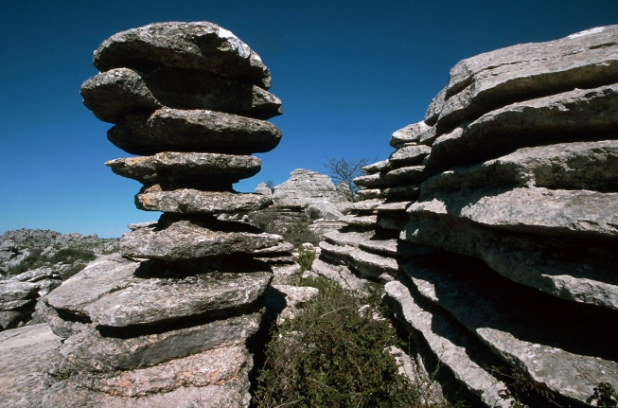
This was followed by millions of years of wind and rain erosion that has produced some of the most spectacular limestone scenery found anywhere in Europe. Humans have been inhabiting the area since around 5500BC. From the Homo Neanderthals up to the Homo Sapiens. There are three set routes through the reserve. A green, yellow and red one. In order to protect the flora and fauna the red route is in a restricted zone and can only be visited with a guide. The green and yellow routes are open to all and can be walked without a guide. By following one of the little paths that leads off from the mirador Las Ventanillas, one suggested spot to visit is in an area known as the ‘Ammonites,’ there are some fantastic fossils.

