EUROPEAN MULTINATIONAL EMPIRES BREAK UP / BIRTH OF NEW EUROPEAN NATION - STATES

How to rebuild peace after the end of the war ?
( INTERNATIONAL WORKSHOP )

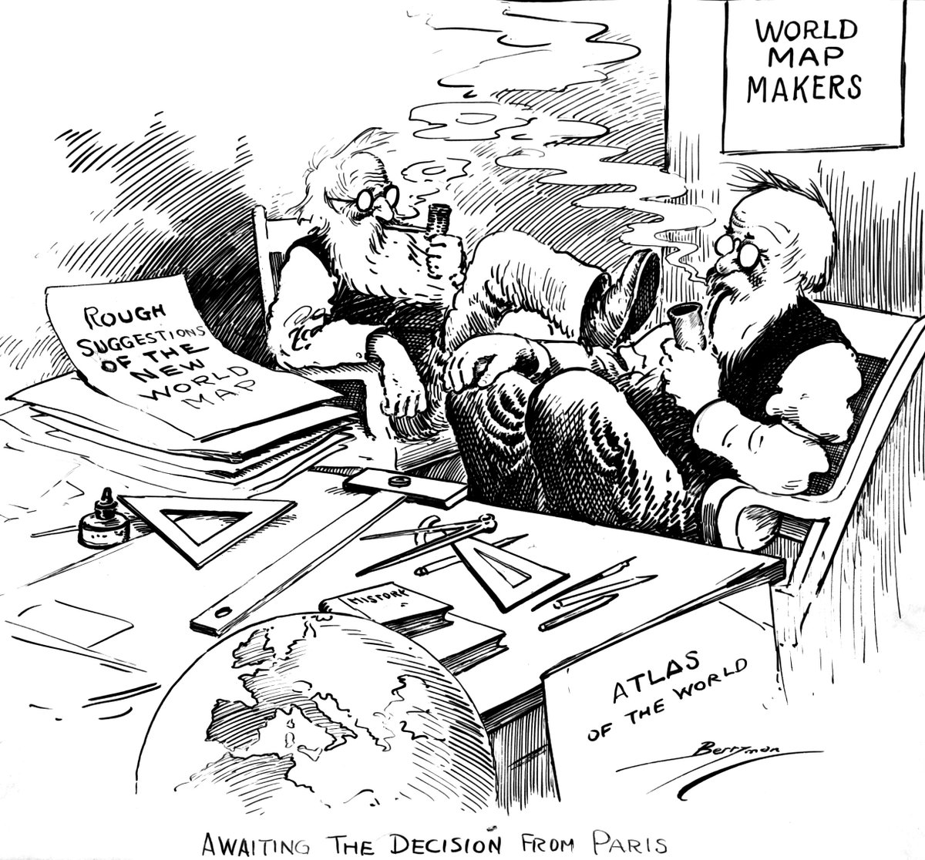
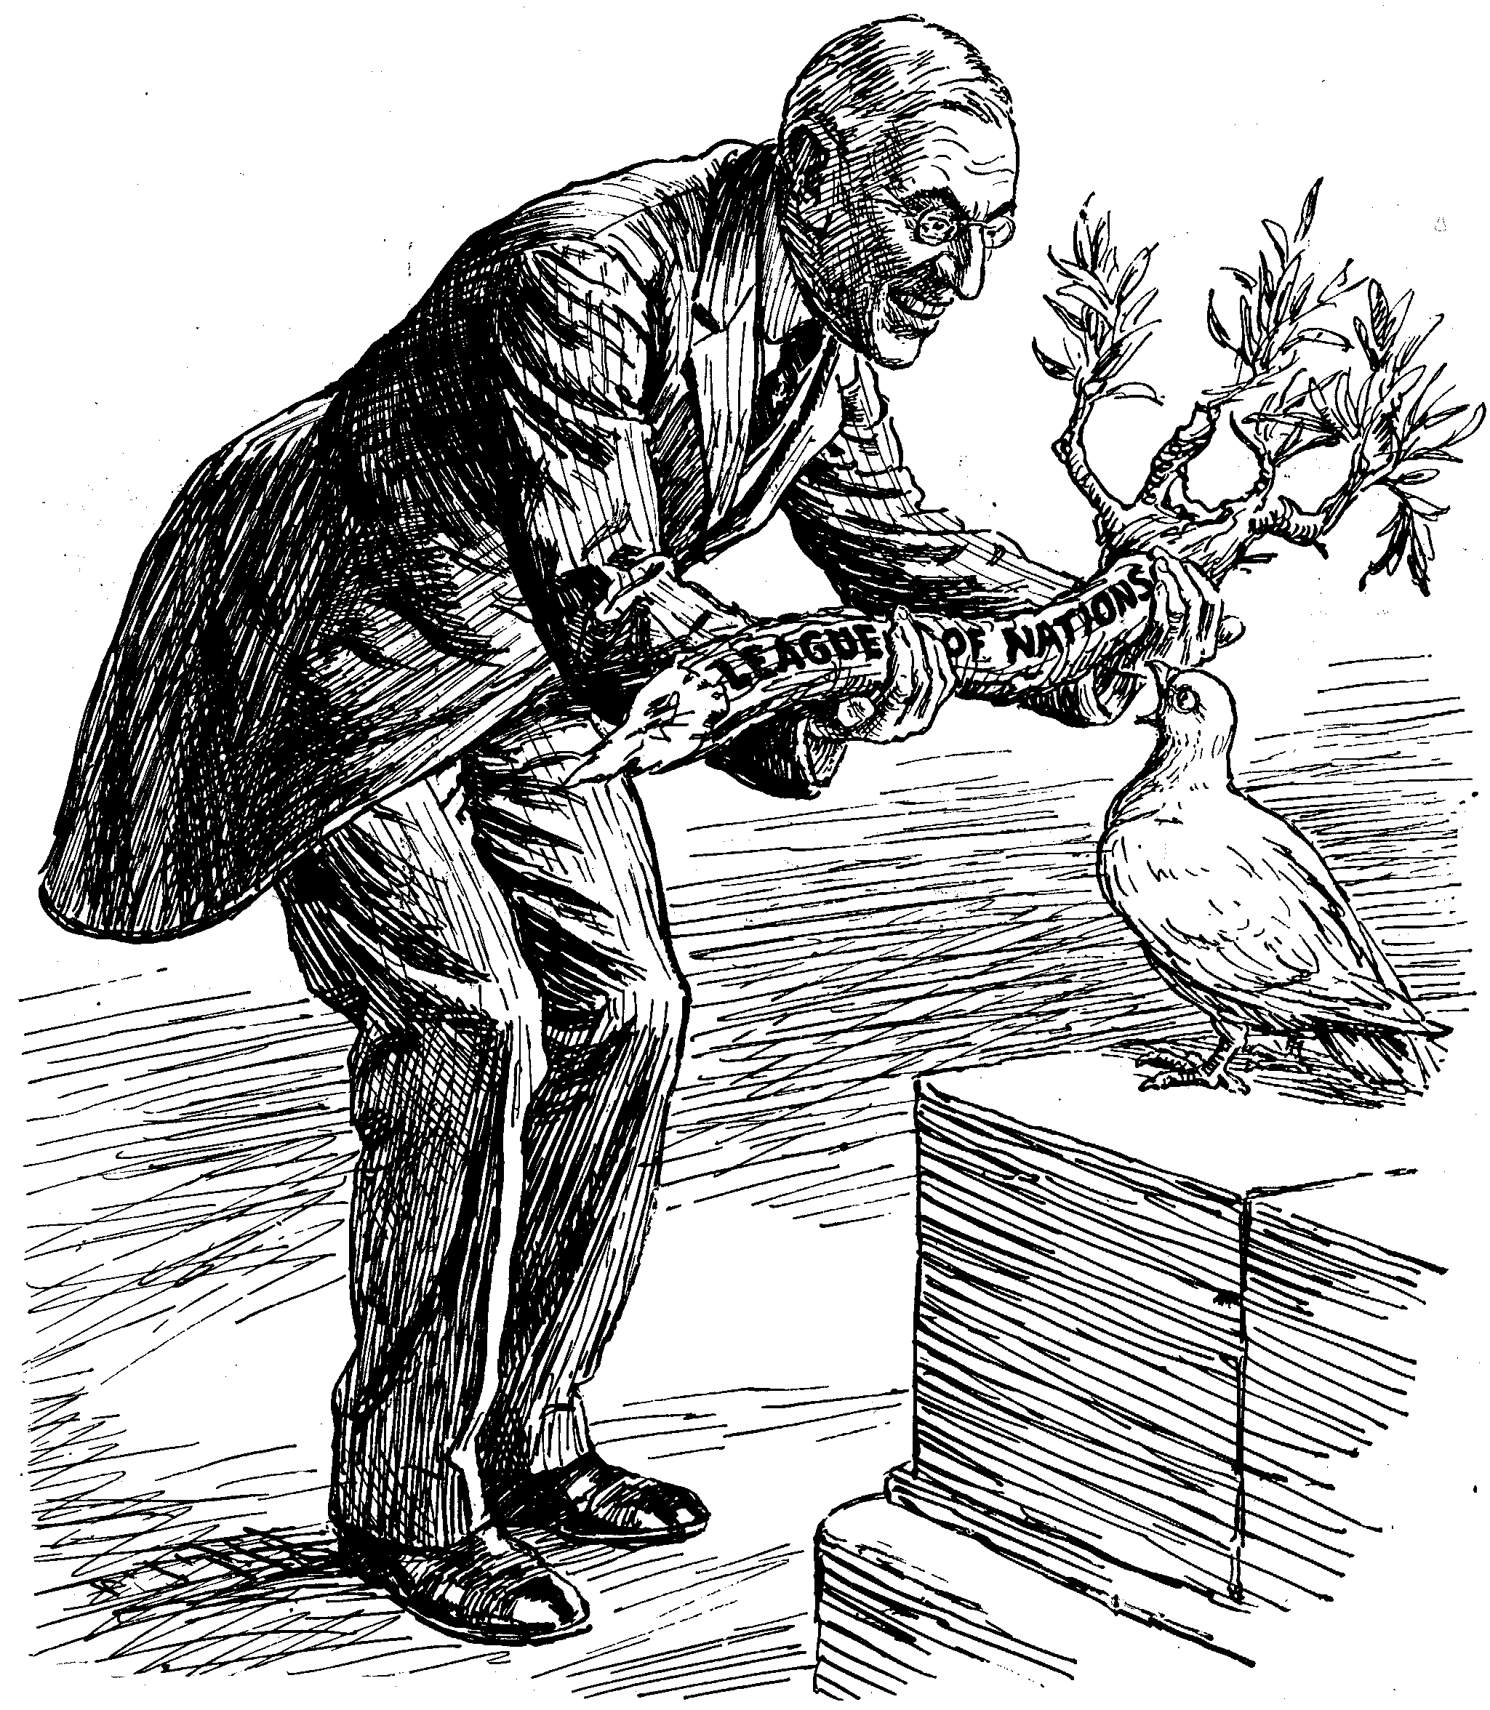

Punch magazine, 26 March, 1919
President Wilson. "HERE'S YOUR OLIVE BRANCH. NOW GET BUSY."
Dove of Peace. "OF COURSE I WANT TO PLEASE EVERYBODY; BUT ISN'T THIS A BIT THICK?"



Your international team must be made of students coming from different origins ( Croatia, Oversea France, Metropolitan France … )
and composed of maximum 8 students.

You'll have to talk, share and part your work together.

A new world order | Russian empire | German empire | Austro-Hungarian empire | Ottoman empire | Migration  of stateless refugees
14 points of W. Wilson  ( 8th January 1918 )  Peace conference – Paris  ( January – August 1919 ) | Treaty of Brest-Litovsk  ( March 1918 ) | Treaty of Versailles  ( 28th June 1919 )  Creation of the SDN | Treaty of  Saint-Germain-en- Laye  ( 10th September 1919 )  Treaty of Trianon  ( 4th June 1920 ) | Treaty of Sèvres  ( 10th August 1920 )  Treaty of Lausanne  ( 24th July 1923 ) | Nansen passport  ( 1922 )
1 team | 1 team | 2 teams | 2 teams | 2 teams | 1 team
1/ Read and comment the documents related to your international team.
2/ Imagine an interesting summary and presentation for our European partners with the main points ( ideas - maps – pictures ).
3/ Present the biography of an important man or woman who acted for peace, a war memorial or a painting ...
4/ Complete a common oneline timeline.
3/ Create a common remembrance object for 11th November ( a poem, a speech, a drawing, a sculpture … )

