http://webcache.googleusercontent.com/search?q=cache:http://www.vrclassforus.eu/Survey.aspx

https://forms.gle/CSADjMRXLMJMhpVK8
https://docs.google.com/forms/d/e/1FAIpQLScy2MSGigvM2hE6nE4Vf_G4Pg0EJkFpSeSRtBJ7CtwgiA_p8Q/closedform

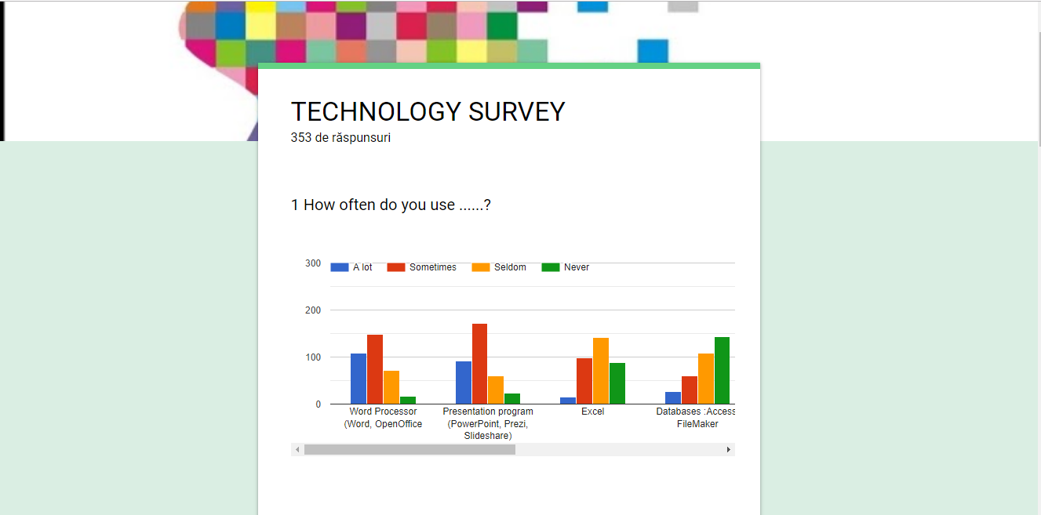

https://docs.google.com/forms/d/1R10Nfks5UQtEEpl6Q--OmWZcMY4tW21nLoQW-KJ9nRo/edit

