Report of October, Vilniaus r. Mickūnų kindergarten, Lithuania

1. "World Day of the Elderly"
In Lithuania we celebrate the Day of Elderly in January, we made a preparation for an event with the Grandparents.
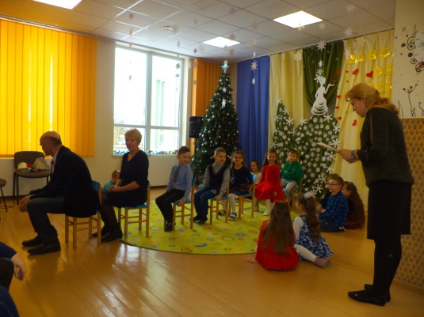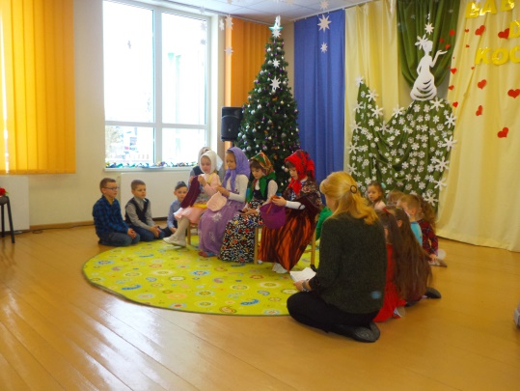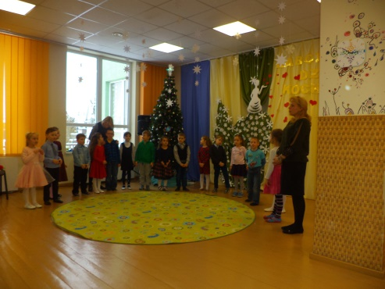
We asked them to tell us how was their life when they were young. Drawing and handicrafts on the topic (children painted their grandmothers and grandfathers
https://twinspace.etwinning.net/62003/pages/page/567381
2. Children activities Children learn about themselves and about children of other European countries. They send their greetings via Skype to other children of participant
We exchanged an autumn song in our motherly language.
https://twinspace.etwinning.net/62003/pages/page/553272
3. Familiarization by the computer
Exercise with computer.” Me and others” Children paintings via computer.
https://twinspace.etwinning.net/62003/pages/page/566855

4. Writing the recipe of “Friendship”
A poster was created by children of our school about the recipe of our friendship and uploaded it in a common Padlet
https://twinspace.etwinning.net/62003/pages/page/553263
https://padlet.com/annmagiosi/stpmq8q321tc
5. Halloween time!
We don’t celebrate Halloween, but we got the activities about this event.
https://twinspace.etwinning.net/62003/pages/page/465738

Management activities
At the end of October we sended the monthly report of October to our project main coordinator.
We have done all project activities for October and we uploaded all our work and have done the publication of our school results
We also had communication via chat room of twin space ,Skype and e mails
https://twinspace.etwinning.net/62003/pages/page/448487
We answered to the questionnaire about October partial evaluation of project implementation.
We received from Greece the list of November activities.

===========================================================

