Report of January, Mickūnų kindergarten, Lithuania

- Winter landscapes.

Together with all partners we created a landscape collage from each country, our project coordinator created the padlet for all pictures.
https://twinspace.etwinning.net/62003/pages/page/517651

- Winter paintings and handicrafts
During the winter we got a lot of ideas for a handicrafts, we can create snowmens, we can create beautiful winter landscapes, we can paint ice and snow and by the imagination of children they can create a lot of beautiful paintings.
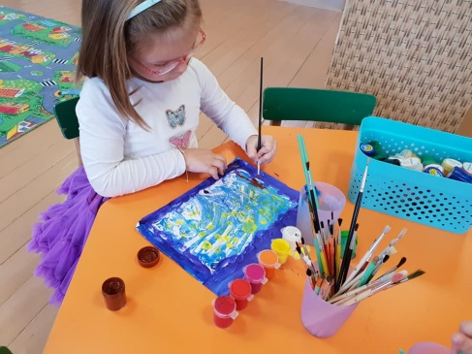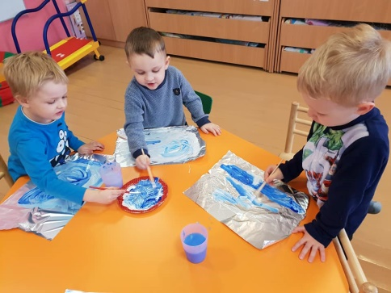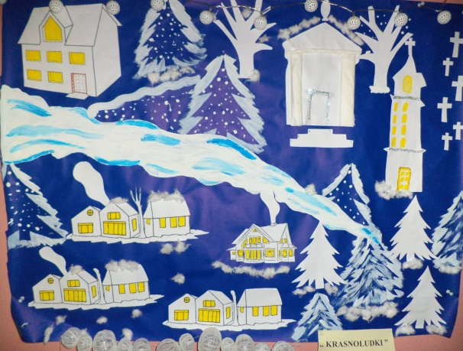

https://twinspace.etwinning.net/62003/pages/page/540125

- Cooking a winter traditional recipe
It was difficult to choose what is in our country traditional winter recipe, together with children we baked traditional cookies, it was really nice process, after that we tried the cookies and we share it with our parents.
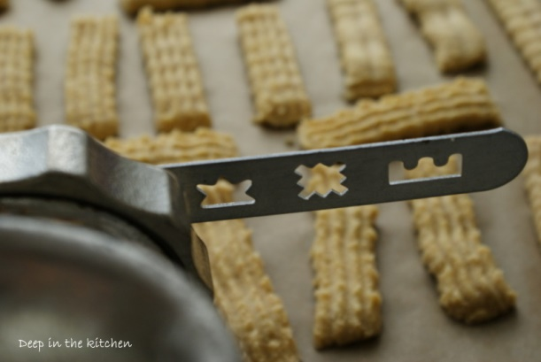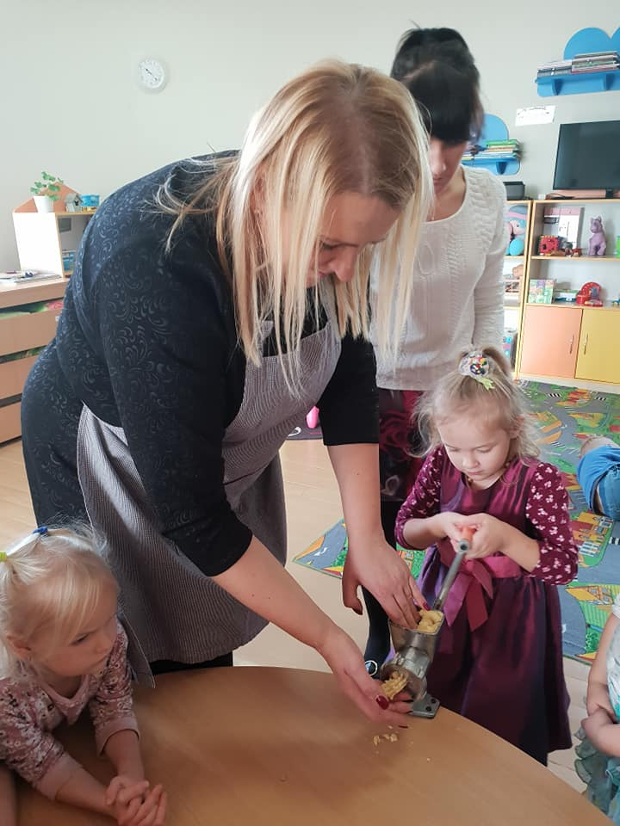

https://twinspace.etwinning.net/62003/pages/page/568109

- We say and write the word „Winter“
https://twinspace.etwinning.net/62003/pages/page/540123

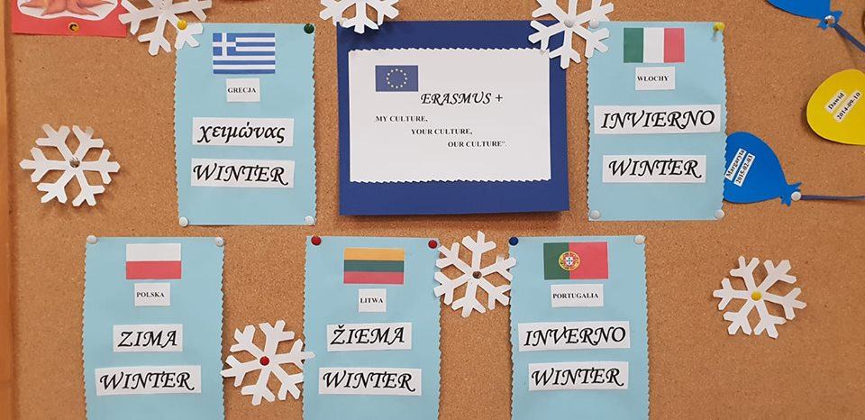

Children learned to say and to write the word "Winter " in all languages of our partners.

- Creation of a story with title : " The story of a wool sweater "
We invited one of our Grandmother, she telled a story for our children, how was the sweater created, she showed us how she made their own sweater, where was the beginning and how was the result.

https://twinspace.etwinning.net/62003/pages/page/534442

- The art of loom

We spoke with children about the art of loom, we showed them pictures about this process, and for the spring we will plan to go to a ethnographical museum to try to work with the loom.

https://twinspace.etwinning.net/62003/pages/page/537989

- Management activities
At the end of January we sent the monthly report of January to our project coordinator. We have done all project activities for January and we uploaded all our work.
We answered to the questionnaire about December partial evaluation of project implementation.
We received on time the list of February activities from our coordinator

