Monthly report of Vilniaus r. Mickūnų kindergarten, Lithuania.
September 2018
Project start
Management activities
Project team was created for the needs of Erasmus+ project
“My culture,your culture,our culture”
Allocation of tasks and responsibilities between the members of project ‘s teachers team
We have received the list of September activities by coordinator
Activation of project twinspace
First project activities
We created the Erasmus+project corner in our schools using material ,collected after research on the Internet (like map of Europe, flags of the participant countries, pictures with landscapes .etc
https://twinspace.etwinning.net/62003/pages/page/465007
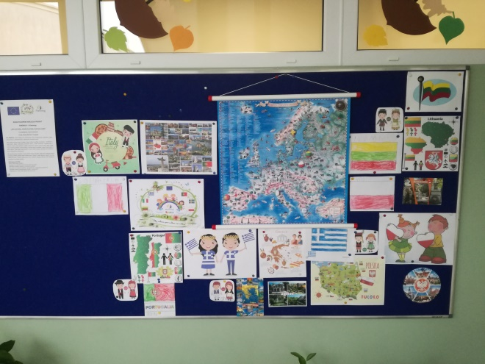
We exchanged information about daily programs and educational systems of each participant school through twinspace.

We exchanged with our partners a brief of demography and history of our country
https://twinspace.etwinning.net/62003/pages/page/433829
We took part in common introduction Padlet of our selves and children selves.
https://padlet.com/aikpapagia/znf3zgzl54s2
We prepared a power point short presentations of our countries and post in project twinspace.
https://twinspace.etwinning.net/62003/pages/page/444494
Other activities
- Children first games of " know each other "
We wrote three of these games and we exchanged them via project twinspace. And we created an ebook:
https://read.bookcreator.com/NjhKK0SqSCMI0VMHsFuBgLDvhkf2/wp9ZBpTQRJyjvoRuvejNEg

2. Children prepared a video to introduce their selves and post it in project twinspace.
https://padlet.com/annmagiosi/d763guuozmf8

- We had the first communication between each other
https://twinspace.etwinning.net/62003/pages/page/448487
6. We have created our “school museum” with old things of past making with this way a good start to learn about our culture.
we posted our work in all project sites ( twin space, project site, school site)
https://twinspace.etwinning.net/62003/pages/page/487811
.
Management activities
At the end of September we have sent the monthly report for September to project coordinator.
We have done all project activities for September and we uploaded all our work and have done the publication of our school results We also had communication via chat room of twin space and e mails
https://twinspace.etwinning.net/62003/pages/page/448487
We answered to the questionnaire about September partial evaluation of project implementation.
https://www.surveymonkey.com/results/SM-87X5RXSZL/
The coordinator has send to us in time the list of October activities
Dissemination activities have done
http://www.lopselis.darzelis.mickunai.vilniausr.lm.lt/?page_id=3627

=======================================================

