Lithuanian autumn traditional dishes
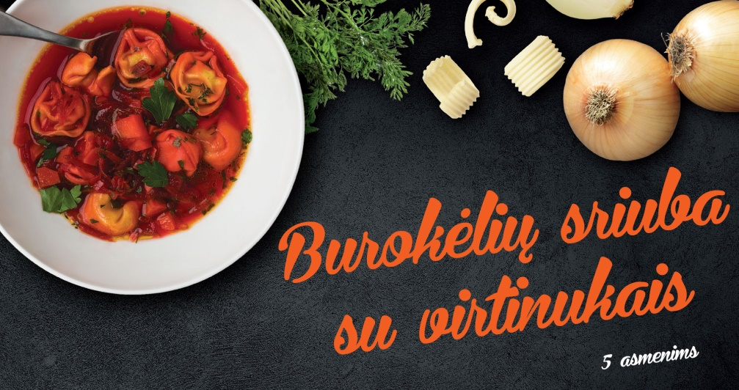
Beet Soup - Burokeliu Sriuba
BOUILLON:
1 quart water - boiled
1/2 onion
1 carrot
6 peppercorns
1 bay leaf
1 sprig parsley
1/2 stalk celery
5 to 6 medium beets - cooked, peeled and grated
Pinch of sugar
Salt
1/2 to 1 tsp. lemon juice
1 tsp. butter
1 Tbsp. flour
To boiling water add the onion, carrot, peppercorns, bay leaf, parsley and celery. Cook for 15 minutes then strain the bouillon and keep it hot. Discard the vegetables and spices. Reserve the bouillon.
Do not peel the beets, boil them in fresh water for about 1 1/2 hours until tender. Drain and cool beets until they are easy to handle. Peel and grate the beets. Add pinch of sugar, salt and 1/2 to 1 tsp. lemon juice. Melt butter, stir in flour, cook slightly and add to the grated beets.
Before you continue with the beet soup boil the "Little Ears" first in the bouillon until they float about 5 minutes - covered (see recipe below). Remove ears and set aside and continue with the beet soup.
Pour bouillon over beets, heat, stir gently but do not boil. Place little ears in hot soup before serving.
"LITTLE EARS" “Ausikes”
DOUGH:
1/2 cup water
2 egg yolks
Salt
Flour
FILLING:
1/4 pound dried mushrooms
1/2 Tbsp. butter
1 chopped onion
Filling: Soak mushrooms in cold water several hours. Drain and rinse thoroughly. Boil mushroom in fresh water till fairly soft. Drain. Chop the mushrooms, and fry in butter with onion, adding salt to taste.
Dough: Make a dough of the water, egg yolks, salt, and add enough flour to make a medium stiff dough and easy to roll. Let rest covered for 15 minutes to relax dough.
Roll out dough thinly and cut into 1 1/2 inch squares. On each square put a spoonful of mushroom mixture. Moisten edges with egg white, fold over opposite sides to form triangle; press edges together tightly. Twist two ends of triangle up and over to form "ears". Boil about 5 minutes in plain bouillon, in tightly covered pot. Add to beet soup.

Lithuanian potato-meat dumplings - Cepelinai.

Ingredients
- For the Meat Filling:
- 1 pound ground pork (or 1/3 pound pork, 1/3 pound beef, 1/3 pound veal)
- 1 medium onion (peeled and finely chopped)
- 1 teaspoon salt
- 1/4 teaspoon pepper
- 1 large beaten egg
- For the Dumplings:
- 8 large Idaho potatoes (peeled and finely grated – not shredded)
- 2 large Idaho potatoes (peeled, boiled and riced)
- 1 medium onion (peeled and finely grated)
- 1 teaspoon salt, more or less to taste
- For the Gravy:
- 1/2 pound bacon (diced)
- 1 large chopped onion
- 1 cup sour cream
- Black pepper to taste
- 1 to 2 tablespoons milk (if necessary)

Steps to Make It
Make the Meat Filling
- In a large bowl, mix together ground meat, finely chopped onion, 1 teaspoon salt, pepper, and egg until well incorporated.
- Cover with plastic wrap and refrigerate until ready to use.
Make the Dumplings
- Add a drop or two of lemon juice to the grated potatoes so they don't turn brown. Place them in a fine-mesh cheesecloth or cotton dish towel and twist over a large bowl to get rid of the excess water. Pour off the water, reserving the potato starch at the bottom of the bowl.
- Unwrap the cheesecloth and place potatoes in the bowl with the potato starch you reserved from the bottom of the bowl. Add the riced boiled potatoes, grated onion, and 1 teaspoon salt or to taste. Mix well.
- Put a large stockpot of water on to boil. To form the zeppelins, take about 1 cup of dumpling mixture and pat it flat in the palm of the hand. Place 1/4 cup or more of meat mixture in the center and, using slightly dampened hands, fold the potato mixture around the meat into a football shape, sealing well. Continue until both mixtures are gone.
Cook the Dumplings
- Carefully lower dumplings into salted, boiling water to which 1 tablespoon of cornstarch has been added (to prevent dumplings from falling apart). Make sure water returns to the boil and continue boiling for 25 minutes.
- Remove dumplings with a slotted spoon or strainer, drain briefly on a clean dish towel and place on a heated platter.
Make the Gravy
- While the dumplings are boiling, make the gravy. In a medium skillet, fry the bacon and chopped onion until tender.
- Drain and combine with sour cream and black pepper. Thin with 1 to 2 tablespoons milk if necessary. Ladle dumplings with gravy or pass the gravy at the table.

Stuffed Potato Pancakes – Bulviniai blynai
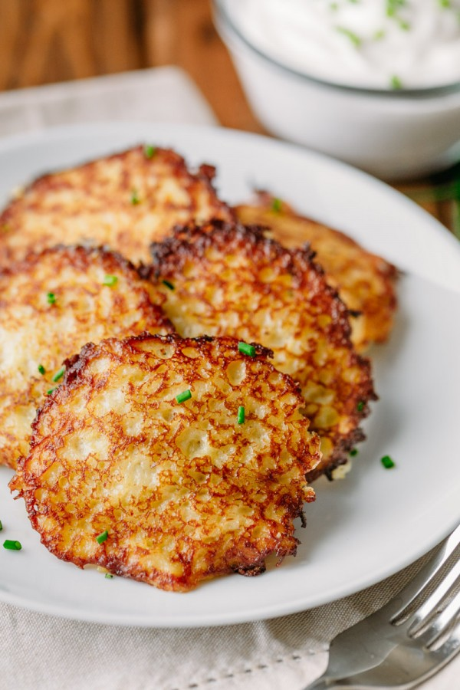
1 1/2 lbs (5 medium) potatoes (we used yukon gold), peeled
1 medium onion, peeled and divided (use 3/4 for potatoes and 1/4 for meat filling)
1 large egg
3 Tbsp all-purpose flour
1 Tbsp sour cream
1 tsp salt, or to taste
1/8 tsp black pepper, or taste
Cooking oil (we use extra light olive oil)
1/2 lb ground pork
1 Tbsp reserved grated onion (see above)
1/4 tsp salt and a pinch of black pepper, or to taste

How to Make Stuffed Potato Pancakes
Into a large bowl, grate potatoes on the star grater. It should be the consistency of applesauce. Use a spoon to skim off 1 Tbsp excess potato water that floats to the top.
Note: If grating by hand, protect your fingers and use safety gloves like these. Grating is the most annoying step so once you get through it, you’re golden! We’ve made these by dicing potatoes and blending in our blender or using a good food processor like this one and they tasted great, but the texture was not as authentic as grating by hand.
Grate onion into the same bowl (reserving 1 Tbsp grated onion for the meat mixture). The onion will keep potatoes from browning.
Add 1 egg, 3 Tbsp flour, 1 Tbsp sour cream, 1 tsp salt and 1/8 tsp black pepper and stir well.
Mix together ground pork, 1 Tbsp reserved grated onion, 1/4 tsp salt and black pepper to taste. Form into 16 skinny patties and place them on a clean surface (I put them on a cutting board lined with plastic wrap).
Heat a large non-stick skillet over medium heat and add 2-3 Tbsp oil. Once oil is hot, add 1 Tbsp of the mixture at a time into the skillet, flattening it out. Top with a thin meat patty and cover the meat with another Tablespoon of potato batter. Saute until potatoes are golden brown then flip and continue sautéing until golden brown and cooked through (about 4 min per side). Repeat with remaining batter, adding more oil as needed. Remove to a paper-towel lined plate and server warm with sour cream.

Potato pudding – Kugelis
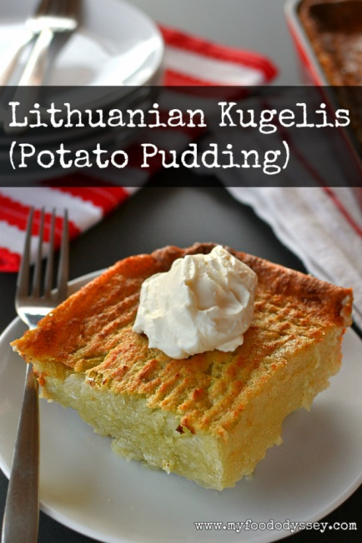
Kugelis is commonly served with applesauce, lingonberry preserves, sour cream, or crumbled bacon bits. It can be eaten as a main course or side dish.

Ingredients
- 1/2 pound bacon (chopped)
- 1 large onion (chopped)
- 5 large eggs (beaten)
- 1 1/4 cups milk
- 1 (7-ounce) can​ of evaporated milk
- 1 1/2 teaspoons salt
- 1/2 cup farina (not the quick-cooking kind)
- 5 pounds red potatoes (or white potatoes, peeled and grated, not shredded)

Steps to Make It
- Gather the ingredients.
- Place the oven shelf in the middle and heat the oven to 350 F.
- Coat a 13-by-9-inch pan with cooking spray and set it aside.
- In a large skillet, sauté bacon and onion until lightly browned and caramelized. Leave them in the skillet and do not drain the fat. Set the pan aside to cool.
- In a large bowl, combine eggs, milk, evaporated milk, salt, and farina. Add the bacon-onion mixture and drippings. Stir until well combined.
- Using a food processor or by hand, finely grate potatoes, squeezing out excess moisture. Work quickly so the potatoes don't darken. While they are still fine to eat if they darken, it is less appealing.
- Add the grated and squeezed potatoes to the bacon-egg mixture, combining well.
- Pour the potato mixture into the prepared pan and bake for 1 1/2 hours or until the top is quite brown and the interior is solid but still moist.
- Remove the pan from the oven and let it sit for 5 minutes before cutting into squares.
- Serve as a side dish or as a main course with a salad.
Cover and refrigerate any leftovers. You can enjoy leftover kugelis by heating portions in the microwave or browning them in butter.

