November report of Mickūnų kindergarten, Lithuania

- Autumn fruits
Children familiarized with the fruits and vegetables and also the forest fruits of their country. They learnt the recipes to cook homemade sweets and marmalades by autumn fruits.

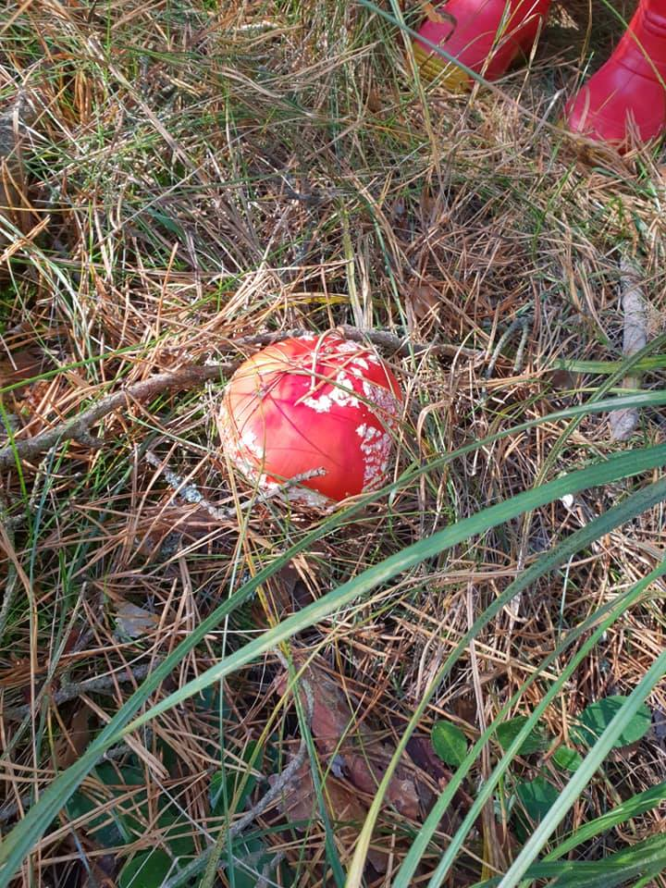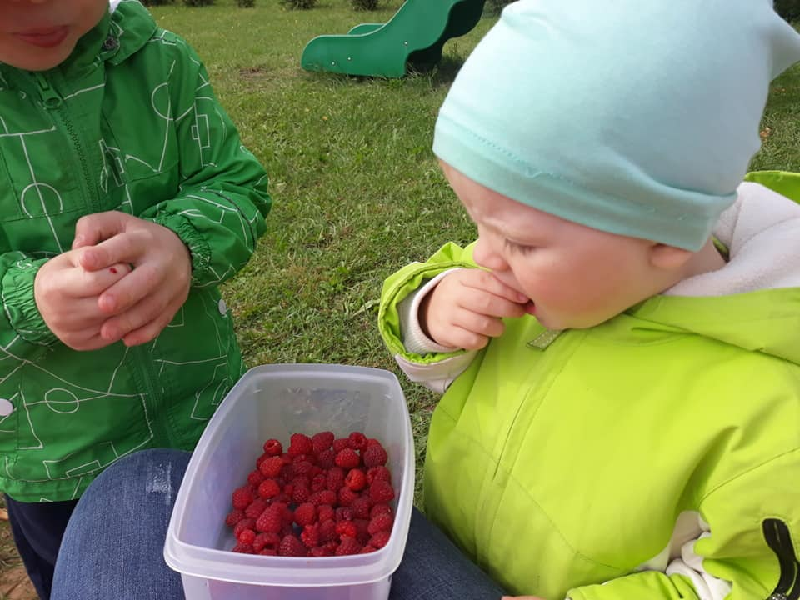

https://twinspace.etwinning.net/62003/pages/page/479556

We also prepared a very popular marmalade recipe with apples, our children tasted this marmalade when we had in our preschool the Harvest Fest.
https://twinspace.etwinning.net/62003/pages/page/567667

- Creations by autumn fruits and nuts
Children used their imagination to create something special with the autumn fruits and nuts. Parents helped them.
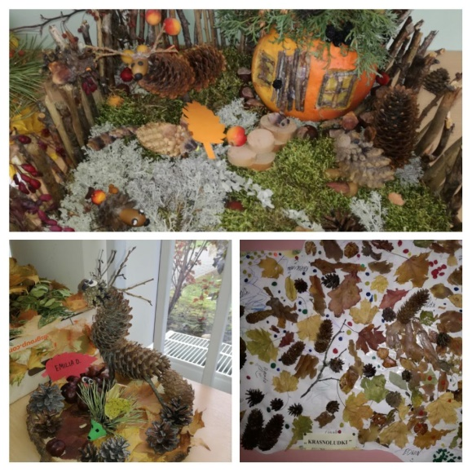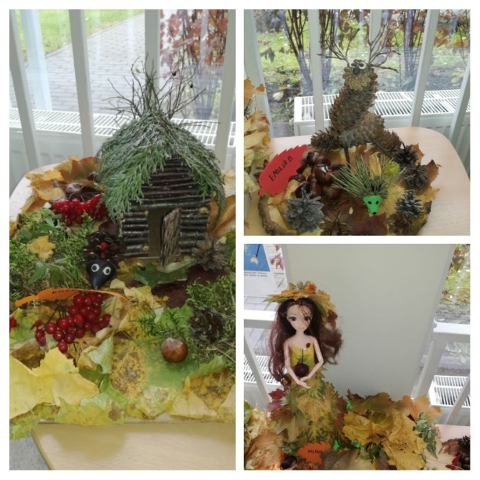
https://twinspace.etwinning.net/62003/pages/page/465727

- Traditional food recipes
https://twinspace.etwinning.net/62003/pages/page/517512

Children cooked some traditional autumn food together with their parents. Each country has exchanged five traditional autumn recipes trough twinspace which were used for the creation of an e-book whose title is: «Traditional recipes of Europe”

- Team work of participant schools
We completed the page with list of plants that crops that cultivate in each region and country of all partners.
https://twinspace.etwinning.net/62003/pages/page/459019

Management activities

At the end of November we have completed and send the monthly report of November to our coordinator. We have completed all project activities for November and we uploaded them and we have done the publication of our school results. We also had communication via chatroom of twinspace, Skype and e mails
https://twinspace.etwinning.net/62003/pages/page/448487

We answered to the questionnaire about November partial evaluation of project implementation.
We have received the list of December activities from our coordinator.

