Lithuanian Christmas Eve Biscuits | Kūčiukai

- 500g plain flour
- 7g dry fast acting yeast
- 2 tbsp sugar
- 1 pinch of salt
- 2 tbsp poppy seeds
- 2 tbsp olive oil
- 1 egg, whisked
- 250ml milk (lukewarm)
  - Mix all the ingredients and form it into a dough. Kneed the dough for at least 5 min.
  - Form the dough into a ball and place it into a bowl. Cover it with cling film and place it somewhere warm for an hour or so. When the dough has risen (at least doubled in size) then punch it to “deflate” it and cover it to proof for another half an hour. 3. Once the final proofing is done shape the dough into sausage shapes and slice them into small bits (about 1cm in size).
  - Bake these in preheated 190C oven for 5-7 min until slightly golden but not brown.
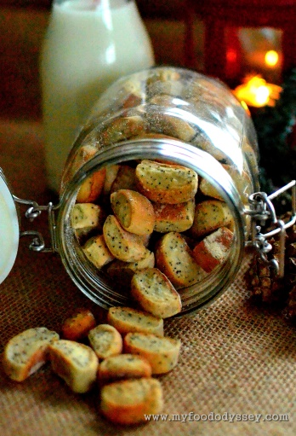

Kūčiukai are typically served with a glass of milk. Old traditions dictated that no animal products, including dairy products, should be consumed on Christmas Eve and so poppy seed milk was used in place of dairy milk. In many regions this custom has now petered out and dairy milk is used. In some homes the biscuits are soaked in milk before eating, in others the milk is served as a drink on the side.
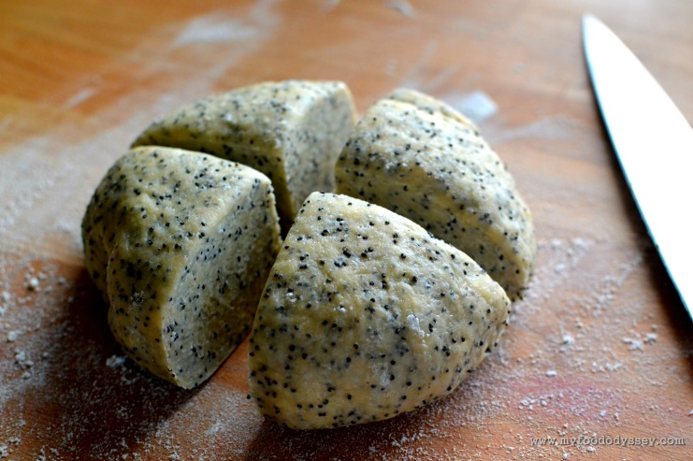

Kūčiukai are incredibly simple to make and only require a small number of ingredients.
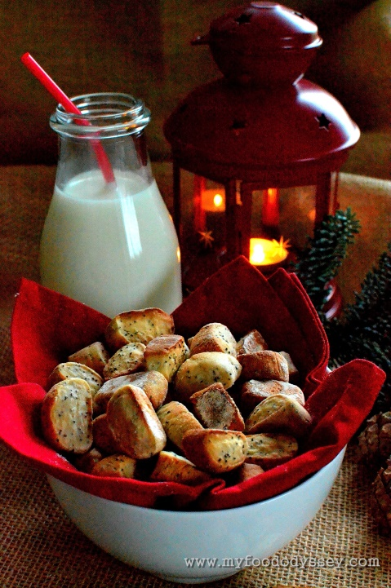

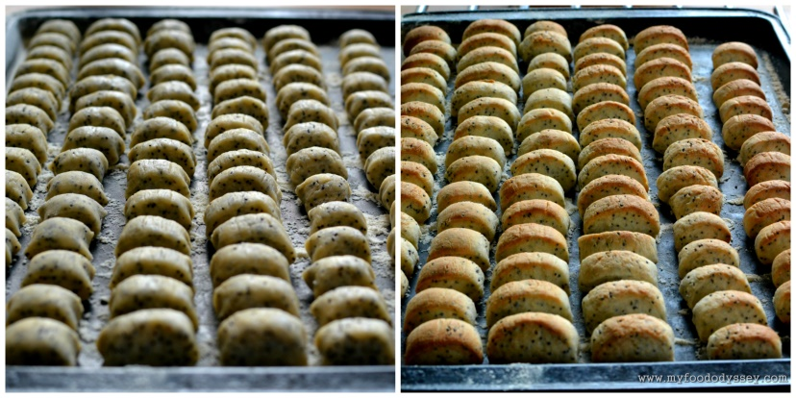
Poppy milk (aguonų pienas) is a traditional Lithuanian drink or soup, one of the 12-dishes Christmas Eve Supper Kūčios. Usually it is eaten together with kūčiukai, another traditional Lithuanian Christmas Eve dish.
Ingredients: To make poppy milk, one or two glasses of poppy seeds are needed.
Directions:
1. The poppy seeds are soaked in some hot water for a day or so, changing the water from time to time, until the seeds become soft.
2. Then the poppy seeds are crushed in a food processor (or with a pestle in a mortar), until a white liquid comes out.
3. Some cold water is added (preferably water that has been boiled, and cooled), and the poppy seeds are strained and crushed once more.
4. This process is repeated several times in order to get a good poppy milk concentrate.
5. The poppy milk concentrate is diluted with some cold boiled water (the quantity of the water used, is a matter of taste, and certain family preferences, but the flavor of the poppy seeds should be pronounced).
6. Finally, some sugar or honey is added to sweeten the poppy seed milk.
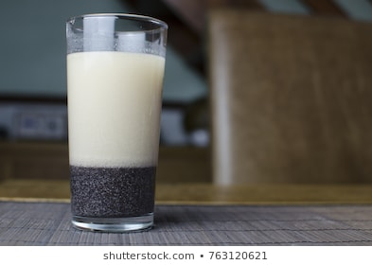

Cranberry Kissel Drink  Kissel is found in many Eastern European cuisines, and it is usually a berry or fruit flavoured thick starchy dessert. In Lithuania, however, kissel is thinned down to a consistency of a drink, and its cranberry variety is a favorite in winter and during Christmas season.  Traditionally, cranberry kissel is made by boiling cranberries, straining them, thickening the hot liquid with starch and adding sugar to taste. As a shortcut, you may heat up ready-made cranberry juice and drizzle some starch suspended in a small amount of water to thicken the juice. Voila - you have a kissel. | 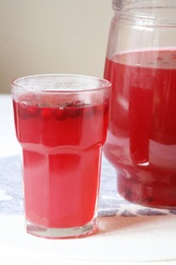  Cranberry Kissel Drink

Herring with Oil and Onions  2 herrings  2 large onions | 4 tbsp. oil  vinegar, sugar
- Soak, skin and bone herrings, cut into pieces and arrange in rows on a serving dish.
- Slice onions, saute in oil until golden.
- Add a little sugar and vinegar.
- Cool and pour over herring slices.
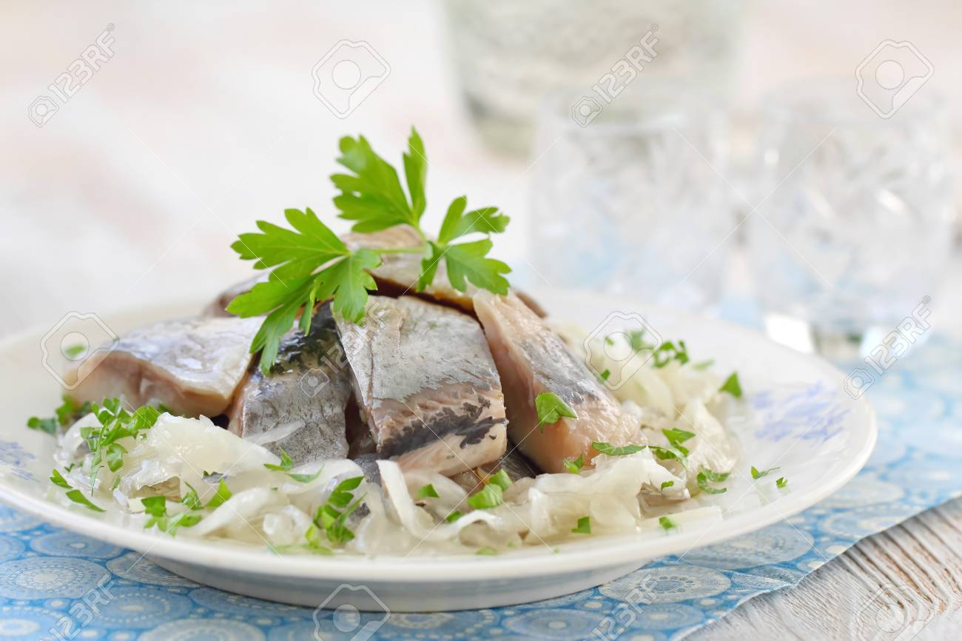

Fish Fillets in Tomato Sauce  (Zuvis Su Pomidorais)  6-8 fillets whitefish, sole or similar  1 c. flour mixed with a tablespoon of seasoned salt  2 tbsp. oil  1 large onion, sliced | 2 carrots, peeled and coarsely grated  1 stalk celery, coarsely grated  1 (7 oz) can tomato paste  2 c. tomato ketchup  1 tsp. sugar
- In a large skillet, saute onions, celery and carrots until tender.
- Add tomato paste, ketchup, and sugar.
- Set aside.
- In another skillet, heat oil and brown fish fillets, dredged in seasoned four.
- Add sauce to fish and simmer for 3-5 minutes.
- May be served hot or cold.
