Report of March, Mickūnų kindergarten, Lithuania

- Welcome Spring

Our teacher read the Greek myth about the Almond tree, our children created a illustration to one of a part of this myth and we placed our work on the padlet.

https://twinspace.etwinning.net/62003/pages/page/559287

https://twinspace.etwinning.net/62003/pages/page/559287

- Spring paintings and handiworks

We love very much spring, because of colorful, warm sun and nice sounds of birds, all our groups created a lot of handiworks and paintings for this activity.
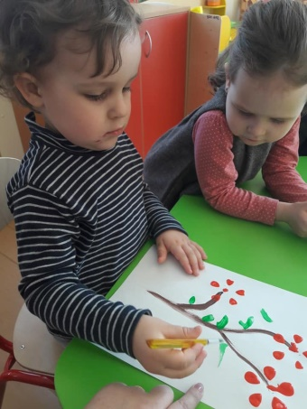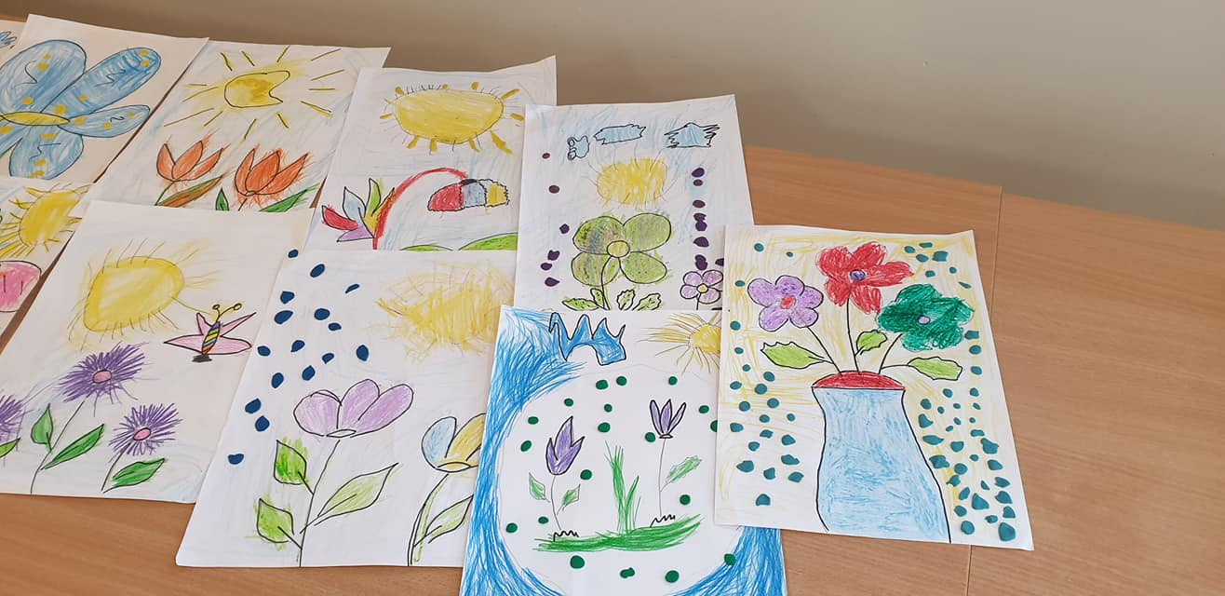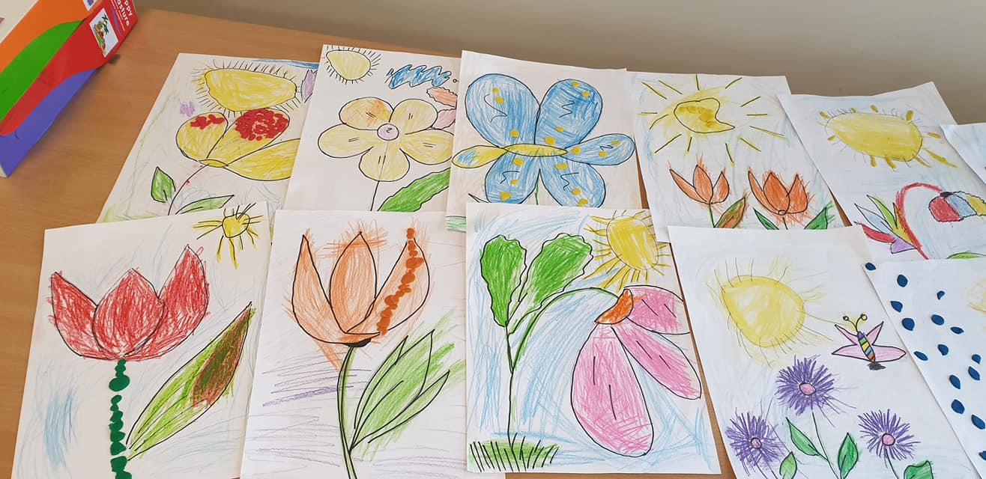

We searched spring signs outside, by the walking trough our village.
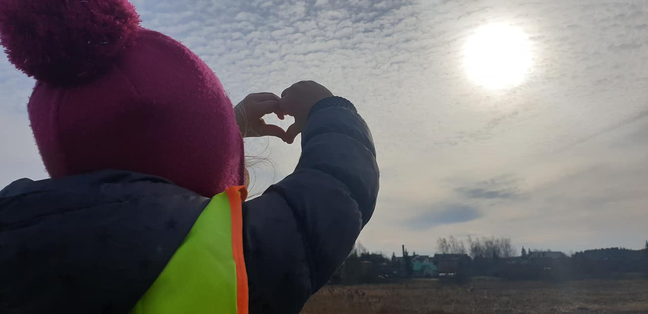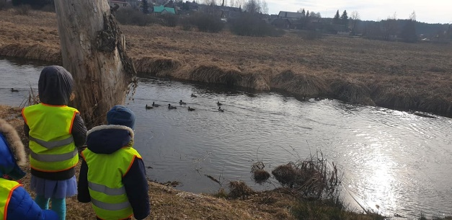

https://twinspace.etwinning.net/62003/pages/page/575689

- Carnival festival
This year the carnival “Užgavenės” in our preschool was on 5th of March, we celebrate this event each year, teachers create a theatrical play, we bake pancakes and create colourful masks, because we want to scare the Winter.
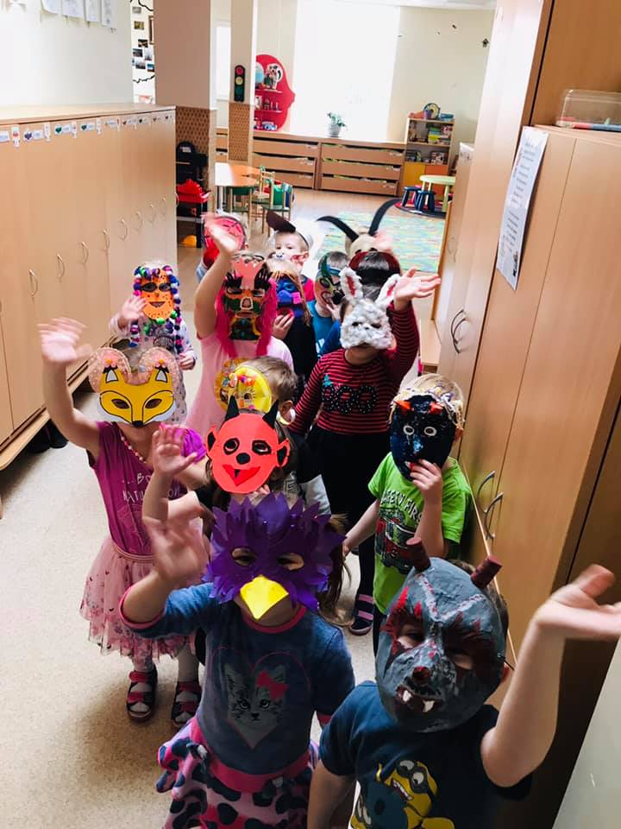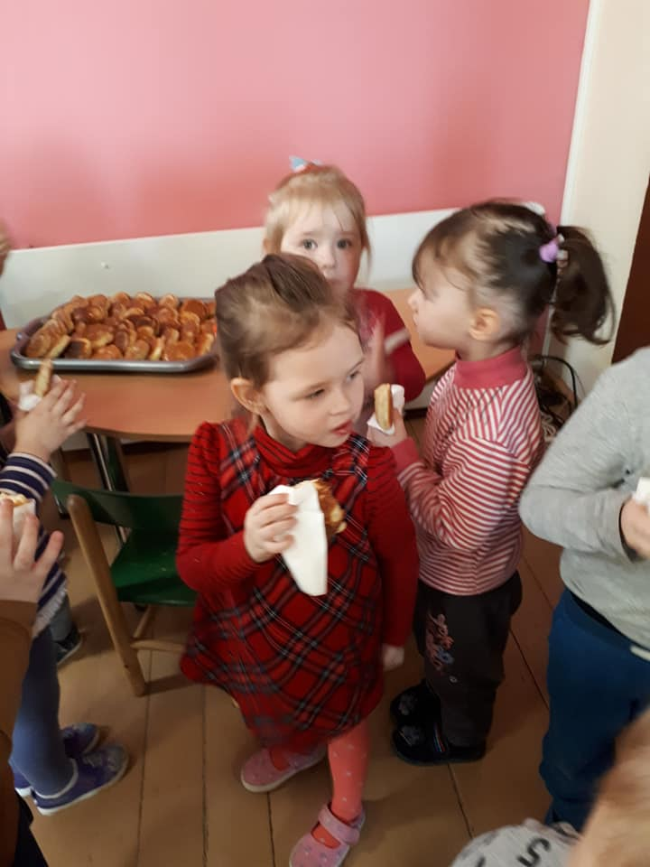
https://twinspace.etwinning.net/62003/pages/page/566880/edit

- Carnival customs

We showed to our partners how Lithuanian people celebrate Carnival in our country, and what is the meaning of this event.

https://twinspace.etwinning.net/62003/pages/page/568933

- Let’s photo tells us a story!

Together with children we watched the old picture book, we analysed about the stories in this book, who are the people on the pictures, what they did and how they lived.

https://twinspace.etwinning.net/62003/pages/page/591231
https://gopro.com/v/XlyyQ6pln8Erz

- Representation of life in old times

Together with our parents we created an old pictures corner in our preschool, where we puted the old pictures from childhood our parents and the grandparents, this exhibition is open for everyone in our preschool.

https://twinspace.etwinning.net/62003/pages/page/591193

- Means of transportation and their evolution

Our children had a lesson in old Road museum, where they knowed more about the old vehicels, they could try to sit in this cars, they could ask the guide about this cars, and they also could play a interactive games about the transport and cars.
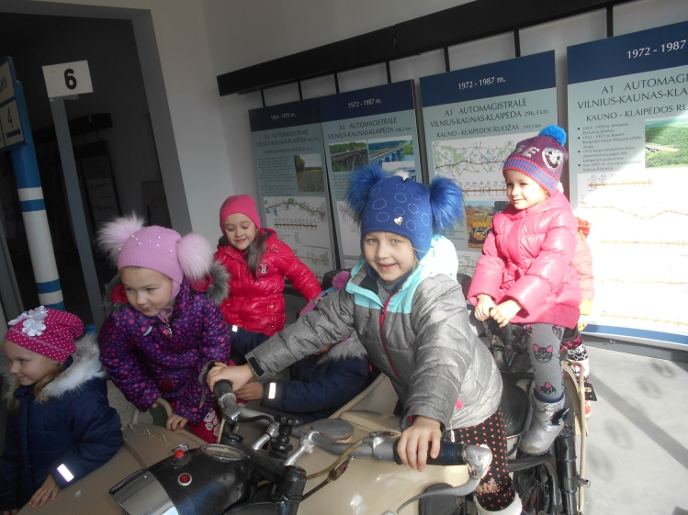

https://twinspace.etwinning.net/62003/pages/page/582797

- Management activities
At the end of March we sent the monthly report of March to our project coordinator. We have done almost all project activities for March, except one, about the Customs of the first Day of March, because we don’t have any tradition to celebrate this event, our children just watched to pictures of customs from other countries and we uploaded all our work.
We answered to the questionnaire about March partial evaluation of project implementation.
We received on time the list of April activities from our coordinator

