Report of April, Mickūnų kindergarten, Lithuania

- Spring has come

Our children together with music teacher learned a song about the sleeping animals, we transformed the song in our way, so our children sang in 3 languages about the sleeping bear, in Polish, Lithuanian and English language.

https://twinspace.etwinning.net/62003/pages/page/611743

https://www.youtube.com/watch?time_continue=1&v=SHYOXn1mZWo

- Children Spring paintings by use of computer.

The oldest children tried to work with computer, they painted the spring flowers via computer, thay liked this work really very much.

https://twinspace.etwinning.net/62003/pages/page/609383

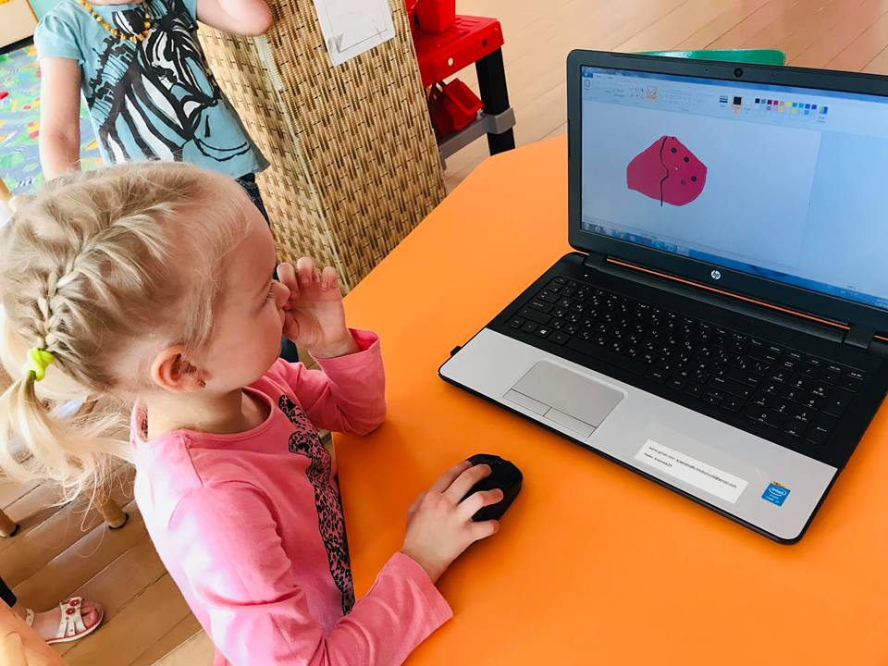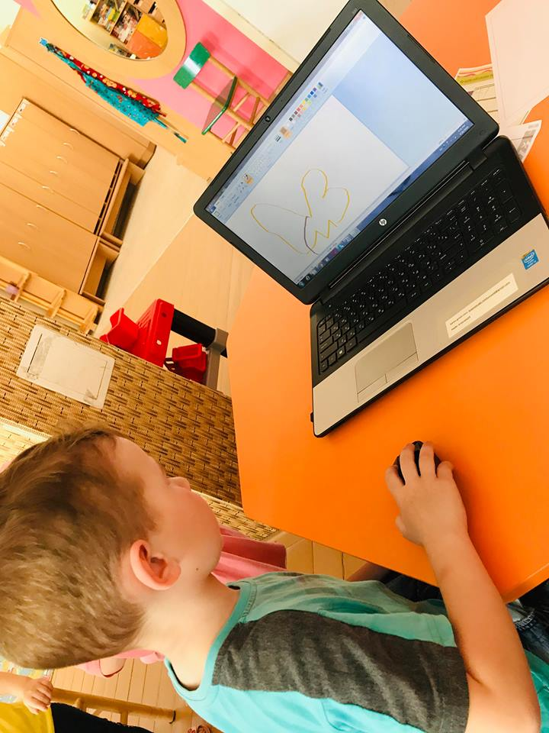

- Easter activities! Painting eggs/ecological colors
We asked our parents to help us with this activity, each family had they one tradition how to paint the Easter eggs, so we asked them to share this moments with us, and we got a lot of beautiful pictures.

https://twinspace.etwinning.net/62003/pages/page/604856
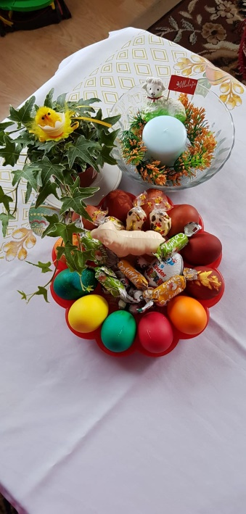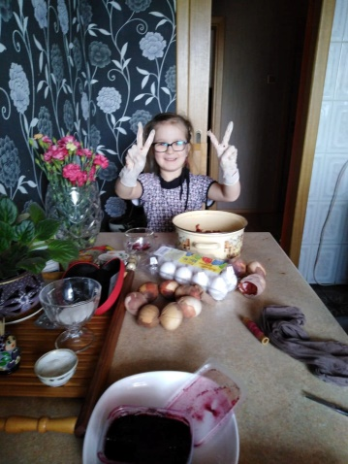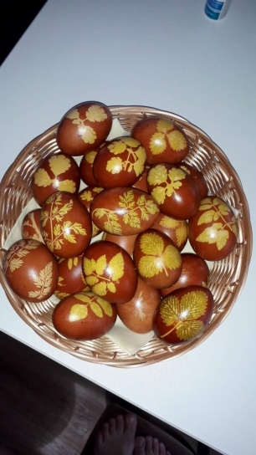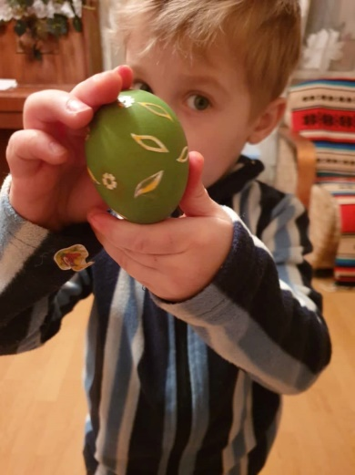

- Traditional Easter recipes

Together with the teachers we created a document about the traditional Easter recipes from our region.

https://twinspace.etwinning.net/62003/pages/page/612347

- Easter cards around the Europe

Together with children we created the Easter cards with the Easter wishes, and we sended this cards to our project partners from around the Europe.

https://twinspace.etwinning.net/62003/pages/page/611738
https://gopro.com/v/Po2vPd3N0Wb12

- Children Easter paintings and handicrafts.

Spring time is the perfect time for the best children paintings, its colourful, a lot of great motives, a lot of flowers and beautiful moments on the paper. Take a look.

https://twinspace.etwinning.net/62003/pages/page/604832

- Management activities
At the end of April we sent the monthly report of April to our project coordinator. We have done all project activities for April.
We answered to the questionnaire about April partial evaluation of project implementation.
We received on time the list of May activities from our coordinator

