Report of December, Mickūnų kindergarten, Lithuania
- Waiting for Christmas
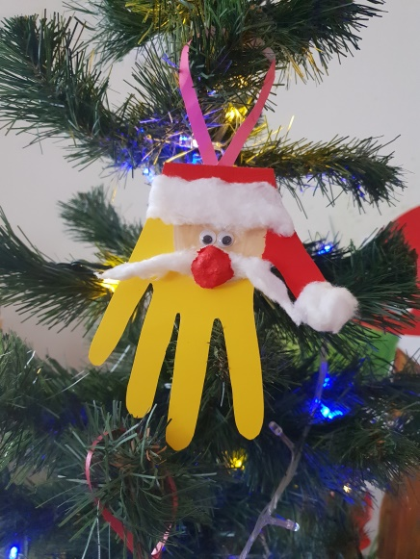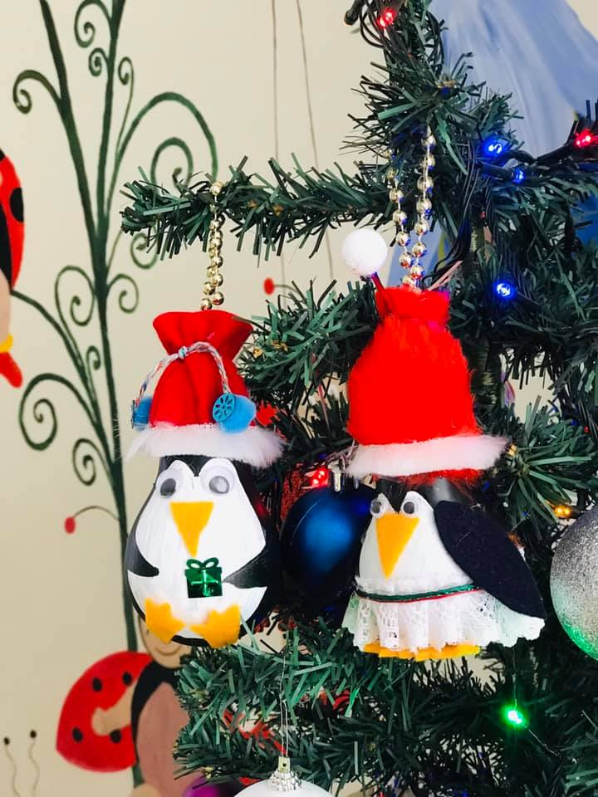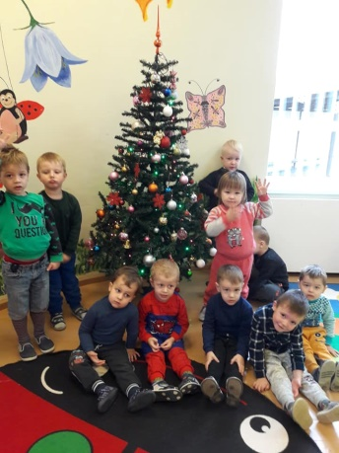
Together with parents our children created some decoration for the christmas trees, started to preper the Christmas performances, and also analysed old pictures about the Christmas customs in old times.

https://twinspace.etwinning.net/62003/pages/page/568047

- Customs and traditions
Each group prepared a corner about the Christmas traditions and customs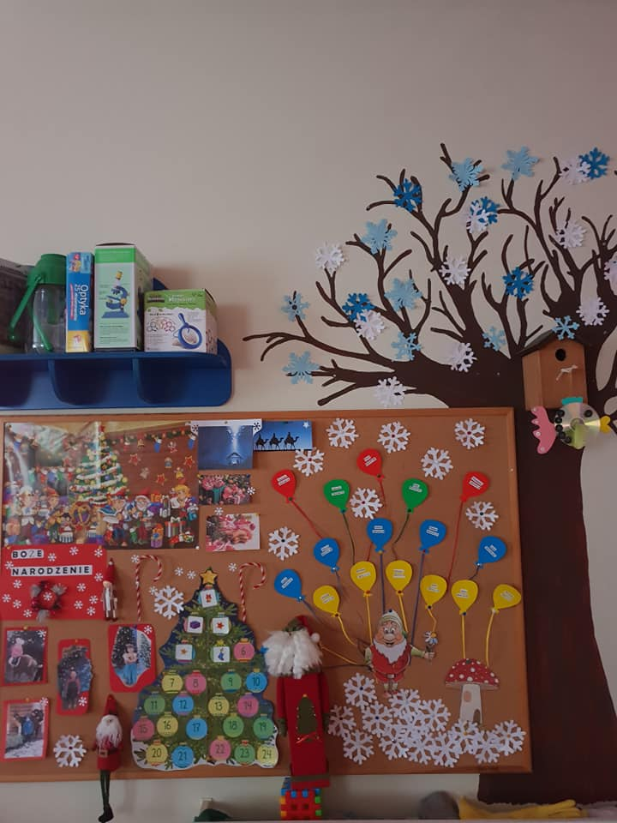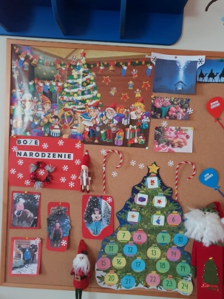
Children and teachers searched stories, customs and traditions about Christmas in our town via internet.
https://twinspace.etwinning.net/62003/pages/page/516792

- Our Christmas story
We have created a common padlet which contains Christmas stories of each country.
https://twinspace.etwinning.net/62003/pages/page/519041

- Christmas cards and handicrafts.

https://twinspace.etwinning.net/62003/pages/page/516798

Children prepared the Christmas cards with different materials, this cards we gave to our partners during our first meeting in Greece.

- Our Christmas wishes

The teachers created a common padlet with their wishes https://el.padlet.com/annmagiosi/gghdf8jzvbwe

- Christmas presents with useless or natural material
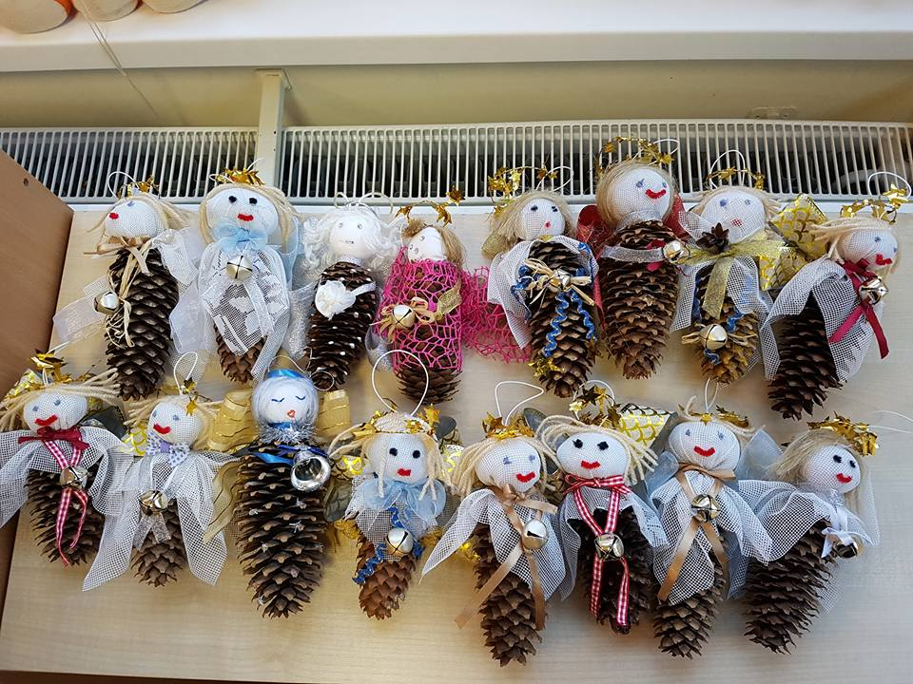
Our children created a beautiful Angels with cone and useless material.
https://twinspace.etwinning.net/62003/pages/page/522432

- Christmas traditional recipes
We created a list with most traditional Lithuania Christmas recipes, shared it with all partners:
https://twinspace.etwinning.net/62003/pages/page/522391

And created all together the e-book with traditional recipes around the Europe:

https://read.bookcreator.com/NjhKK0SqSCMI0VMHsFuBgLDvhkf2/EAuuP6S3TX2X_d7mRTP86A

- Management activities
At the end of December we sent the monthly report of December to our project coordinator.
We have done all project activities for December and we uploaded all our work.
We answered to the questionnaire about December partial evaluation of project implementation. We received on time the list of January activities from our coordinator In December we had our first training event in Greece.
All partners have been traveled to Rizario Kindergarten of Trikala in Greece.

Dissemination:

http://l24.lt/pl/napisali-do-nas/item/279944-po-doswiadczenie-zawodowe-do-grecji?fbclid=IwAR3W63PeSWUsCaWUz2Np00yLGE90lWssq3J2haXE59gE3pSeNgPmZ7am68U

