Report of May, Mickūnų kindergarten, Lithuania

- Mothers Day

In Lithuania we celebrate the Mother day on first Sunday of May, we prepared the beautiful cards for our Mother, and we prepared the event in the church.

https://www.facebook.com/elita.narkiewicz/videos/2632689446760896/?t=13

https://twinspace.etwinning.net/62003/pages/page/617150

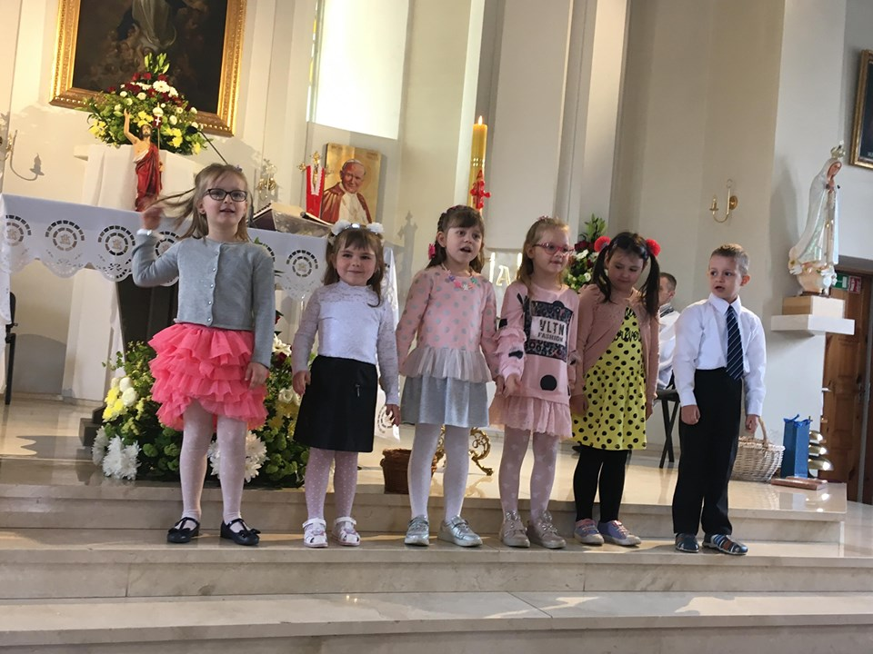

- Children will paint the tree of peace

During our traditional Family event in the preschool, all together we created the paint of tree of peace, it was a beautiful work from our parents and children.
To collect of this paintings we created the padlet wall for all partners schools.

https://padlet.com/mickunulopselis_darzelis/upsy76yhfgaq
https://twinspace.etwinning.net/62003/pages/page/655239

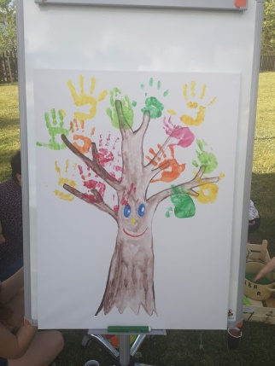

- Event entitled: Spring flowers around the Europe!
For our parents and children we created a picture competition about the flowers that we can find in our area, we got beautiful pictures, we choosed the winner, and we got nice result of this competition.
https://www.facebook.com/pg/mickunuld/photos/?tab=album&album_id=2347550825523609&__xts__%5B0%5D=68.ARD-FlxtG3QZdQvcFDE0RbpQ8WAJb1JUg_78PC1WAzC1HCrgr6ZR_S2jItGP31whqsppceR3Mf5bNkuhHrVe6NTsNeYZxLPFQLRZbThmpFlx2-hLV6V5C7Ll1LD0FN4vetJF5td3pH1p89yoyVbspLkGZdb0V-ot_94GZBt70112GbdaNYO-9xwg4H4X4Q6xhX8XqzJO2rcSS9cj1IE3asBObNmd2Clm1G-71fLR0_rrFu7Cu1VMNFN3QN02zRq9bAV8hcKv7hd2_ESYuuLwREOyUURugRzUn74KbbL85J7DEk2HMUBC6fHJ9twZlJ4YBoi0-ulNWU8dcNi9Ivh6H4DVYBiUY0fYo_u8mtuzOl3ZCti-1Cc_RNhqNo9PY8b3223DW9fvceK86pZNa0eljdPp8YXixJILjtF5yPa3JIBJddiwseinRhhsHmqkEBgPjFp3bGbnboHzT02BVxdUwu3B8Q&__tn__=-UC-R
In our Twinspace we created padlet with flowers around the Europe:
https://padlet.com/annmagiosi/hdrlp8msogty

- Puzzles and pairing games with spring paintings.

From the pictures, that was sended by our parents and from the children paintings we created the online games, that was tried by children, teachers and parents.

https://twinspace.etwinning.net/62003/pages/page/632934
https://www.facebook.com/pg/mickunuld/posts/?ref=page_internal

- Traditional games
Spring is the best time to spend a lot of time outside, so we created the day of games for children, me played traditional and modern games for children, we want to share with you the moments of this day.

https://twinspace.etwinning.net/62003/pages/page/640354

- Management activities
At the end of May we sent the monthly report of May to our project coordinator. We have done almost all project activities for May, we didn’t did the first activity about the customs of 1st May day, because in our country we don’t celebrate this event, and we didn’t created the event for Europe day.
We answered to the questionnaire about May partial evaluation of project implementation.
We received on time the list of June activities from our coordinator

