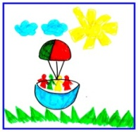  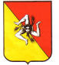 | ISTITUTO COMPRENSIVO STATALE  ad indirizzo musicale  “POLITEAMA”  Scuola dell’infanzia – plessi La Masa e Serpotta  Scuola primaria – plessi La Masa e Serpotta  Scuola secondaria di I grado – plessi Archimede e Federico II  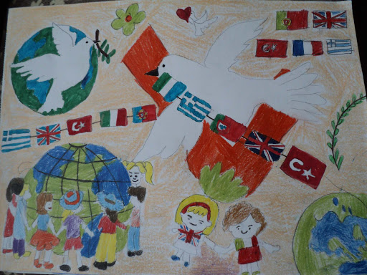 | 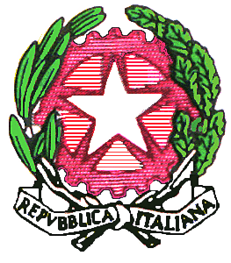

ERASMUS PLUS PROJECT
“ EVERY CHILD MATTERS – REFUGEES AND IMMIGRANTS IN EDUCATION”
DRAFT PROGRAMME FOR THE MEETING IN PALERMO

MONDAY 27 MARCH

09.00 Meeting at school “Archimede”
09.10 - 09.40 Headmaster’s welcome and presentation of the meeting days
09.40 - 11.10 Student presentations - Teacher presentations
11.00 - 11.40 Coffee break
11.50 - 13.00 Presentation of the school, town, region (Italy)

13.00 – 14.30 Lunch time

14.40 – 15.10 Presentation of the school, town, region (Turkey)
15.15 – 15.45 Presentation of the school, town, region (England)
15.50 – 16.25 Presentation of the school, town, region (Portugal)
16.30 – 17.00 Presentation of the school, town, region (Greece)

TUESDAY 28 MARCH

09.00 Meeting at school “Archimede”
09.10 – 10.10 Presentation of the works on immigration (Turkey)
10.10 – 11.10 Presentation of the works on immigration (England)
11.10 – 11.40 Coffee break
11.50 – 13.00 Presentation of the works on immigration (Portugal)

13.00 – 14.30 Lunch time

14.40 – 15.40 Presentation of the works on immigration (Greece)
15.45 – 17.00 Presentation of the works on immigration (Italy)

WEDNESDAY 29 MARCH

09.00 Meeting at school “Archimede”
09.15 – 13.00 Visit of characteristic places in Palermo
……………………………………….
…………………………………………
13.00 – 14.30 Lunch time

14.40 – 16.00 Workshop in the computer lab. Students work together in the mixed national
groups. Coordinators’ briefing.
16.00 – 16.15 Coffee break
16.15 – 17.00 Workshop in the computer lab. Students work together in the mixed national
groups .Coordinators’ briefing.

THURSDAY 30 MAR.

09.00 Meeting at school “Archimede”
09.15 Visit of characteristic places in Palermo
…………………………………
…………………………………….
13.00 – 14.30 Lunch time

14.40 – 16.00 Workshop in the computer lab. Students work together in the mixed national
groups. Coordinators’ briefing
16.00 – 16.15 Coffee break
16.15 – 17.00 Workshop in the computer lab. Students work together in the mixed national
groups. Coordinators’ briefing

20.00 Farewell dinner……………………………………………

FRIDAY 31 MARCH

09.00 Meeting at school “Archimede”
09.10 – 11.00 Assembling, fixing and sharing students work
11.00 – 11.20 Coffee break
11.20 – 13.00 Assembling, fixing and sharing students work

13.00 – 14.30 Lunch time

14.40 - 16.00 Certificate ceremony
16.00 – 16.15 Coffee break
16.15 – 17.00 Certificate ceremony

FINAL GREETINGS

