Erasmus+ Portugal Mobility trip
On Sunday 26th of November, we travelled to Portugal to participate in the fourth mobility of Erasmus+ project. Students from Italy, Greece, Turkey and us flew to meet up.
Day one we spent travelling to our apartment in Porto, we met up with Turkish students and walked around town.
On day two, we caught a train to travel to Lousado, and meet up at the Portuguese school. We played some games to get to know the other pupils. I enjoyed the treasure hunt we participated. We were split into groups and went round the village answering questions.
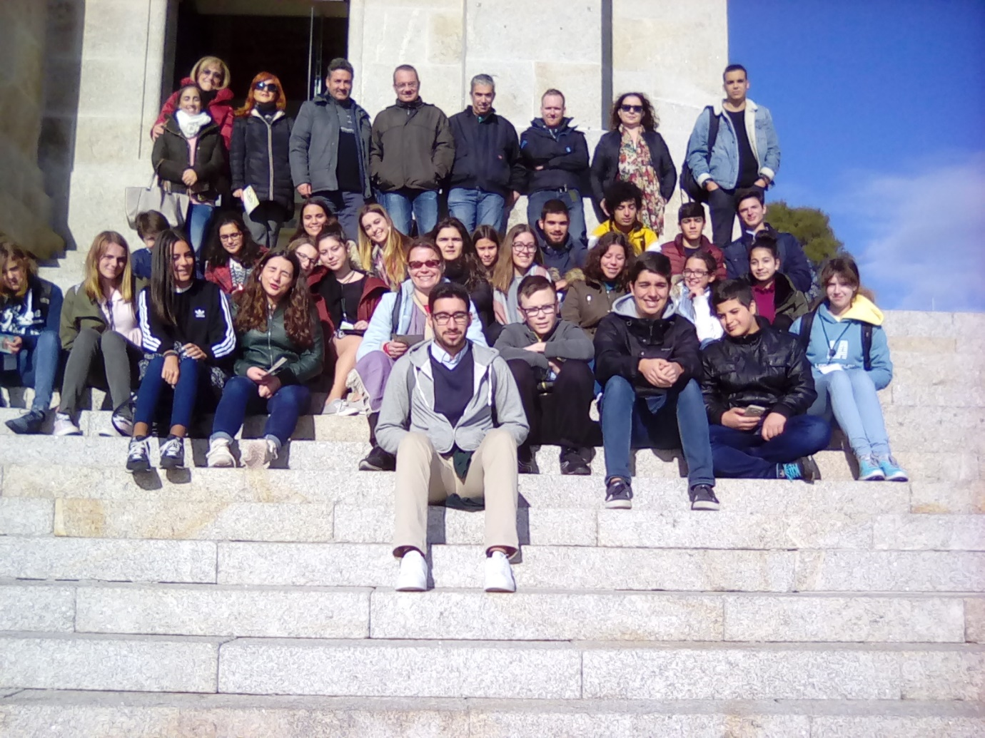
We spent day three at the Portuguese school taking part in activities based on traditional cultures. As part of art, we used traditional tile painting to illustrate refuge stories. We worked in mixed groups, each student and accompanying teachers painting one tile. In the afternoon, we were also taught some traditional Portuguese dances. On the way back to our apartment, we stopped off to visit a decorative Porto cathedral. In the evening, we held a party at our apartment. The Turkish and Greek students came over. It was great fun!
On day four, we presented our slideshow about Christmas. To teach the other students about some British traditions we gave out some advent calendars. We also completed a translation task and presented our painting project to the Portuguese students. In the afternoon, we gave out samples of traditional foods and tried other cultural foods.
On day five, we went on a school trip to a private school to listen to a presentation about refuges. We explored a Guimarães castle and had some free time to walk around the city. In the evening, we all attended a celebration dinner in Porto. We listened to some people singing and soon afterwards, we all had to join in dancing.
For day six, we went on second cultural to visit to Viana do Castelo. First, we stopped at the church of Santa Luzia, which had panoramic views of the city. On the way down, we caught a cable car. Our next stop was a ship museum. It was interesting as it was a hospital and supply ship in the North Atlantic fishing industry. In the afternoon we went back to Porto in time to watch the Christmas lights switch on; there was even a big firework display. We said goodbye to the Portuguese and Italian students. In the evening, the Greek and Turkish students came over to our apartment. We soon had to say goodbye to them to.
Day seven we travelled back to England. We had all enjoyed such a wonderful time in Portugal and thank you to Mr Pryer and Mrs Bulrey who organised this trip.
By Daisy Simpson
And here are thoughts from three other students who represented TTC in Portugal:
‘The best part of the trip was when we had a party at the apartment and we got to spend extra time with students from Greece and Turkey. There were loads of jokes, laughs and food.’ Rosie Mortimer
‘The best part of the trip was when we went on the trip to Guimarães and visited a private school. We listened to students speaking how they made refugees welcome. They told us the stories of some of the families.’ Joshua Stockwell
‘My best part of the trip was when we had landed in Porto. I bought a model plane and asked to be signed by the pilot. The flight attendant came back with it signed and when we landed the pilot shoed us around the cockpit. It was the best ten pounds I have spent. The trip was so much fun and I made so many friends. I hope to see them in the future.’ Oliver Dye

