Keep the Faith
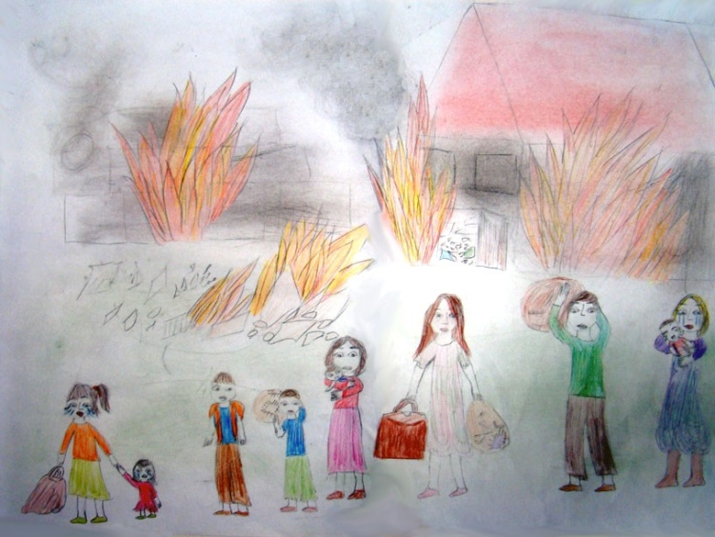
In Kenasba, a Syrian village in the Al-Haffah district, there was a happy family composed by Nasha, her twin sister Sara, their brother Mahament and their parents, Samantha and Jame. They always had fun together, they all went to school and to work and when the sun came down, they knew that the coming tomorrow would always be an unforgettable day. But one day, when they were returning home, they realized that a bad feeling was slowly corrupting the town. They were getting closer and closer to the town, not really knowing where those feelings came from, but soon they realized what was happening: Flames and giant bombs were destroying houses, people were screaming and shouting, hoping to be saved, and dead bodies were rolling down the streets. They didn’t understand what exactly happened, because it was the first time they were getting in contact with a thing our world uses to call “War”.
Since that day, their minds started to be tortured by a terrible sensation, by the fear of waking up without a friend, a son or a parent so, they decided to take a different way, to try to change their futures for better, to pursue their dreams, to be who they deserved and who they wanted to be, to be FREE. The only choices they had were to risk their lives or to get away from their native country, to travel to a foreign land and have a peaceful life. So, a man promised them he would take them to a safe place, Europe, but they were running out of money and selling their house still wasn’t enough to let the whole family travel: Samantha and Jame decided to stay in Syria to save their children’s lives.
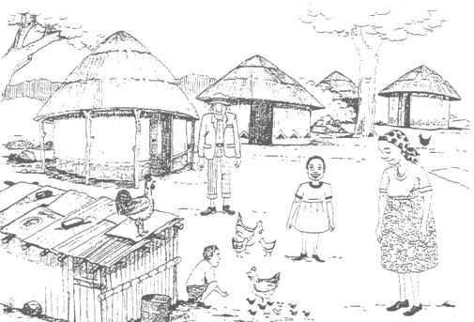
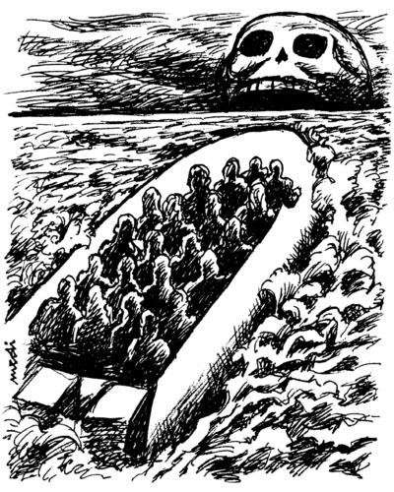
After walking for days and days through deserts, Nasha, Sara and Mahament were hungry, thirsty and tired of chasing something they thought would ruin their lives, by separating them from their family. Finally, they saw people on the road to Assos, village near the coast, and they realized they were really close to sea. Everyone in the town seemed to be really positive though most of the citizens were poor, living under bridges or in crumbling and ruined houses made of wood. The man brought them to the coast, where they had to wait for an inflatable boat to get closer and closer to the beach, with over a hundred people just like them, escaping from a ruthless reality they didn’t belong to. It was time to leave, and many parents started crying, knowing they would never see their children again, but Nasha, Sara and Mahament were all on their own, so they didn’t have nobody to say goodbye to. They fastly had to get on the boat, which was carrying too many people. Extremely high waves were scaring the travellers, desparately showing their emotions and their deepest thoughts with transparent tears falling down from their eyes. As they were going away from the coast, many mothers tried to keep their memories close to them, to believe that their dearests would become able to believe in theirselves and to escape from the darkness. After about 45 minutes, a man started shouting and repeating “Land!” and most of the people showed for the first time a smile on their face, but nobody knew that something was going to happen. As they were reaching the beach, the boat started shaking, causing loud noises and making children cry. In a few seconds, people started to fall in the sea, and men and women tried to keep the faith though everything they believed in was fading away, just like sand. Many parents jumped in the water, as their only dream was to die with their dearests. Nasha and Sara were holding tightly Mahament’s hands, do not wanting him to fall in the water and become one of the lost souls the world thinks to know all about, though it doesn’t. As their brother was drowning in the sea, memories, memories, and only memories were on the twins’ minds. The word suddenly turned black and white. In the end, Nasha and Sara were able to know what desperation feels like. They were now understanding where all those hopeless and frantic tears came from. While they were crying and shouting Mahament’s name, a rescue squad on a small rubber boat finally reached them, giving them towels to cover with and taking them to a safe place, but nothing could ever let them dream away. They just stopped and tried to close their eyes and forget the pain, as a crowd was watching them breathlessly on the coast.
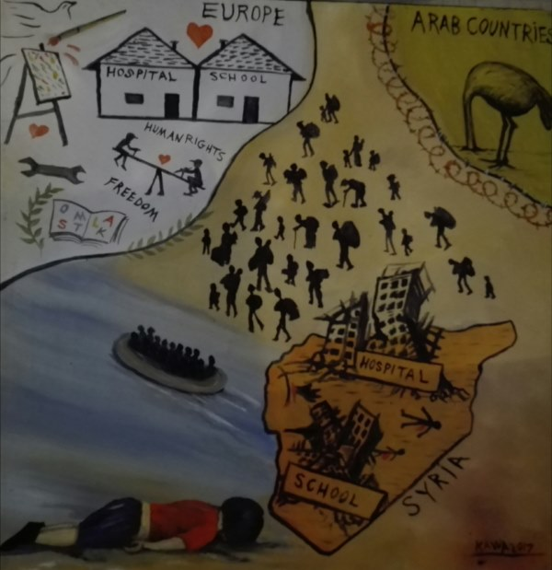

Tsampika Tsoplaki, Ferdinando Ambrosino, João Ferreira, Esma Nur Turgut

