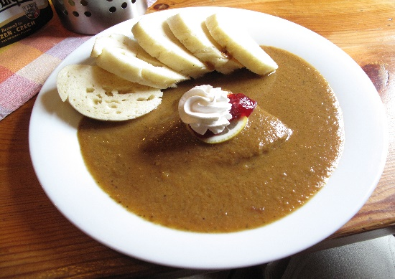
TRADITIONAL CZECH FOOD
Tato fotka od autora Neznámý autor s licencí CC BY-SA

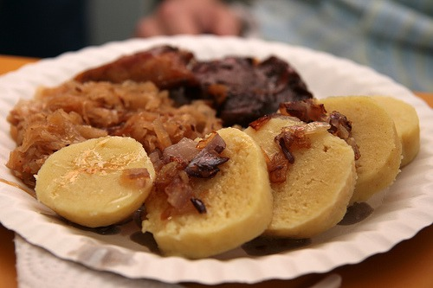
TENDRELOIN-It is a sirloin beef roast served with a cream sauce with root vegetables, we call it a sirloin sauce. It is usually served with bun dumplings, and flavoured with cranberries, a slice of lemon and whipped cream. Traditionally, the sauce is made from grazed root vegetables (carrots, celery, parsley), and cream.

PORK DUMPLINGS-Pork dumplings, a common (folk) name for the Czech national dish, pork roast with bun dumplings and braised cabbage, which consists of three components, served on a plate together: Roast pork, bun, potato, dumpling, steamed white sour cabbage After placing these components on a plate, the roast juice is poured or poured over the plate

