Can you complete the following information about these objects and devices?
OBJECT | Is it necessary? | How is it manufactured? | 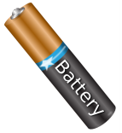  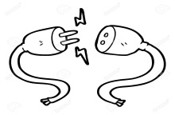  What kind of energy does it use? | 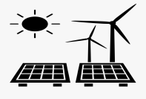  Where does that energy come from? | 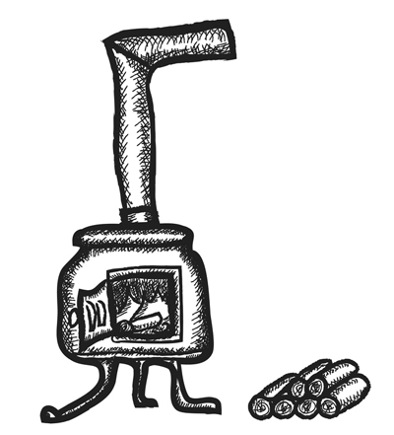  What did your grandparents or great-grandparents use instead?

