Virtual project meeting

Project number: 2019-1-ES01-KA229-063906_1

Project coordinator: Izaskun Garrote

DATE:

Twinspace
All the work on the project will be presented in Twinspace.
Forums. Several forums will be created to let the students share their ideas about different topics; e.g. School time and spare time during Covid, feelings about the project and about this meeting…

Monday
- Present the different tasks we will be doing during the week to students.– They will work in groups on renewable and non-renewable energy and they will present their work at the end of the week. They will look for information, discuss their ideas and agree on how to present it to the rest of the groups (it could be a poster, a film, a short story, a collage, etc.).

Tuesday
- Renewable and non-renewable energy - working on the topic
- 10:00 am Online meeting: Cultural workshop: each school will prepare an online Kahoot quiz. Topic: our countries. After the quiz, each group will present to the others the work done during this school year.
- Energy treasure hunt. Students will find installations that don´t work properly and bad habits that cause a waste of energy at school and the ways to save energy.
Wednesday
- Renewable and non-renewable energy - working on the topic
- 10:00am Online cooperative games for students of the different countries to meet and enjoy together.

Thursday
- 10:00am Online: Presentation of students’ work about their work on renewable and non- renewable energy and Energy treasure hunt.
- 18:00 – Online: workshop for teachers: Project Based Learning and other methodological approaches (practical examples)

Friday
- 13:00- Online: teachers ‘meeting to evaluate the week. Coordinators will gather each school´s impressions about the week.
- Certification

GAMES

Games for online meeting - Czechia

GAME ONE – pinwheel
- You need: paper A4, skewers, scissors, pin
- https://www.youtube.com/watch?v=69sbTbyH35k
- Competition:
  - 4 children
  - Each child will do only one part of the pinwheel and pass it to the next one
    - Child 1 cuts out the square out of A4
    - Child 2 folds the square and cuts the lines
    - Child 3 pins the paper on the skewer
    - Child 4 blows the pinwheel to prove it works

GAME TWO - Collect colored squares through a straw into bowls
- You need: 4 different coloured papers, straws, bowls
- Watch the game: https://pin.it/7617zKJ
- Competition:
  - 4 children
  - Cut coloured papers into 32 squares (squares = we make rectangles by folding colored A4 into 32 pieces (fold and cut 5 times in half)
  - Mixed them on the table
  - Children will sort the papers using straws into their bowls
  - the winner is the team that will have an empty table and squares in the right bowls

Games for online meeting - Cyprus

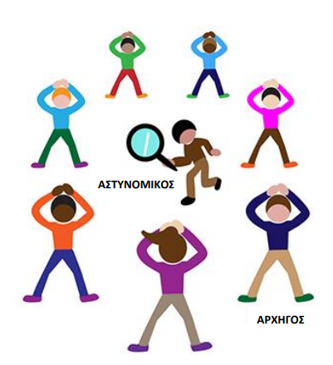
GAME 1
Find the culprit
This game can be played by groups of students. Each group has 8 persons (or more).
Pupils stand in a circle. Every student takes a lottery ticket from a box. Among the tickets there is one with the policeman and one with the secret culprit. The policeman stands in the middle of the circle. Nobody knows who the culprit is.
CULPRIT
POLICEMAN
The culprit waits to find the proper time to make a signal and the others must copy him/her. The policeman tries to find who the culprit is. He/she can try 2 times. If he/she doesn’t find him, the game begin again with a new draw from the box.
GAME 2
Run with a potato or egg
Students stand in a line. Each game can be played by 5-6 students. They hold a spoon with their mouth with a small potato or a boiled egg in it. They start to walk to the finish line. The winner is the student that reaches the finish line without dropping the egg or the potato.
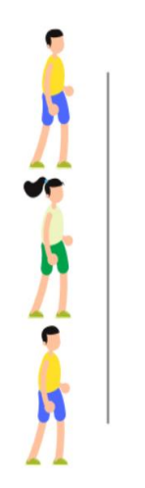
FINiSH LINE

Games for online meeting – Latvia

Game #1
“WORD HUNT”
- You will see a list of words with miss-matched letters.
- As a group you will have to put the letters in correct order and figure out the words.
- All words will be project related.
- Wins the country with the most correct words.
- Time 2/3 minutes.

Game #2
“FAST FEET”
- Measure a distance of 3 meters.
- At the end of the 3 m line put a chair.
- All students stand at the start of the 3 m line.
- You will need two A4 paper pages.
- Using the two paper pages each student has to walk to the chair and run back.
- Both feet have to be on one page at a time. Then put the other page in front of you and step on it…. and keep changes the pages until you reach the chair.
Games for online meeting – Basque Country

- Glass pyramid. Your group has to build the highest pyramid you can using cardboard glasses. Bear in mind:
- You will have 2mins/3mins? to do it
- Each row should have one glass less than the row below .
- The pyramid is finished only if there is a single glass at the top of it.
- Follow the alphabet. You have to find at school and collect different objects that start following the alphabetical order
A: Apple/armchar/arm/…
B:banana/ button..
C: cardboard/ car ( toy car)
D: doll/ door
E.gg/..
- The winner is the team that completes the most letters of the alphabet in 5 mins

