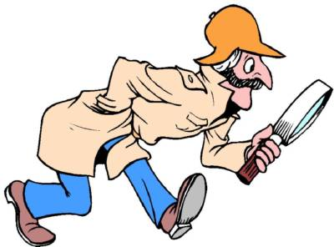
ENERGY HUNT
Go on an energy hunt. Think of your daily life and write down things that need energy to work.
CLOCK

