ELEKTRIZITATERIK GABEKO BIZITZA
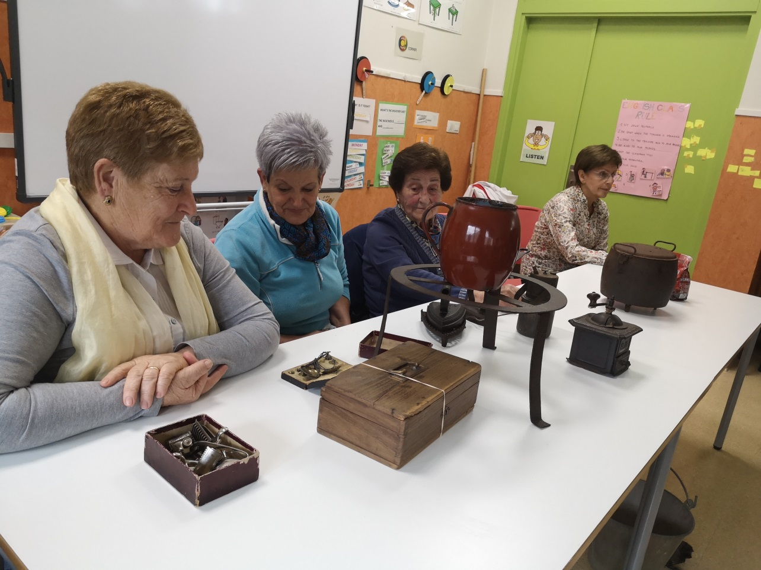
LIFE WITHOUT ELECTRICITY

Zer ekartzen dizu gogora argazki honek?Noiz atera zen?
What do you remember about this photograph? When was it taken?
Zenbat aitite-amam etorri ziren eskolara?
How many grandparents came to school?
Gogoratu mahai gainean dauden objektuen izenak eta erabilera.
Do you remember the names of the objects on the table and what they were used for?
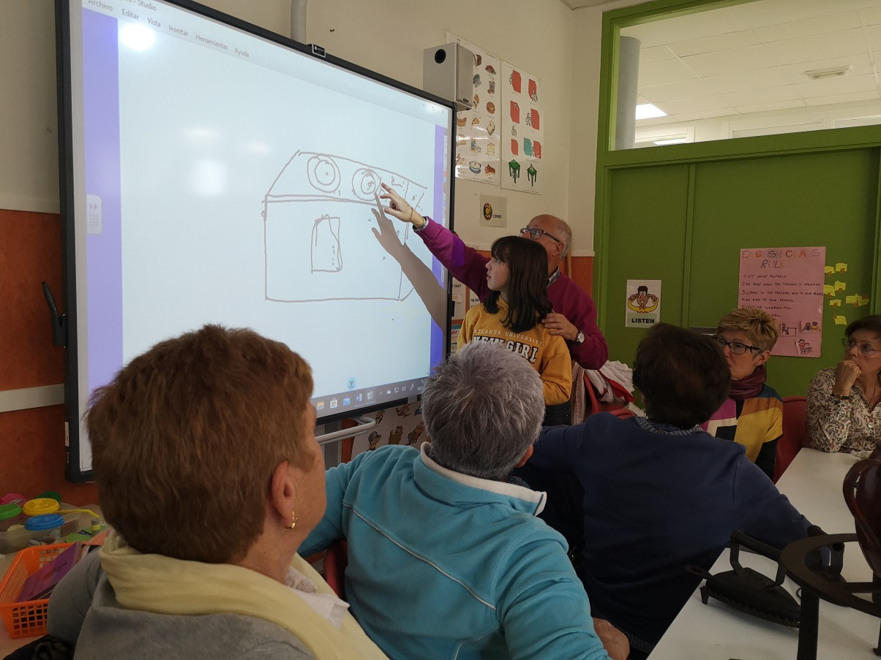
Zer marraztu du Haizeak?.Zertarako erabiltzen zen?.What did Haizea drew on the smart board? What was it for?

Kandelaz gain, Zzr erabiltzen zen iluntzean ikusteko?.Apart from candles , what other things did they use to see in the dark?
Zer da karburoa?...What is carbide?
Zelan garbiten zuten arropa?..How did they wash the clothes?
Zelan kontzerbatzen zuten janaria?..How did they conserve the food without a fridge?
Bidaiatzen zuten?Did they travel?
.Zelan joaten ziren eskolara? Bazegoen jantokia eskolan?
How did they go to school? Was there a school canteen?
..Zer egiten zuten entrenitzeko orain dauzkagun aparatu barik ( telebista, mobila, bideo jolasak…)Aspertzen ziren?…What did they do to have fun without a TV , computer games, posibilities to go out ...
Jolasteko denbora asko izaten zuten? Haiek aipatutako jolasen bat gogoratzen duzu?..Did children have any time to play? What games did the grandparents mention?
Zelan komunikatzen ziren albiste inportanteak?..How did they communicate important news?
Haien iritziz garai hartako bizitza gogorra zen?....In your opinion was it a hard life?
Eta zure iritziz? Zer botako zenuke faltan gehien?Zergatik?..What would you miss if you lived in the 50ties? Why?

