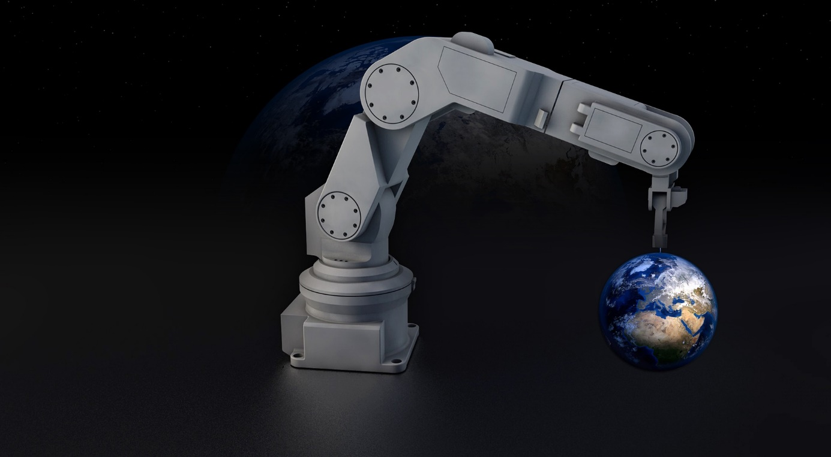
Industry in transition phase
Industry is changing. We are on the verge of entering a new industrial age. The so-called industry 4. 0! With this change, however, there are changing demands on the world of work that need to be mastered.
But what is industry 4. 0 anyway? To answer this question, we should look at the previous stages of development. The first Industrial Revolution began in the 19th century, with the emergence of modern factories as a new workplace for people. In industry 2. 0, these factories became more effective through electrification and assembly line work. Industry 3. 0, at the end of which we are at the moment, has been responsible for the introduction of information technology into our factories. With the help of the computer automation increased. The transitions to industry 4. 0 are fluent. In the fourth generation of industry, machines and products are to become even more networked than they already are. This should make the products more adaptable, multi-layered and cheaper than ever before. The production is to take place in real time, so that the articles can be more strongly adapted to the respective customer needs. The same applies to the products themselves. A washing machine, for example, should know how to clean a sweater most effectively without being told by humans.
But it is not only production and products that will change. The entire world of work is on the verge of change. Due to automation, some professions and activities are no longer required. For example, a simple courier could lose his job if he were replaced by drones. However, supporters often argue that industry 4. 0 also creates new jobs. The IT and electrical industries will grow strongly over the next few years. But the problem is deeper. In industry 4. 0, there is only room for highly qualified specialists. The tasks that are still performed today by less highly qualified employees will in future be performed by machines. However, we should remember that the goal of most developers who produce technology for industry 4. 0 is not to endanger jobs. Nevertheless, employees in endangered industries should continue to receive training in order to be able to keep up with developments. Computer skills will become increasingly important in the future. But creativity, willingness to learn and the ability to solve problems are also of great importance. Statistics show that these skills are becoming increasingly important as leadership positions increase.
In the future we should rather try to enable cooperation between machines and people instead of replacing people with machines. But no matter what industry 4. 0 looks like and what changes it brings, one thing is clear. It will come and this cannot be prevented.
Mervan, Ben, Torge, Andreas (documentary group D)

