The Norwegian Scheme to reduce truancy and dropping out | COOPERATION  in teams in departments, subject-based teams and class teams

CLOSE FOLLOW UP PLANS
And individual plans and arrangements of the training for students with low professional progression and students not showing up for class. Key words: TTT and FFF.
TTT and FFF
ta telefonen tidlig = meaning get in contact with the student, the parents, other teachers, contact teacher etc. early).
før fravær fort/register absence quickly (so that other teachers notice and total absence is revealed ASAP)
FYR
Fellesfag, and Relevans. Fellesfag = teaching general subjects (math, Norwegian, English, Science) with a vocational focus (Yrkesretting) to show relevance for profession.

RELEVANCE
Teach subjects relevant to your students, keep activity high, avoid cancelation of classes

ASSESSMENT FOR LEARNING
Assesssing what the students has learnt and needs to reach the next level of competence

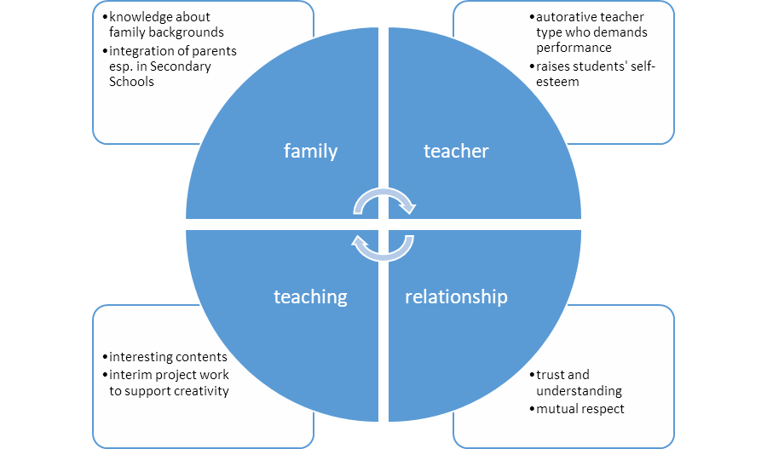

Background Information:
The Austlofoten Videregående skole developed a scheme to reduce truancy and students dropping out of school:
This summary is based on a document newly updated for the period 2018-2022, guiding the school towards the goals set by the school owner, the regional department. The plan is printed as a brochure to all employees, and they have all participated in the making of it in 2014 and the update.
Summary of the relevant goals for the TTT and FFF scheme of the Norwegians:
GOALS:
Reduce the number of drop outs from 6 to 4 % (common goal for all upper secondary schools in the region)
A minimum of 87 % of students continue to Vg2 from Vg1 (to the second year from first year)
MEASURES:
COOPERATION in teams in departments, subject-based teams and class teams
CLOSE FOLLOW UP AND INDIVIDUAL PLANS and arrangements of the training for students with low professional progression and students not showing up for class. Key words: TTT and FFF.
TTT = ta telefonen tidlig = meaning get in contact with the student, the parents, other teachers, contact teacher etc. early).
FFF = før fravær fort/register absence quickly (so that other teachers notice and total absence is revealed ASAP)
FYR stands for Fellesfag, Yrkesretting and Relevans. Fellesfag = general subjects (math, Norwegian, English, Science). Yrkesretting = vocational focus in general subjects (e.g. learn about how to care for a patient in English class in English, for Health students). We have FYR-groups consisting of teachers in vocational subjects and general subjects who teach in the same class. We try to plan a few FYR-projects for each class every year, where they get a task with goals in several subjects, both general and vocational subjects. Teachers plan the project together, and the students’ work are assessed in all subjects – sometimes it is a presentation given to all the involved teachers. In this way students can more easily see how for example math is relevant when planning meals in health institutions, and how Norwegian language is important when writing the care report for a patient.
FYR was a project for all upper secondary schools in the period 2011-2017, led by the Directorate of Education under the Ministry of Education. It was a measure to combat drop out and increase the number of students completing their VET education. It is still a focal point in all VET schools, now even more implemented in the regular school year.
RELEVANCE = (norw. ‘Relevans’), plan your teaching so that it is relevant to the actual group of students you teach. Pick examples from daily life, from their vocational subjects etc. Keep activity in class high throughout the year (avoid periods of low activity and cancelations of classes)
ASSESSMENT FOR LEARNING – a concept our school has been trained in for two years – along with most schools in the country. There is a focus on going from the teacher assessing the students to set a grade, to assessing what the student has learned, and what does each student need of supervision to get to the next level of competence (less focus on grades/marks).
https://www.udir.no/utdanningslopet/videregaende-opplaring/yrkesretting-av-fellesfagene/

