40 Ways to make a great European school project (Erasmus+ KA2)!

(This list was created on the basis of an Erasmus+ project called “Robots ‘R Us”, with students in Secondary and Vocational Schools which included students who need support)

- With your project, address some needs that your school really has! Choose the subject matter according to focus of your school and your fellow teachers:

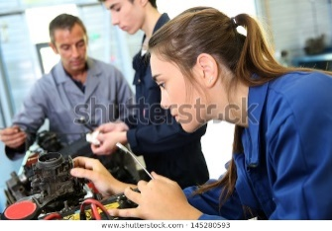
Example: Intercultural learning for intercultural schools, Robotics for boosting your students’ computer skills, encouraging girls for technical professions, challenges of the new labour market etc.)

- Make sure the final (technology) product is interesting for youngsters and society!

Example: Scheme for Individual support for weaker students,
Example: A functioning little robot

- Make sure that this subject matter is relevant for your partner schools! The participating teachers should be very committed to a work-intense project!

- Find at least 2 schools from different cultural/geographical backgrounds to take part in your project with your school, so that the international meetings give new insight into other parts of Europe/other cultural backgrounds

- Find at least 5 teachers at your school who are experts in this field, have a lot of experience and who want to take part before you write your application

- Find at least another 4 teachers at your school who will help you with the application of the project, the constant documentation and the finances who have enough endurance to stay in the project

- Make sure you work with colleagues who are flexible! Because there will always be changes in the schedule.

- Make sure you have or can buy the necessary equipment! Ask help from your principal and make a list of costs beforehand (you can take money from the management budget for relevant equipment or find other sponsors). Don’t apply for unaffordable projects!

- Inform students those students you want to include that you have a focus on their participation about the subject matter you intend to deal with and give them time to decide whether to take part

- Choose participants out of the group of interested students in an application process and by a credit point system during lessons and by interviewing them. QR code: video mit Felix

- Test students’ knowledge about this field regularly to evaluate the outcome of the project Test your students’ performance in a broader sense so that adjacent fields are tested as well. Then you will have a greater variety of objectives to check on (example: robotics as the focus, the broader field is ICT) and you get a more complex view on their achievements.

- Let your colleagues and students fill in a form with the rules of participation
example form: ???

- Make sure all work is done in an environment of safety, Formulate safety instructions! (see Norwegian form)

- If possible create a new course at your school for the field of your subject matter! If that’s not possible, plan regular extra times within your and your colleagues’ timetable for this particular project

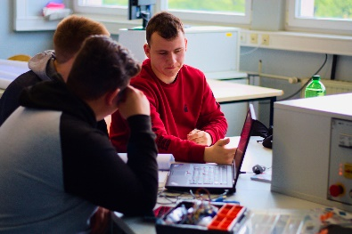
(Example: in our students’ timetable we implemented a weekly course called ‘robotics’)

- Publish interim results at your school so that the whole school knows what you are doing (and become motivated to join the project or start a new one)

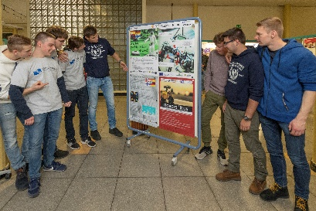

- If the participating students come from different departments of your school (as was the case in our project) fix a time slots for working together! (Maybe in the morning or breaks and slots in the afternoon when your students have time).

- If a common time slot is not possible in the given time table of the students, fix special project days or project weeks for the students to come together and work only on the project (without any other lessons)

- Make clear schedules for all participating staff allocating responsibilities: Who is responsible for project meetings? Who is for virtual meetings (via Skype, Zoom, Teams)? Who is in charge of the work phases with the students during their common working time at your school?

- Plan clear phases of the project (before writing your application) and then do the fine-tuning at the beginning with the students, formulating clear tasks and aims which have to be reached in the given time spans – include the students in all planning phases and all responsible positions as far as possible right from the beginning
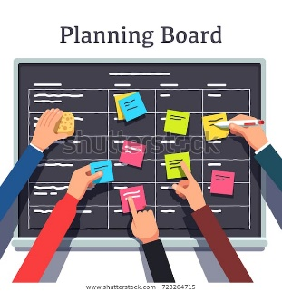

- Form teams mixing your students who need more support with more advanced students by starting with a practical task, a little (technical) challenge that your ‘special’ students can manage well for raising their self-esteem and easy integration into the work groups.

- Always start a new work phase with a new ‘challenge-orientated’ task or a ‘problem’ to solve so that your students can try to find the way and the solution themselves in mixed teams and make a solution plan for little steps along the way to the overall goal (like our Norwegian team did).

- Use cooperative learning techniques in your group work (see Norm Green, German materials: Gerold Brägger), so that each student gets a task he/she is responsible for in his/her team, meaning all students are necessary to reach the aim (principle of mutual dependence).

- Find at least one teacher who helps students with attractive visualisations for the documentation and presentation of their results in order to enrich the presentations and enlarge students’ competences in this field (like our Spanish participants who showed us how to do it).

- Use interesting and efficient ways and methods to carry out intermediate evaluations of work phases. This example is very useful to detect faults (introduced by the German team):

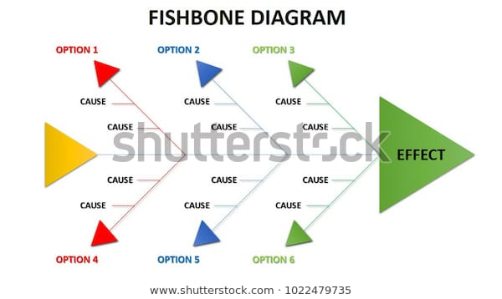

- Make the students carry out attractive presentations (nonverbal communication, language skills) so they can be proud when presenting their results.

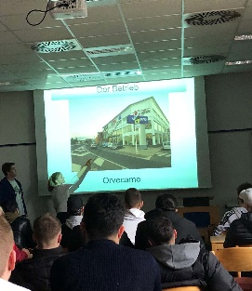

- Find at least one teacher who takes the minutes of all work phases and meetings and uploads them onto your school website and another web platform of your choice (e.g. etwinning, facebook, twitter etc.)

- Make sure to publish intermediate results on your platform and on other media and school festivals and Open-door-days immediately after you have got them to keep track of all progress of the project.

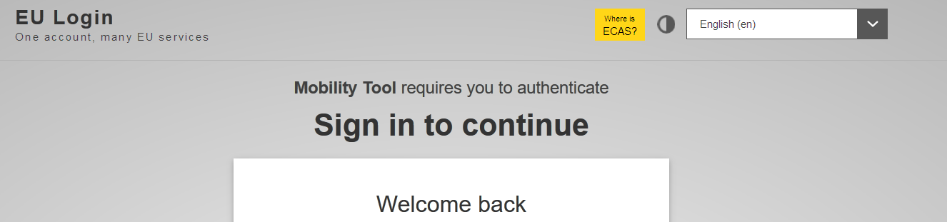

- Make sure that regular Skype meetings (or virtual meetings on e-twinning) help all international groups keep track of the tasks and intermediate results.

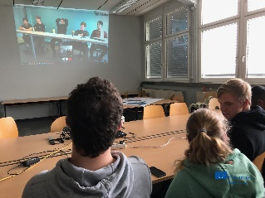

- Make sure your students and you have regular contact with each other to be able to react to unforeseen problems or changes! In our project there was a constant fluctuation of teachers (becoming severely ill or leaving the school) and students (leaving school for their next educational steps as the project took much longer than planned). New teachers and new students had to be motivated and recruited.

- For the schedule of an international Learning and Teaching Activity, guarantee intensive work phases with all students in teams and carry out great leisure activities Example: Choose a remote youth hostel so that all students also the residential students stay together for best group processes like our Finnish team did.

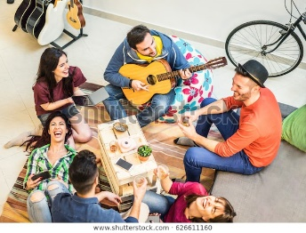

- Coordinators, start writing the intermediate report right from the beginning, so that you don’t miss important steps or changes in the process. Do so for your final report as well, straight after the intermediate report.

- Coordinators, give your reports to your partners for checking before you publish them.
In this way, you make sure that you haven’t missed important information about their work, either!

- Document all your expenses in an Excel-sheet right from the beginning and regularly, at least after each meeting or simply once a month so that you keep track of your accounting.

- Upload all interesting materials in the Mobility Tool regularly. It’s much harder to find them all at the end for your final report.

Example: Drawings, texts, pictures, all project results!

- For the final presentation, make sure that weaker students or students with special needs have a great share in the job of preparing and carrying out the festival, according to their abilities and the achieved skills, always on eye-level.

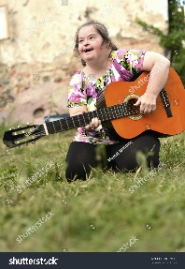 Hazheen film?

- Make sure to carry out a great presentation at the end of your project with authorities and parents and fellow-students and –teachers in a nice festival so that your ‘environment’ can take part in this great project and can see what your students have achieved.

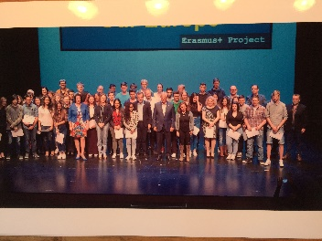
(Example: A festival on stage with invited parents and authorities like in Spain at the previous project “Recording Our Europe. Unfortunately Covid-19 stopped our plans.)

- Reward students’ performance with little “European presents” like flags, pens, pencils, bags, T-shirt and other little items to show your appreciation of their achievements

- Mention your students’ achievements on their school reports so that they can make use of the participation in the project for their future career!

- Write all of your reports in the common language of the project (ours was English) because then all of your partners can profit from your texts and use parts of them for their reports. It also gives your partners a help how to formulate future applications and reports in future projects.

- Keep cool! There will be phases when you think you can’t manage and you will not reach the goals of the project. Don’t worry! These phases only make you more alert to aspects that should be improved! Analysing them with your partners leads to improvement and great results! Sure!

