Open your mind!*

Scheme for an approach to integrate/include students with refugee and migration background through projects
*Rafif Alnajjar (class BF, mixed class of students born in Germany and newly immigrated youngsters, from Syria)

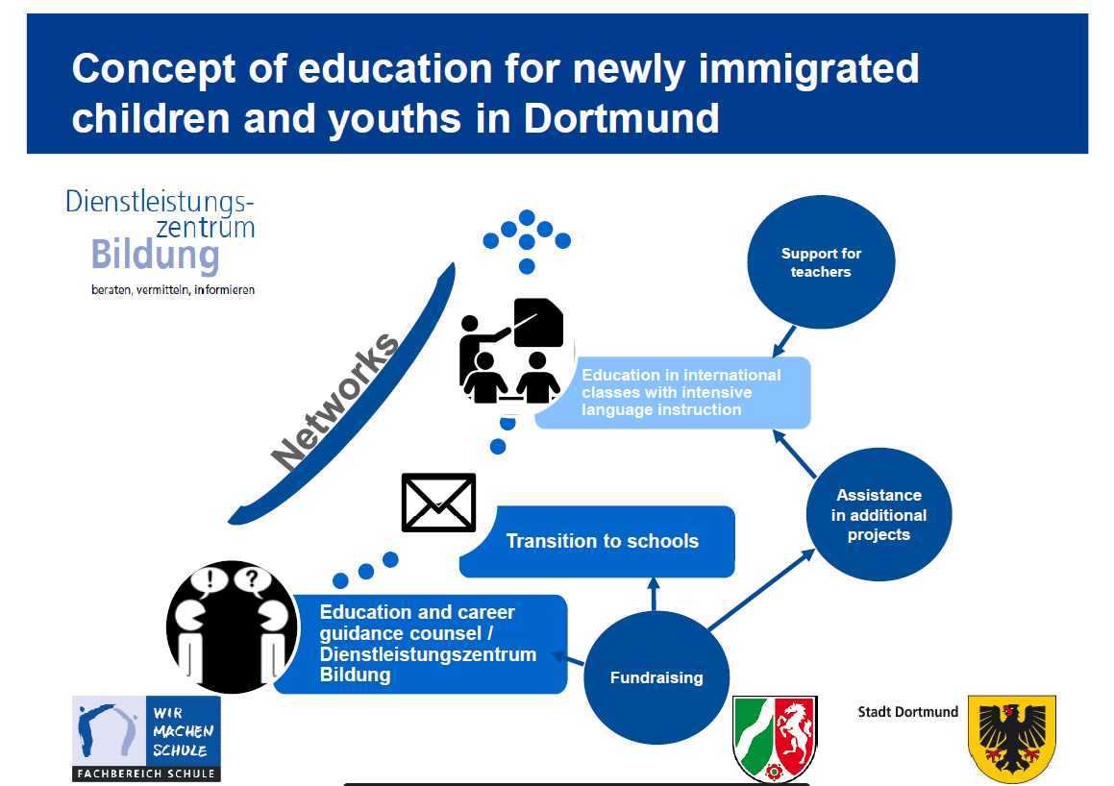

Results of the plenary:

General Approach: Approaches for integration no longer only apply to asylum seekers or refugees but to all people who travel (to Germany) and who stay => called “Zugereiste” (‘newcomers’)
The aim should be called “inclusion” instead of “integration”, because it should not be a process of assimilation of a new group to an established group but the support within a group

Cooperation between authorities:
- City Council and schools work closely together to simplify educational paths
- All participants: Close support network must exist between all authorities
- “Plan B” in Dortmund supports families about housing, finances, language support in official situations, also by providing interpreters through networks, language courses

School:
- In Puerto del Rosario: “Welcome class” before attending mixed class
- In Norway: 1. Level class of Norwegian before next level
- “Tandem courses” for learning Spanish at the LHB in which immigrated students teach students who were born in Germany => meeting at eye level, getting away from the deficiency approach in a one-to-one learning situation
- In Norway: Connected teaching approach: no subject is taught in isolation but linked with other subject matters
- Youth- orientated methods with podcasts, blog entries etc.
- Raising students’self-esteem (realised by presentations and more independent learning)
- Implementing regular project structures in teaching (e.g. competence-oriented approach in Germany in Youth Training Classes) instead of time-table structure
- More practical modules in learning bring students together
- More support to enable students to gain school certificates and reports which open doors to labour market
- In Finland and Germany: vocational training and language training simultaneously

Labour market:
- In Norway: convince employers about the necessity of training people to be skilled workers because they are needed => older workers must transfer knowledge to younger workers
- In Finland: Vocational training parallel to language learning courses
- In Germany: project-orientated approach in metal technology at the LHB => making a barbecue grill, planning, sketching, drawing, building, calculating etc. in student company “Young Steel”
- In Norway: every student is self-employed, students get a pre-contract in the companies
by which the employer can see how the student works, can be immediately changed into a
real contract
- More work placements for a hands-on experience in order to find out what you like to do for a living

- “Dual System” in Germany to connect practical hands-on approach at the company with learning the underlying theory at school simultaneously (but you need a contract with a company that the school must prepare you for)
- More application fairs (like “Markt der Möglichkeiten” where companies present themselves at one big event in a festival hall)
- Employers present themselves more at the schools to reduce students’ intimidation to get into contact with an employer themselves on application fairs
- Extra technical tuition from student to student for more successful apprenticeships, paid by job center
- More support for motivated company owners, because there are a lot who would like to employ a ‘new citizen’ to help with the transfer from school to working world
- More internships which show employers how well someone works beforehand
- City Council offers extra courses for students in an apprenticeship (Dual System)

Social integration:
- In Finland: focus on learning the Finnish language through social interaction on special events
- Project “Angekommen” as a scheme to support all ‘newcomers’ in education in more complex terms (additional German courses, cooking, climbing, leisure activities, extra tuition) in a special building and environment

- European projects that support European identity and cooperation between school departments and learning levels with a hands-on approach working in international teams like “Robots ‘R Us”
- More contact between all classes of one school
- Common journeys and trips to open your mind to other cultures
- Enrichment approach through social events to find out what refugees bring into the country, not only what they have to learn and don’t bring in (soft skills etc.)

Hopes and dreams:
- More support from companies to help integration in labour market
- More practical work (with metal, wood, plastics) in mixed classes across departments and levels of education
- Longer breaks for common meals and other activities together
- A library as a communication centre building bridges between youngsters and cultures
- More money for the necessary equipment for a practical approach
- More teachers for team teaching
- More lessons to be shared in international groups

